SPEAKING TEST 3
The Media

Name: _____________________________________________________ No. _____ Class: _____
Opinion: _______________________________________________________ Date: ___/___/___
My opinion

- In small groups prepare your speaking test. Duration: 6 – 10 minutes
In order to do this, bear in mind the following steps:
1. Together choose one of the statements given.
2. Discuss it and give your own opinion(s) on the matter relating it to the topics you have
studied along the module: The Media. You don’t have to share the same opinion.
3. Devise a plan to share your opinion(s) with the class and decide:
- what you are going to say;
- how you are going to present it;
- who is going to say what.
4. Prepare yourselves for the questions your classmates / teacher may ask you.
5. Rehearse the presentation.

2. Evaluation
You will be evaluated on: organisation and development, structures, fluency, clarity, creativity and interaction.
After the presentation, evaluate yourself using the chart below.
Put a circle around the number that corresponds to your performance on each indicator.

Self-assessment

 | Very Weak | Weak | Fair | Good | Very Good | Points
Organisation and development (25%) | 10 | 20 | 30 | 40 | 50
Structures (15%) | 6 | 12 | 18 | 24 | 30
Fluency (15%) | 6 | 12 | 18 | 24 | 30
Clarity (15%) | 6 | 12 | 18 | 24 | 30
Creativity (15%) | 6 | 12 | 18 | 24 | 30
Interaction (15%) | 6 | 12 | 18 | 24 | 30
 |  |  |  | TOTAL SCORE
Signature: ________________________
3. Choose one of the opinions given below. Do you agree or disagree with it?
Discuss it and give your own opinion on the matter. Give reasons for your opinion(s).
“In my opinion, the print media is still the most important medium.”
Harry


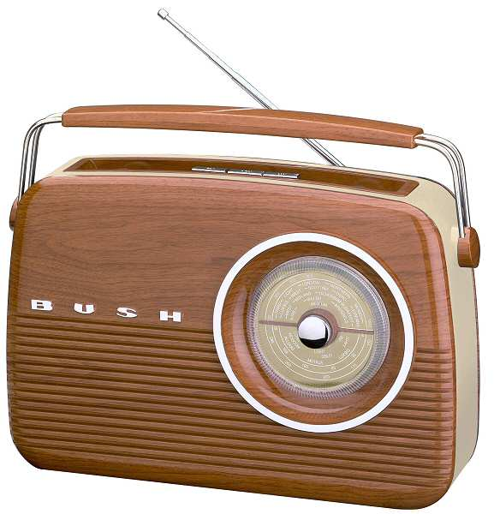
“I think listening to music means mainly listening to the radio.”
Ruth

“Television influences our ideas and the way we have grown.”
Philip

“Any kind of violence on TV should be banned if you ask me.”
Steven
Philip


“Reality TV should not be watched by children or young teens, don’t you think?”
Samantha

“Too much television affects our behaviour negatively.”
Kate


“The Internet allows us to be far better informed than newspapers, television or radio.”
Michelle

“The media have the right to publish any pieces of news even if people’s feelings are exploited.”
Sean

