UNIT 0 Worksheet — Film

NAME: Nr. CLASS:
DATE: EVALUATION:
TEACHER: E. E.

SITCOM: “FAWLTY TOWERS”

BEFORE WATCHING

1 You probably don’t know this sitcom because it was broadcast on TV many years ago. Before watching some excerpts do some research about it. Surf the Internet and discover the following.

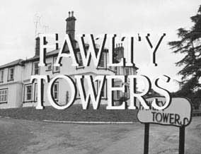a) Where it was made (the country).

b) When it was broadcast.

c) How many episodes there were in each series.

d) Who the main characters were.

e) Where the series was set (the place).

WHILE WATCHING

2 Watch the 1st episode "Cheking in" and answer the following questions.
a) What is happening at the hotel reception?

b) What is the problem at the reception?

c) How does the receptionist solve the problem?

d) What is Manuel’s problem?

3 Watch the 2nd episode "Basil gives Manuel a language lesson" and find out ...
a) what Basil Fawlty is trying to tell Manuel.

b) why Manuel doesn’t understand at first.
c) what Basil does to try to make Manuel understand him.
d) the reason why Basil hired Manuel to work at the hotel.
e) the excuse Basil gives for not understanding Manuel.

BE CONNECTED • Inglês • 10.º ano • Material fotocopiável © Santillana-Constância

4 Watch the 3rd episode "Manuel mans the phone" and complete the sentences.

a) When the phone rings …
b) Manuel doesn’t understand English very well, so …
c) At the end …

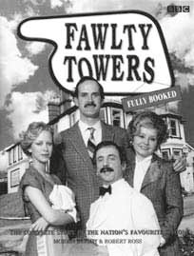AFTER WATCHING

5 Complete the description of Manuel, using the words from the box.
Three of them do not apply.

verbally | tolerance | disorganised | English
character | waiter | afraid | actor
languages | accent | happy | proud

Manuel, a (a) played by Andrew Sachs, is a well-meaning but

(b) and confused Spaniard from Barcelona with a poor grasp of the

(c) language and customs. He is (d)

and physically abused by his boss. When told what to do, he often answers, "¿Qué?" (What?). Manuel’s (e) was used to demonstrate Basil’s instinctive lack of sensitivity and (f) . Every episode would involve Basil becoming enraged at Manuel’s confusion at his boss’s bizarre demands and even basic requests. Manuel is (g) of Fawlty’s quick temper and violent assaults, yet often expresses his appreciation for being given employment. He is relentlessly enthusiastic and is (h) of what little English
he knows. Manuel’s exaggerated Spanish (i) is part of the humour of the show. Andrew Sachs’ native language is German. He moved to Britain as a child.
WIKIPEDIA. Retrieved from en.wikipedia.org/wiki/Fawlty_Towers
(abridged and adapted, November 2012)

6 Answer the questions.

a) Does Manuel have any problems because of the language? Explain, giving examples.

b) Does the influence of his Spanish accent in English cause him any problems? How?

c) What kind of problems can you encounter if you are in an English speaking country and you can’t speak English?

d) Have you ever had a communication problem? If so, when, and what happened?

7 Think about Manuel’s situation and write a short text about the importance of speaking English and the influence your mother language may have on your English accent.

BE CONNECTED • Inglês • 10.º ano • Material fotocopiável © Santillana-Constância

