UNIT 1 Worksheet — Film

NAME: Nr. CLASS:
DATE: EVALUATION:
TEACHER: E. E.

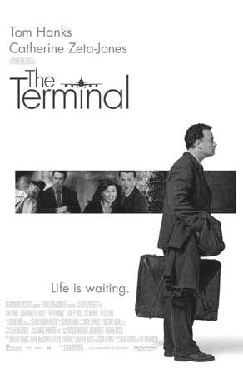FILM: THE TERMINAL

BEFORE WATCHING

1 Answer the following questions.

a) What is the most interesting thing you like to know about when visiting a foreign country?

b) How open-minded are you towards foreigners and their different habits?

c) Do you often generalise about people from other countries?
Explain.

d) Why is it important to learn English if you want to travel to other countries?

e) Do you think it’s important to learn about the habits, customs and behaviour of people from other countries?

2 These are important words/phrases in the film. Explain their meaning using a dictionary.
a) flight attendant
b) border
c) immigration control
d) immigrant
e) visa
f) asylum
g) bureaucracy
h) military coup

3 Look at the pictures below and speculate about what you are going to see in the film. Share your ideas with your classmates and then, after watching the film, see who got closer to the real story

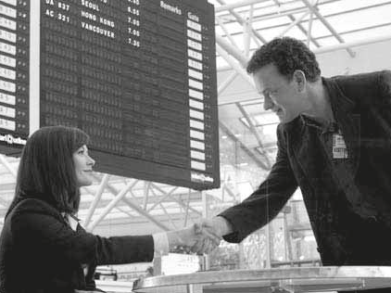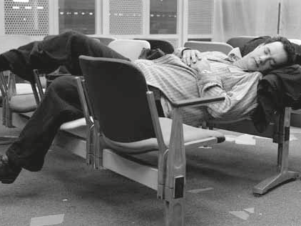

BE CONNECTED • Inglês • 10.º ano • Material fotocopiável © Santillana-Constância

AFTER WATCHING

4 Read the paragraphs of the plot summary and put them in the right order according to the film.

a) One day, Viktor explains to Amelia that the purpose of his visit to New York is to collect an autograph from the tenor saxophonist Benny Golson. It is revealed that the peanut can Viktor carries with him contains nothing more than an autographed copy of the photograph "Great Day in Harlem". His father was a jazz enthusiast who had discovered the famous portrait in a Hungarian newspaper in 1958, and vowed to get an autograph of all the 57 jazz musicians featured on the photograph. He succeeded in obtaining 56, but died before he could finish his collection.

b) Viktor is asked to interpret for a desperate Russian man with undocumented drugs for his sick father. Viktor claims it is «medicine for goat,» barring the drug from confiscation and resolving the crisis. Dixon is being evaluated for an upcoming promotion under pressure and the watchful eye of the Airport Ratings committee. Though Dixon is advised that sometimes rules must be ignored, he becomes obsessed with getting Viktor out of the airport.

c) Viktor Navorski (Tom Hanks) arrives at JFK International Airport, but finds that he is not allowed to enter the United States. While he was en route to the US, a revolution was started in his home nation of Krakozhia. Due to the civil war, the United States no longer recognizes Krakozhia as a sovereign nation and denies Viktor’s entrance to the US. Unable to leave the airport or return to Krakozhia, Viktor instead lives in the terminal, carrying his luggage and a mysterious Planters peanut can.

d) A few months later, the war in Krakozhia ends, but Dixon will still not allow Viktor to enter the United States. He instead blackmails Viktor into returning to Krakozhia, or he will have Enrique fired for allowing Viktor into the restricted food preparation area and deport Gupta back to his native India, where he is wanted for assaulting a corrupt police officer.

e) Customs and Border Protection (CBP) Head Frank Dixon wants Navorski removed from the airport. Navorski collects money for food by retrieving vacant baggage trolleys for
the 25-cent reward from the machine, until Dixon prevents this. He then befriends a catering car driver named Enrique who gives him food in exchange for information about a female Customs and Border Protection officer. With Viktor’s help, Enrique and Dolores eventually marry each other.

IMDb. Retrieved from www.imdb.com/title/tt0362227/synopsis
(abridged and adapted, October 2012)

a) b) c) d) e)

BE CONNECTED • Inglês • 10.º ano • Material fotocopiável © Santillana-Constância

