UNIT 3 worksheet — Film

Name: _______________________________________________________________________ Nr. Class:
Date: Evaluation:
Teacher: e. e.

FILM: WAG THE DOG
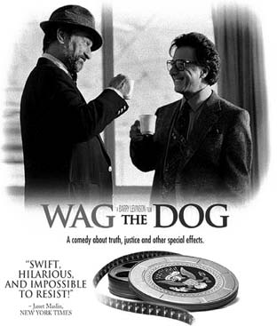
Before watching

1 Do you know what the expression “wag the dog” means?

2 Why do you think the film is called "wag the dog"?

While watching

3 Choose the best option to answer the questions about the film.

a) At the beginning of the film the President is not in the USA. Where is he?

1. In Albania.

2. In China.

3. In Japan.

b) According to Conrad what do people remember about wars?

1. The slogans.

2. The wars.

3. The soldiers and the heroes.

c) How many Oscars did Motss win?

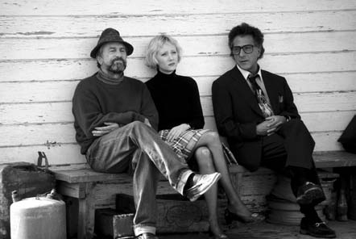
1. One

2. None

3. Two

d) Why did Motss decide to help Conrad?

1. For the fun of it.

2. To be famous.

3. To be an ambassador.

e) Where should the fake “suitcase bomb” be?

1. In Andrews.

2. In Washington DC.

3. In Canada.

f) A famous actor is from Albania. Who?

1. John Belushi.

2. Joe Belushi.

3. Jim Belushi.

g) Why does the President’s plane go to Boca Raton instead of Andrews? Because …

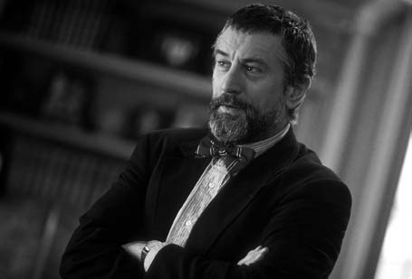
1. It will rain in Andrews.

2. It will not rain in Andrews.

3. It will snow in Andrews.

h) Why do people go to war?

1. To ensure their way of life.

2. To earn money.

3. To become heroes.

i) What was written on Schumann’s sweater?

1. Brave mom.

2. Courage mom.

3. Bravo mom.

j) What is the title of the song that is about a shoe?

1. "Good old shoe".

2. "Good new shoe".

3. "Good shoes".

After watching

3

4 Complete the film synopsis with the missing words. Some words do not apply.

victory | producer | caught | character | specialists | re-election
president | fictional | media | filmed | war hero | scandal
news | song | report

When an unnamed president of the United States is (a) in a closed room with an underage "Firefly Girl" (the fictional equivalent of a Girl Scout) less than two weeks before (b) _____________________, Conrad Brean (robert De Niro), a top spin-doctor, is brought in to try to take the public attention away from the (c) . He decides to construct a fake war with albania, hoping the (d) will concentrate on this instead. In order to come up with his "war", he contacts a Hollywood producer named Stanley Motss (Dustin Hoffman), who brings in a series of (e) who help construct a theme song, build up interest, and fake some footage of an orphan in albania. the plan’s continual setbacks – including an error that led to seizing a criminally insane army prison convict (Harrelson) to be their "hero" who was "shot down behind enemy lines" – do not disturb the (f) , who repeatedly claims "this is nothing" while comparing the situation to past movie-making catastrophes he averted. In the end, with the election completed and the president re-elected, everything seems fine – until the producer finds out from the tV (g)_________ that the media are crediting the president’s (h) to his tired "Don’t change horses in mid-stream” campaign slogan, rather than Motss’s elaborate plans.

Motss announces that he will call the media to "set them straight", despite Brean warning him that he is "toying with his life". When Motss refuses to back down, Brean has him killed and makes it look as if he had a heart-attack while tanning next to his pool. The film ends with a news (i) about a violent incident in Albania, but it is unclear whether this is a true event or simply a continuation of the (j) _______________ war.

http://en.wikipedia.org/wiki/wag_the_Dog (abridged and adapted, august 2012)

5 Answer the following questions about the film.
a) Why do they hire a Hollywood producer?

b) Why do they choose to go to war with Albania?

c) Comment on what Motss says: “If I’ve seen it on TV, it is true.”

d) How important are the Media?

e) Do you believe everything you see on TV? Why? Why not?

f) Is media manipulation a reality in your country?

Material fotocopiável © Santillana-Constância

