UNIT 3 Worksheet Writing 1

NAME: Nr. CLASS:
DATE: EVALUATION:
TEACHER: E. E.

1 Look at the following headline carefully. Imagine you are a journalist in the year 1969 and write
a newspaper article about this monumental event in world history. Follow each of the steps below to help you plan and write your article.

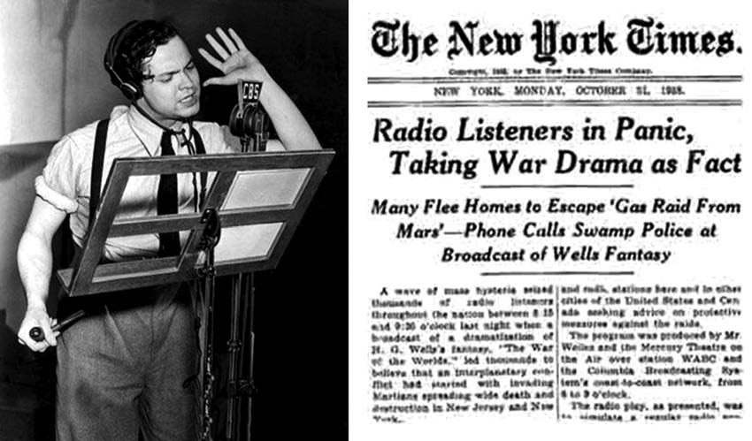

STEP 1

Do some research about this event: “The first man on the moon”.

STEP 2

Come up with a good introduction with one or two sentences that will catch the reader’s attention and give him/here an idea of what the article is about.

STEP 3

Begin writing the article. Be sure to cover the Wh-questions: who, what, when, where, why and how of the event.

STEP 4

Edit your article and see if your article is really related to the headline.

STEP 5

Ask a classmate to act as your editor to correct and revise your article.

BE CONNECTED • Inglês • 10.º ano • Material fotocopiável © Santillana-Constância

UNIT 3 Worksheet — Writing 2

NAME: Nr. CLASS:
DATE: EVALUATION:
TEACHER: E. E.

Write a composition of about 180 words, on the following quotation by Malcom X.

“The media’s the most powerful entity on earth. They have the power to make the innocent guilty and to make the guilty innocent, and that’s power. Because they control the minds of the masses.”

Use the following steps to help you plan write your composition.

STEP 1 — Understand

Read the quotation carefully to make sure you know what you are being asked to do.

STEP 2 — Think

Take notes of some ideas on the topic as you think of them. Don’t forget to make a list of vocabulary/key words that you know you may need when writing about the topic.

STEP 3 — Plan

It is important to organise your notes (thoughts and arguments) so that you can present them clearly. Plan your paragraphs before you start to write. A composition or essay is usually organised as follows:

Paragraph 1 — Introduction to the topic.
Paragraph 2 — Points of view and information/examples that support the argument(s).
Paragraph 3 — Contrasting views.
Paragraph 4 — Conclusion (give your opinion on the topic).

STEP 4 — Write

Write your text using your plan as a guide.

STEP 5 — Review your text and edit it if necessary.

BE CONNECTED • Inglês • 10.º ano • Material fotocopiável © Santillana-Constância

