NAME: | Nº
CLASS: | DATE:
CLASSMATE: | Nº

Student’s Book - Writing page 23

You received an email from your new pen friend.
Write a reply to him/her.

- Read your classmate’s email. Check to see if all the information is clearly communicated.

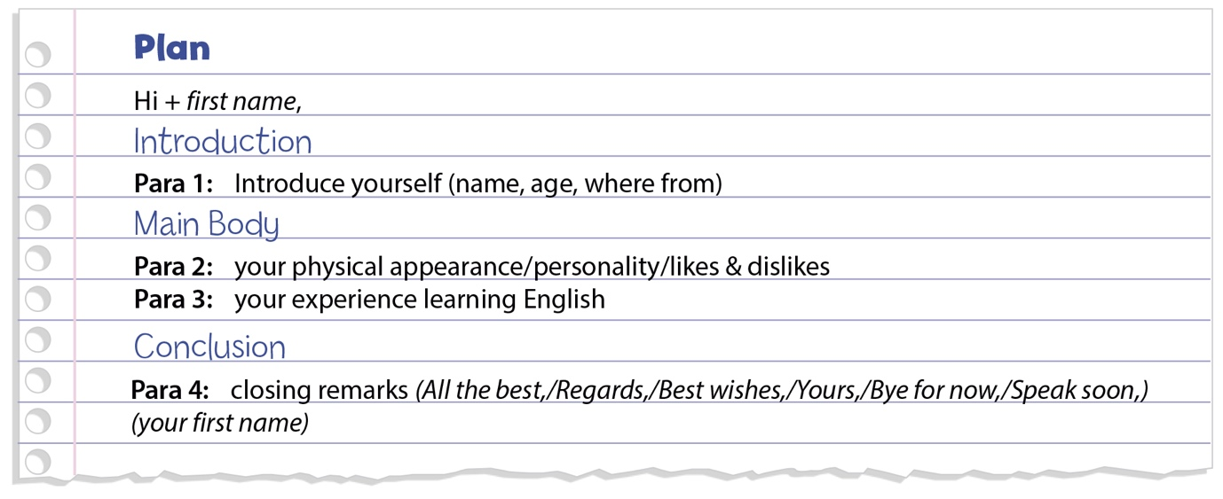
- Use the checklist to assess your classmate’s presentation: did he/she present all the ideas according to the plan described in ex. 6 b)?

Appropriate opening/closing remarks
Appropriate informal style
Organised in paragraphs with the correct information in each one
No grammar, spelling or punctuation mistakes
Correct number of words

Extra recommendation:
_______________________________________________________________________________________________________________________________________________________________________________________________________________________________________________________________

- Give your feedback to your colleague so that he/she can improve his/her writing skills.

