ENG10TRF © Porto Editora

Test specifics

Conteúdos temáticos / Domínios de referência | Tipologia de itens | Cotação | Critérios de classificação
– Internet dangers  – Technology | Listening
– Internet dangers  – Technology | A) de seleção: True / False | 16 | 2 pontos: resposta correta 0 pontos: resposta incorreta
– Internet dangers  – Technology | B) de construção: resposta restrita | 20 | 4 pontos: resposta correta 0 pontos: resposta incorreta
– Passive voice  – Indirect passive voice  – Future continuous  – Word formation: nouns | Reading and Use of English
 | A) de seleção: encontrar evidência | 18 | 3 pontos: evidência correta  0 pontos: evidência incorreta ou incompleta
 | B) de seleção: antónimos | 10 | 2 pontos: resposta certa 0 pontos: resposta errada
 | C) de construção: questões diretas | 24 | 8 pontos: resposta correta e completa sem erros ortográficos ou gramaticais  4 pontos: resposta correta, mas incompleta ou com alguns erros gramaticais / ortográficos  2 pontos: resposta correta, mas muito incompleta ou com muitos erros gramaticais / ortográficos  0 pontos: resposta incorreta ou incoerente
 | D) de construção: identificação de objetos | 6 | 2 pontos: resposta certa 0 pontos: resposta errada
 | E) de seleção: escolha múltipla | 15 | 5 pontos: seleção correta 0 pontos: seleção errada
 | F) de construção: reescrita de frases | 16 | 4 pontos: reescrita certa 0 pontos: reescrita errada
 | G) de construção: preenchimento de espaços | 15 | 5 pontos: resposta certa 0 pontos: resposta errada
 | H) de construção: preenchimento de espaços | 15 | 3 pontos: resposta certa 0 pontos: resposta errada
Vocabulário relacionado com os temas | Writing
Vocabulário relacionado com os temas | De construção: resposta extensa (cerca de 100-120 palavras) sobre uma das unidades temáticas. | 45 | 36-45 pontos: articula as ideias de forma adequada num texto claro e coerente; bom domínio das estruturas e formas gramaticais, vocabulário variado e adequado; erros ortográficos e gramaticais pouco frequentes e não impeditivos de compreensão; respeita os limites de palavras.  19-35 pontos: texto pouco organizado, mas coerente; vocabulário pouco variado, mas adequado; erros ortográficos e gramaticais frequentes e não impeditivos de compreensão; pode não respeitar os limites de palavras.  9-18 pontos: texto desorganizado e simples, abordando o tema de forma genérica e recorrendo a repetições e pormenores pouco relevantes; vocabulário pouco adequado; erros ortográficos e gramaticais frequentes; pode não respeitar os limites de palavras.  1-8 pontos: texto muito desorganizado e simples; erros ortográficos e gramaticais sistemáticos, vocabulário pobre e frases sem sentido; não respeita limites de palavras; conteúdo pode afastar-se do que é pedido.  0 pontos: texto sem sentido; estrutura elementar e desajustada; conteúdo não corresponde ao que é pedido.

Answer key and Scripts

ENG10TRF © Porto Editora

Listening
A. 1. F; 2. T; 3. T; 4. F; 5. F; 6. T; 7. T; 8. F
B. Inappropriate content; Ignoring age restrictions; Friending or communicating with people they don’t know; Sharing personal information; Gambling or running up debts

Reading and Use of English
A. 1. “Almost none of us can imagine life without it.”
2. “…we should only focus on the advantages of technology, however, …we can very well face its negative effects.”
3. “If an adult uses technology in a harmful way, we can call it a 'choice' instead of “unconsciousness”.”
4. “Here are some questions that preoccupy parents’ mind.”
5. “Positive effects… problem solving skills, as well as their mental and physical development.”
6. “The overuse of technology and unsupervised access to the internet may cause many negative effects on teens’ social skills, as well as their mental and physical development.”
B. 1. required; 2. advantages; 3. harmful; 4. unconsciousness; 5. improper
C. 1. Teens are associated with the unconscious use of technology because they are normally unaware of the negative effects of using it the wrong way.
2. Personal answer
3. Personal answer
D. 1. prosthetic limb; 2. exoskeleton; 3. drone
E. 1. are being faced; 2. chose; 3. is provided
F. 1. …have been provided wonders by technology.
2. …technology are being discussed (by them).
3. …effects are caused by the overuse of technology.
4. …was shown many interesting sites (by them).
G. 1. will be playing; 2. won’t be waiting; 3. will be holding
H. 1. explanation; 2. assistance / assistants; 3. safety; 4. scientist, childhood; 5.
inspiration

Script A:
The internet, with its endless access to information, is a valuable tool but also a potential risk to safety and security. It is important to monitor or be aware of what a teen sees and shares, or could become exposed to. There is a high risk of being exposed to sexual predators (for example, in chatrooms), pornography or radicalisation.

Using e-technology to bully people has become an increasing problem in recent years, with over a third of young people having been affected at least once. There has been a massive increase in online bullying due to the use of social media such as Twitter or Facebook, which is easily accessible through mobile devices as well as computers.
Examples include: posting negative comments on someone’s Facebook / Twitter page; taking on someone’s identity on the web to humiliate them; harassing someone via their mobile phone / social media.
Staff should be aware of the risks and check that any technological devices teens use are secure and have the relevant security installed. Teens may be enticed to access certain websites with special offers and prizes. They should report any concerns to a line manager immediately.

Script B:
The Risks Associated with the Internet and Online Social Networking Inappropriate content – Teens may see illegal or unsuitable content such as pornography, child abuse images, dangerous advice on eating disorders, self-harm or suicide, radicalisation, excessive violence or race hate materials.
Ignoring age restrictions – Some websites and games use age restrictions and checks to make sure that teens don’t see unsuitable content. Children must be at least 13 to register on most social networking websites and therefore such companies do not provide safety advice for children under the age of 13.
Friending or communicating with people they don’t know – Children and young people may chat or become ‘friends’ with people on social networks or online games. They may not actually know anything about the person they are communicating with, having never met them in person. This makes teens vulnerable to bullying, grooming and sharing personal information.
Sharing personal information – Privacy controls can limit who can see your teens’ details, like their name, age and where they live. But when a teen connects to someone as a ‘friend’, that person will have access to the teens’ personal information, including their GPS location on some devices. Some ‘free’ games might ask a teen to fill out lots of details before they can play and then illegally rent or sell this data on to others. Children and young people can also reveal their location by tagging photos, such as on Instagram, or checking in on Facebook or Foursquare. This enables people to find out where a teen lives, socialises and studies.
Gambling or running up debts – Many online games are free but offer the chance to buy items such as extra lives or new levels. So, teens may run up big bills without realising. Gambling sites have strict measures to make sure that their users are adults, but young people aged 18 and over could be enticed by offers and prizes and try to access these sites with the temptation to win money, etc.

Name No. Class Date Mark Teacher Parent

Listening
ENG10TRF © Porto Editora


You will hear someone talking about the risks associated with the internet and social networking. Say if the following statements are True or False.
A
8×2=16

 | True | False
1. The internet is totally safe and secure.
2. There’s a high possibility that a teen may encounter a sexual predator.
3. Cyberbullying has been increasing lately.
4. The use of social media has nothing to do with that increase.
5. Cyberbullying may include posting neutral comments on someone’s Facebook /
Twitter sites.
6. Harassing someone through their mobile phone / social media is also
cyberbullying.
7. Technological devices should have the relevant security installed.
8. Teens shouldn’t be concerned with access to certain websites that offer prizes.


Listen to the second part and complete the risks associated with the internet and online social networking.
B
5×4=20
Risks
1. content
2. Ignoring
3. Friending or
4. information
5. or
debts

Reading and Use of English

Read the following text.



Positive and Negative Technology Impacts on Teens

Technology is the knowledge, skills, methods and techniques required to produce tools and equipment for people’s needs. Almost none of us can imagine life without it. Based on this definition, we may think that we should
₅ only focus on the advantages of technology; however, in case of unconscious use, we can very well face its negative effects!
When we speak of unconscious use of technology, teens are the first ones that come to mind. If an adult uses
10 technology in a harmful way, we can call it a “choice” instead of “unconsciousness”. But it’s different for teens
because they are generally not aware of the possible negative impacts of technology, which are caused by its improper use.
Here are some questions that preoccupy parents’ minds: How does technology work for teens, is technology
15 good or bad for kids, how to stay safe on the internet for kids?
The answers are pretty simple. Until a certain age, technology is all about cell phones, tablets, and computers. So, by applying the internet safety tips for kids that we’ll share with you later on and by choosing the right applications and websites, you will be able to provide internet safety for them.
But first, let’s look into the positive effects of technology on teens that you can benefit from and the
₂₀ negative effects of technology on teens’ health and development that you should avoid.
Positive effects
1. Increase in IQ;
2. Mental skill development with educational contents;
3. Learning enhancement;
4. Problem solving skills;
₂₅ 5. Parental control in emergency situations.

Negative effects
We’ve talked about the wonders technology can provide, so now it’s time to discuss the negative effects caused by misuse. The overuse of technology and unsupervised access to the internet may cause many negative effects on teens’ social skills, as well as their mental and physical development.
1. Lower attention span;
₃₀ 2. Minimised social interaction;
3. Increased aggression;
4. Health problems: vision problems; neck pain; distortion of the skeletal structure of the body; arm, hand, finger numbness; overstrain;
5. Reduced sleep quality;
35 6. Cyberbullying, abuse and security risks.
ENG10TRF © Porto Editora
https://www.mentalup.co/blog/positive-and-negative-effects-of-technology-on-children (adapted and abridged)


Find evidence in the text for the following statements.
A
6×3=18
ENG10TRF © Porto Editora
1. We can’t imagine life without technology.

2. There are positive and negative aspects in technology.

3. When an adult uses technology, he / she is being conscious of that action.

4. Parents worry whether technology is a good tool for their kids or not.

5. Problem solving skills is one of the benefits of technology use.

6. Teensʼ mental and physical development can be affected by the overuse of technology.


Find in the text (first two paragraphs) the antonyms to the words below.
B
5×2=10
1. optional
2. disadvantages
3. beneficial
4. awareness
5. appropriate


Answer the questions about the text in your own words.
C
3×8=24
1. Why are teens associated with the unconscious use of technology?

2. Which of the benefits of technology mentioned in the text do you find most useful? Explain.

3. What about you? Do you overuse technology or do you use it with moderation? In which situations do you use it?

Name the following gadgets.
D
3×2=6
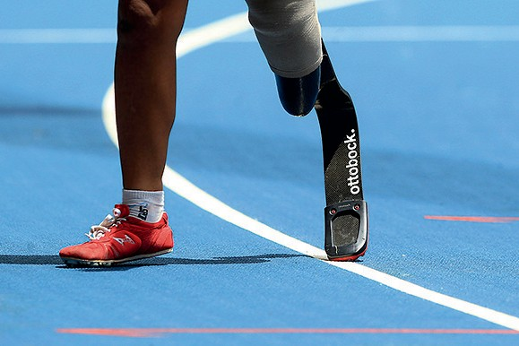



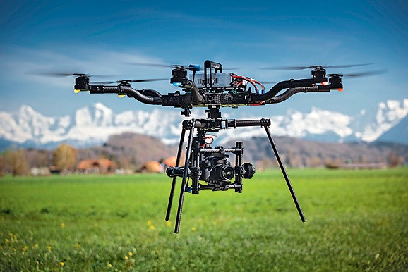

1. 2. 3.

Choose the correct option to complete each sentence.
E
3×5=15
1. We are facing the negative effects of technology.
The negative effects of technology are facing / are being faced.
2. The right applications were chosen to protect teens.
They chose / have chosen the right applications to protect teens.
3. You provide internet safety to kids.
Internet safety is provided / was provided to kids.

Rewrite the following sentences in the passive voice starting as suggested.
F
4×4=16
1. Technology has provided wonders to all of us.
All of us
2. They are discussing the benefits of technology.
The benefits of
3. The overuse of technology causes many negative effects.
Many negative
4. They showed me many interesting sites.
I

Fill in the gaps with the future continuous of the verbs in brackets.
G
3×5=15
1. He (play) online games until the sun rises.
2. I (not wait) for you after 6 pm.
3. The scientists (hold) a meeting in the morning.

Add suffixes to the words in brackets to form nouns.
H
5×3=15
1. I require an immediate ! (explain)
2. Some scientists need a lot of in their work. (assist)
3. You must handle this drone with ! (safe)
4. He has always wanted to be a since his . (science / child)
5. I need some for this work. (inspire)

Writing

Choose A or B and write about 100-120 words.
A
45
Comment on the following statement:
“Men are only as good as their technological development allows them to be.”
George Orwell
B
Your best friend is addicted to online video games. He / she is always playing and doesn’t care about school or friends anymore.
Write an email warning them about the dangers of that addiction.

Listening | Reading | Use of English | Writing | Your score
36 | 52 | 67 | 45 | 200

