Casa da Aula – Centro de Explicações
Name: ________________________________________________ Class: ____ Nº: _______
Date: _________________________________________________ Score: _______________
Enc. Educação: ________________________________Teacher: __________________

Module 3 Test A

The Sims Online

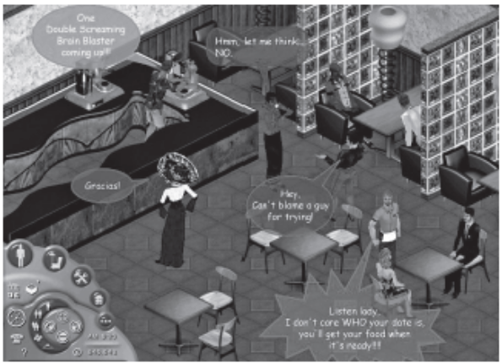
The Sims Online, a networked version of The Sims PC game, received a lot of buzz with its launch. Unlike the PC game, where the Sims basically function as virtual pets, online Sims are clearly a virtual version of each player or avatar. Interestingly, online Sims still have to sleep, eat and socialise. For those who simply want to chat and hang out with other people online, this can be annoying. On the other hand, these tasks offer endless chances for small talk when meeting other Sims.

The Sims Online has been heavily marketed to teens, and the majority of residents seem to be in their teens and twenties. Although it is similar to social chat environments, The Sims Online is still constricted by “gaming” rules like earning skills and money. The object of the game is to earn as much money as possible in order to furnish your virtual home with beautiful household objects. In fact, part of the fun is seeing the creative ways the players decorate their homes.

http://www.virtualworldsreview.com/thesimsonline/ (adapted)

READING COMPREHENSION
A. Match the words on the left with their meaning on the right.
- a. to frequent a particular place
- b. to supply a house with necessary appliances
- c. unlimited or continuous
- d. a rumour or report
- e. an inauguration
1. buzz (n.)
2. launch (n.)
3. hang out (ph. v.)
4. endless (adj.)
5. furnish (v.)

B. Are the statements true (T) or false (F)? Correct the false ones with phrases from the text.
1. The Sims Online is a version of the PC game to be played on the Internet.
2. It didn’t cause much reaction when it entered the market.
3. In this game, you can create a character that looks like you.
4. Unlike the PC game, you don’t have to do the usual tasks: eating, sleeping, etc.

C. Complete the following sentences on the text.
1. If a player just wants to chat, it’s annoying that…
2. The Sims Online was designed for…
3. The basic rules of the game are…
4. The players earn virtual money to…Yes, I enjoyed it very much.

D. Answer the following questions.
1. How are the Sims Online and the Sims PC different?
2. How old are the majority of players?
3. Does this game have anything to do with a chat room? How?
4. What is so fun to see?

GRAMMAR
A. Say whether the following nouns are Countable (C) or Uncountable (U) and make a sentence with that word.
e.g. book ^{C} I bring all my books to school.

1. water _________________________________________________________
2. sugar _________________________________________________________
3. pencil _________________________________________________________
4. news _________________________________________________________
5. chair _________________________________________________________

B. Fill in the gaps with the past simple or the past perfect of the verbs in brackets.
e.g. When I logged in, you had already left (already / leave).
1. Before I _______________ (buy) the computer, I had worked with some specific programs.
2. He talked about the game he _____________ (play) the night before.
3. Macy ____________ (fall) in love with a guy she had met online two months ago.
4. I __________ (be) late for my first date because I had missed the bus.

C. Write the sentences correctly using the future with will or going to.
e.g. I don’t know what to wear. I think I put on my black suit. I think I will put on my black suit.
1. Your friend is so pale. He go faint.
__________________________________________________________________________
2. I forgot about your e-mail. I send it to you tonight.
__________________________________________________________________________
3. Here are the predictions for next year. Salaries stay the same.
__________________________________________________________________________
4. I’ve already booked my summer holidays. I spend a week in Brazil.
__________________________________________________________________________

D. Complete the sentences with the correct form of the verbs in brackets. These are Conditional sentences Type 1 and 2.
e.g. If I can’t meet people in real life, I will try (try) online.
1. If it doesn’t rain, we ______________ (go) to the city park.
2. What would you do if you _____________________ (not / have) a car?
3. If I was famous, I ____________ (do) a lot of charity work.
4. He will never have friends if he _________________ (continue) with that attitude.

WRITING

A. In about 100 words, describe your ideal virtual game to play online with your friends: scenario, objectives, rules, etc.
_____________________________________________________________________________________________________________________________________________________________________________________________________________________________________________________________________________________________________________________________________________________________________________________________________________________________________________________________________________________________________________________________________________________________________________________________________________________________________________________________________________________________________________________________________________________________________________________________________________________________________________________________________________________________________________________________________________________________________________________________
___________________________________________________________________________________________________________________________________________________________________________________________________________________________________________________________________________________________________________________________________________________________________________________________________________________________________________________
_____________________________________________________________________________________________________________________________________________________________________________________________________________________________________________________________________
______________________________________________________________________________________________________________________________________________________________________________
_____________________________________________________________________________________________________________________________________________________________________________________________________________________________________________________________________

Reading Comprehension
A. 5 x 4 = 20
B. 4 x 5 = 20
C. 4 x 5 = 20
D. 4 x 5 = 20
Grammar
A. 4 x 5 = 20
B. 4 x 5 = 20
C. 4 x 5 = 20
D. 4 x 5 = 20
Writing
40

Total
200
TEST SPECIFICATION

