School: ____________________________________________________________________
Name: ________________________________________________ Class: ____ Nº: _______
Date: _________________________________________________ Score: _______________
Enc. Educação: ________________________________Teacher: __________________

Module 6 Test C

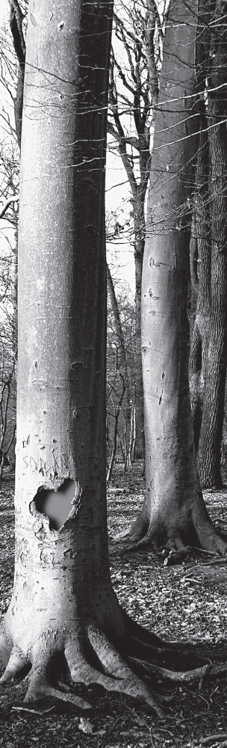
Protect Ancient Forests!

All over the world, ancient forests are in crisis. Many of the plants and animals that live in these forests are almost extinct. And many of the people and cultures who depend on these forests for their way of life are also threatened. But the news is not all bad. There is a last chance to protect these forests and the life they support.

The world’s ancient forests are truly diverse. They include boreal, temperate and tropical forests, coniferous forests, rainforests and mangroves. Together they maintain environmental systems that are essential for life on Earth.

They influence weather by controlling rainfall and the evaporation of water from soil. They help stabilize the world’s climate by storing large amounts of carbon that otherwise would contribute to climate change.

These ancient forests are home to millions of forest people who depend on them for their survival – both physically and spiritually.

These forests also house around two-thirds of the world’s landbased species of plants and animals. That’s hundreds of thousands of different plants and animals, and literally millions of insects – their futures also depend on the ancient forests.

These magnificent ancient forests are under threat. More than 87 human cultures have been lost in Brazil alone; in the next 10 to 20 years, the world will lose thousands of species of plants and animals. But there is a last chance to SAVE these forests and the people and species that depend on them.
www.greenpeace.org

READING COMPREHENSION
A. Match the words taken from the text to their definitions.

- a. the amount of water falling from the sky
- b. growing and living on the land
- c. in danger, facing extinction
- d. accumulating something
- e. living under bad conditions
1. threatened
2. rainfall
3. storing
4. survival
5. land-based

B. Find the synonyms to these words in the text.
1. old (l. 1)
2. hold (l. 5)
3. various (l. 18)
4. wonderful (l. 20)
5. opportunity (l. 23)

C. All these statements are WRONG. Correct them according to the text.
1. Animals, plants and people who live in ancient forests aren’t being affected by this crisis.
2. Ancient forests control climate change by sending carbon to the atmosphere.
3. 87 new human cultures were found in Brazil.
4. There isn’t a chance of saving these forests.

D. Answer the questions.
1. What types of ancient forests are there?
2. How do they influence weather?
3. Who and what depends on these forests?
4. What will happen in the next 10 to 20 years?

GRAMMAR
A. Make a verb out of these nouns and adjectives.
e.g. simple – simplify

1. stable
2. structure
3. example
4. armed
5. short

B. The following adverbs are misspelt. Rewrite them correctly.
e.g. This house was beautifuly decorated. – beautifully

1. The dogs barked agressivily.
2. Dinner was delightfuly served.
3. He did the exam too quickely.
4. They are gradualy adapting themselves to their new house.
5. She sees him very frequentely.

C. Join the sentences together using the subordinating conjunction in brackets.
e.g. You don’t take out the trash. I won’t cook you dinner. (If)
If you don’t take out the trash, I won’t cook you dinner.

1. She never saw Titanic. She doesn’t like romantic movies. (because)
2. He has never practised any sports. He is very slim. (although)
3. I use a sheet of paper. I recycle it. (after)
4. I forward dozens of Greenpeace e-mails. People may begin to care about the forests. (so that)
D. Complete each sentence with a passive verb.
e.g. Garfield caught a mouse.
A mouse was caught by Garfield.

1. People cut down millions of trees every year.
Millions of trees ___________ every year.
2. People built houses in the Amazon.
Houses ____________ in the Amazon.
3. People are watching too much TV nowadays.
Nowadays, TV ______________ too much.
4. I will finish this project very soon.
This project ______________ very soon.

WRITING
In about 80-100 words, write an e-mail to all of your friends explaining the problem of deforestation and
suggesting ways they can help.


Dear friends,
I am writing to tell you about…____________________________________________________
_______________________________________________________________________________________________________________________________________________________________________________________________________________________________________________________________________________________________________________________
Reading Comprehension
A. 5 x 4 = 20
B. 5 x 4 = 20
C. 4 x 5 = 20
D. 4 x 5 = 20
Grammar
A. 5 x 4 = 20
B. 5 x 4 = 20
C. 4 x 5 = 20
D. 4 x 5 = 20
Writing
40

Total
200
TEST SPECIFICATION

