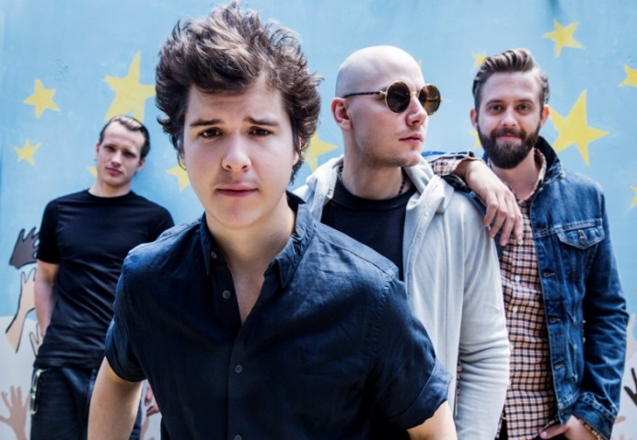
1. Listen to/Watch the song and complete it with the missing
Name No. Class Date
The world of teens
Unit 1
words or expressions.

Chorus
My Mama said that it was okay
Mama said that it was quite alright
Our kind of people had a bed for the night
And it was okay
5

15

20

Mama told us we were a. _________ ___________
And daddy told us never listen to the ones
Pointing nasty fingers and making b. ___________
Lukas Graham – Mama Said
https://www.youtube.com/watch?v=HdAkYCyCZv8

’Cause we were good kids

Remember asking both my mom and dad
10

15

20

Why we never travelled to exotic c. _____________
I know which place I'm from
I know my j. __________
When I'm in doubt and struggling
That's where I go
An old friend can give k. __________
When new friends only know a half story
That's why I'm always keep them tight
And why I'm l. __________
I said I'm okay

You know what my mama said?
You know what she told me?

Chorus

25

15

20

We only ever really visit d. ________________
Nothing to tell when the summer ends
We never really went buying e. _________________
Folks were passing on this stuff in plenty loads
15

15

20

New shoes once a year and then
30

15

20

Out to play ball so we could ruin them

Chorus

Don’t get me wrong I didn’t have it f. _____________
I got enough loving from my mom and dad
35

15

20

But I don’t think they really understood
20

15

20

When I said that I wanted the deal in g. ___________
I told them I’ll be singing h. _______ ________
The other kids were calling me a wannabe
The older kids they started bugging me
But now they’re all standing right i. ______ ______ of me


2. Find the line(s) in the text where he refers to:

a. the people his father told him to ignore; ________________________________________________________________________
b. what he never did in the summer; ________________________________________________________________________
c. the little he had compared with other people; ________________________________________________________________________
d. his relationship with his parents; ________________________________________________________________________
e. his parents’ reaction to his childhood dream; ________________________________________________________________________
f. being made fun of; ________________________________________________________________________
g. his house being a safe haven for him; ________________________________________________________________________
h. the importance of keeping old friends. ________________________________________________________________________

3. Make a short list of things your mother/father tells you to do and not to do and discuss it
with your classmates.

DOs | DON’TS
 | 

Answer keys
1. a. good kids b. fun c. lands d. friends e. clothes f. bad g. Hollywood h. on TV i. in front j. home k. advice l. okay.

2.
a. And daddy told us never listen to the ones / Pointing nasty fingers and making fun (lines 6-7)
b. (…) we never travelled to exotic lands (line 10)
c. We never really went buying clothes / Folks were passing on this stuff in plenty loads (lines 13-14)
d. I got enough loving from my mom and dad (line 18)
e. But I don’t think they really understood / When I said that I wanted the deal in Hollywood (lines 19-20)
f. The other kids were calling me a wannabe / The older kids they started bugging me (lines 22-23)
g. I know my house / When I’m in doubt and struggling / That’s where I go (lines 26-28)
h. An old friend can give advice / When new friends only know a half story / That’s why I’m always keep them tight / And why I’m okay (lines 31-33)

