Short Story: "The Uncles", by Fitch O’Connell
EXTENSIVE READING TEST 1

Escola Secundária: ________________________________________________
Name: _____________________________________ No. _____ Class: _________
Date: ____/____/____ Mark: _______________ Teacher: _________________
I
A. Look at the picture and describe it in a paragraph.
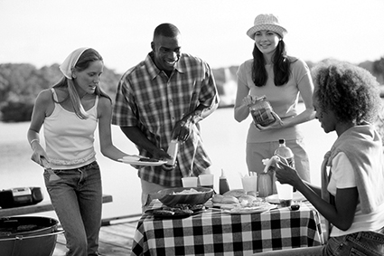
____________________________________________________________________________
____________________________________________________________________________
____________________________________________________________________________
____________________________________________________________________________
____________________________________________________________________________
____________________________________________________________________________
B. Complete with the words from the box.
A barbecue grill is a (1) ________ for cooking (2) ________ by applying (3) ________ directly from below. There are several varieties of such (4) ________, with most falling into one of two categories: gas-fuelled and (5) ________. There is a great debate over the merits of charcoal or gas for use as the cooking (6) ________ between barbecue grillers.
• charcoal • device • grills • food • method • heat

From: www.wikipedia.org (adapted)

II
Read the extract of the short story “The Uncles” by Fitch O’Connell.
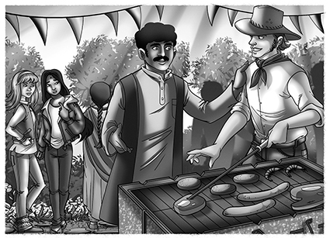
The Saturday of the barbecue was warm and bright. By one o'clock there were delicious smells coming from Uncle Ted's grill and the garden at Ali's house was full of people. Sima had warned Ali that when you invited her family to anything then you invited the whole family – parents, grandparents, cousins, aunts and uncles – and so it was that twenty four of Sima's relatives arrived together in a minibus. Six of Sima's aunties, all dressed in colourful saris and glittery shoes, sat in a line near the kitchen door and managed to look fierce and friendly at the same time. They had brought with them a basket of food and were unpacking potato bhajis, puris and muthias which they handed around to anyone who passed by. Meanwhile, Uncle Ted, assisted by Ali and Sima, was shouting to everyone to come and help themselves to the food he was cooking. Sima's dad was worried, and talking to Ali's dad about his cousin Sanjai, who had been left in charge in the shop for the first time. Would he manage alone? Had the shop burned down? Ali's dad tried to look interested. Uncle Ramesh, on the other hand, was standing alone, a big smile on his face and with his arms folded, watching everyone in turn. After a while he looked directly at Uncle Ted, unfolded his arms and walked across the garden to where Uncle Ted was prodding the hot coals. Uncle Ted looked up as Uncle Ramesh came close.
20
10
15
5
From: MashUp 10 Extensive Reading (abridged)
A. Complete the following sentences.
1. The weather on this Saturday was _________________________________________.
2. ___________________________________________________________ in Ali’s garden.
3. The smell was ___________________________________________________________.
4. Sima’s relatives arrived in _____________ because __________________________.
B. Answer the following questions.
1. Why do they decide to do a barbecue?
____________________________________________________________________________
2. Was doing a barbecue a good idea?
____________________________________________________________________________
3. Who planned it?
____________________________________________________________________________
4. Describe Sima’s aunts.
____________________________________________________________________________
5. Where was Uncle Ramesh? Was he happy? Explain.
____________________________________________________________________________

C. Explain the following expressions taken from the excerpt.
1. managed to look fierce and friendly at the same time (l.11-12)
____________________________________________________________________________
2. Sima's dad was worried (l.17)
____________________________________________________________________________
3. watching everyone in turn (l.20)
____________________________________________________________________________
III
Choose one of the characters in this short story and write about him or her.
____________________________________________________________________________
____________________________________________________________________________
____________________________________________________________________________
____________________________________________________________________________
____________________________________________________________________________
____________________________________________________________________________
____________________________________________________________________________
____________________________________________________________________________
____________________________________________________________________________
____________________________________________________________________________

Short Story: “Star Light”, by Isaac Asimov
EXTENSIVE READING TEST 2

Escola Secundária: __________________________________________________
Name: ______________________________________ No. _____ Class: _________
Date: ____/____/____ Mark: ________________ Teacher: __________________
I
A. Complete the following paragraph on the essential ingredients of a science fiction story.
Most science fiction relies on a considerable degree of (1)_____________ or disbelief. Science fiction elements include:
• A time setting in the (2)_____________.
• A spatial setting or scenes in (3)_____________ (e.g.: (4)_____________)
• Futuristic technology such as (5)_____________ machines, and humanoid (6)_____________.
• Scientific principles that are new or that contradict accepted laws of nature, for example (7)_____________
• Other (8)_____________ or dimensions and travel between them.

B. Muse wrote a song entitled “Starlight”. Look at part of the lyrics and explain what message the band is trying to convey.
Far away
The ship is taking me far away
Far away from the memories
Of the people who care if I live or die

II
Read the extract of the short story “Star Light” by Isaac Asimov.
Trent smiled. He was still alive. No star was too close and there were thousands that were close enough. The sky was alive with stars and the pattern was so different that he knew the Jump had gone far. Some of those stars had to be spectral class F and better. The computer would have a nice rich pattern to match against its memory. It shouldn't take long.
He leaned back in comfort and watched the bright pattern of star light move as the ship rotated slowly. A bright star came into view, a really bright one. It didn't seem more than a couple of light-years away and his pilot's sense told him it was a hot one, good and hot. The computer would use that as its base and match the pattern centred about it. Once again he thought: It shouldn't take long.
10
5
But it did. The minutes passed. Then an hour. And still the computer clicked busily and its lights flashed.
Trent frowned. Why didn't it find the pattern? The pattern had to be there. Brennmeyer had showed him his long years of work. He couldn't have left out a star or recorded it in the wrong place.
15
Surely stars were born and died and moved through space while in being, but these changes were slow, slow. In a million years the patterns that Brennmeyer had recorded couldn't –
A sudden panic clutched at Trent. No! It couldn't be. The chances for it were even smaller than jumping into a star's interior.
20
He waited for the bright star to come into view again and, with trembling hands, brought it into telescopic focus. He put in all the magnification he could, and around the bright speck of light was the telltale fog of turbulent gases caught, as it were, in mid-flight.
It was a nova!
From: MashUp 10 Extensive Reading (abridged)

A. Complete the following sentences.
1. The computer would match _______________________________________________.
2. Trent leaned back and relaxed because_____________________________________.
3. As the minutes passed Trent_______________________________________________.
4. Trent suddenly _________________ because ________________________________.

B. Answer the following questions.
1. Trent smiled. Was he alone in the spaceship? Why? Why not?
_________________________________________________________________________
2. What was the Jump?
_________________________________________________________________________
3. Why was the bright star a good sign?
_________________________________________________________________________
4. Who was Brennmeyer?
_________________________________________________________________________
5. The bright star was a nova. How did this discovery determine Trent’s destiny?
_________________________________________________________________________
C. Explain the following expressions taken from the excerpt.
1. Trent smiled. He was still alive (l.01) ________________________________________
____________________________________________________________________________
2. Trent frowned. (l.12) ______________________________________________________
____________________________________________________________________________
3. with trembling hands (l.19) ________________________________________________
____________________________________________________________________________
III
This story is set in the future but man’s greed and insensibility hasn’t evolved or disappeared. Explain how these human traits are present in Asimov’s story.
_______________________________________________________________________________
_______________________________________________________________________________
_______________________________________________________________________________
_______________________________________________________________________________
_______________________________________________________________________________
_______________________________________________________________________________
_______________________________________________________________________________
_______________________________________________________________________________
_______________________________________________________________________________
_______________________________________________________________________________

