I
MOCK EXAM 2

Escola Secundária: ________________________________________________
Name: _____________________________________ No. _____ Class: _________
Date: ____/____/____ Mark: _______________ Teacher: __________________
Duração da Prova: 50 minutos

A. Before reading the text, look at the pictures and label each electronic device.
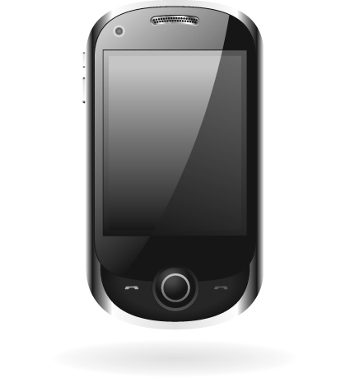

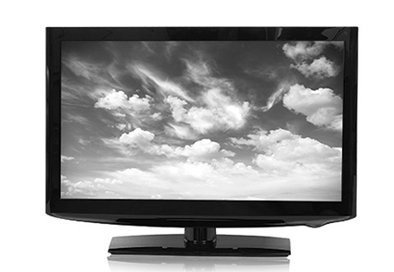
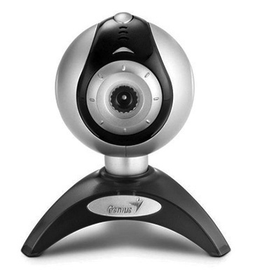
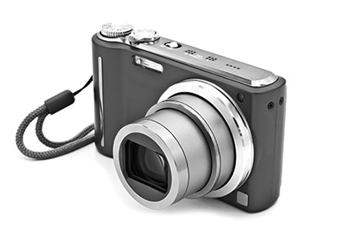
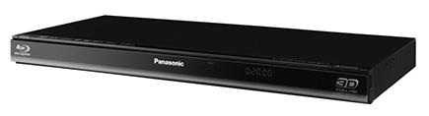
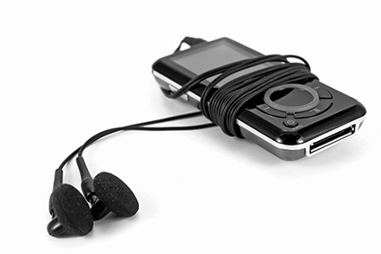
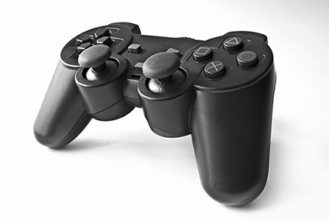
B. Which electronic device is your favourite? Account for your answer.
1. | 2. | 3. | 4.
5. | 6. | 7. | 8.

1.

2.

3.

4.

5.

6.

7.

8.

____________________________________________________________________________
____________________________________________________________________________
____________________________________________________________________________
____________________________________________________________________________
____________________________________________________________________________
____________________________________________________________________________
____________________________________________________________________________
____________________________________________________________________________
____________________________________________________________________________

II
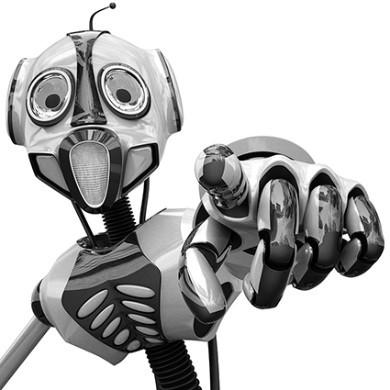
Read the following text attentively.
Robots

The word robot comes from Czechoslovakia. It first appeared in a 1920 play by the writer Karel Capeck called R.U.R (Rossum’s Universal Robots). Robots are machines which can be taught or programmed (by a computer) to do useful work.
5
Thousands of robots work in factories these days. They’re very useful on production lines. That’s where something like a car or a TV is put together piece by piece. Production line work is very tiring and boring for human workers. It means they have to do the same thing thousands of times every year. But, of course, robots never get tired or bored.
10
In factories they move objects, use tools in their ‘hands’, carry objects around the factory floor… In fact, today’s robots are more intelligent than ever before. In the future, they’ll be able to work in homes, offices, shops… almost anywhere.
15
Apart from working in factories, they do all kinds of jobs which are difficult or dangerous for us. Here are just a few examples: they can help to defuse bombs, work under the sea, take photos and collect rocks on planets like Mars without risking human life and work underground helping to find minerals.
But will robots really help to create a leisure society? Isn’t there a risk that they’ll just increase unemployment? Of course that depends on us. Only man can decide if we control the robots or they control us.
From: www.robotbooks.com (abridged and adapted)
A. Decide whether the statements are TRUE or FALSE. Correct the false ones.
1. The word robot appeared for the first time in the 19th century.
T | F

_______________________________________________________________
2. There are lots of robots working in factories.

_______________________________________________________________
3. Robots do boring jobs in factories.

_______________________________________________________________
4. Factory workers like to work on production lines.

_______________________________________________________________
5. Today’s robots are as intelligent as robots in the past.

_______________________________________________________________
6. Robots can do jobs on other planets.

_______________________________________________________________

B. Match the words on the left with the equivalent word or expression on the right.
1. useful (l.06) a) gradually
2. piece by piece (l.07) b) below the surface of the planet
3. boring (l.08) c) instruments used for working
4. tired (l.09) d) helpful
5. tools (l.10) e) feeling that one would like to sleep or rest
6. underground (l.15) f) uninteresting
C. Answer the following questions. Use your own words.
1. What jobs do robots do in factories?
__________________________________________________________________________
2. What other jobs do robots do?
__________________________________________________________________________
3. Will robots increase unemployment? Why? / Why not?
__________________________________________________________________________
III
A. Complete the sentences with the verbs in brackets in the future with will or going to.
1. There ____________________ (be) robots everywhere in the future.
2. I think I ____________________ (start) doing my shopping online.
3. Paul ____________________ (work) for a Spanish company next month.
4. They ____________________ (buy) a computer next weekend.
5. I feel really tired. I think I ______ (go) to bed.
6. Do you want me to help you? No thanks. John ______ (help) me.
B. Write three sentences with things you used to do when you were a child.
__________________________________________________________________________
__________________________________________________________________________
__________________________________________________________________________
C. Rewrite the following sentences replacing the underlined expressions by a suitable modal verb.
1. It is the students’ duty to be careful in written communication.
__________________________________________________________________________
2. I’m sure that this girl is addicted to her mobile phone.
__________________________________________________________________________
3. In some schools it is forbidden to use phone text shorthand.
__________________________________________________________________________
4. It is possible that this girl becomes a very successful writer.
__________________________________________________________________________

IV
Choose one of the topics and write about it.
A. In about 100-120 words, describe your ideal robot.
• What would you call it?
• What would it be like?
• What would the robot do? You can use the following ideas:
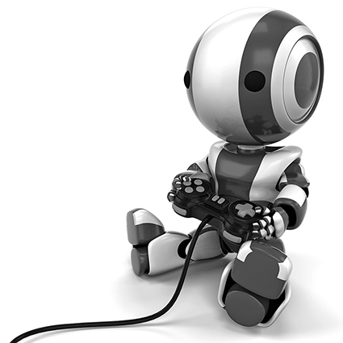
– clean and do the housework
– read the minds of other people
– transport you quickly around the world
– play games with you…
– Shop and cook for you
– Look after you when you are ill
– teach
• Why would you like to have a robot?
B. Comment on this quote.
“The world of the future will be an even more demanding struggle against the limitations of our intelligence, not a comfortable hammock in which we can lie down to be waited upon by our robot slaves.”
Norbert Wiener, The Human Use Of Human Beings: Cybernetics And Society

__________________________________________________________________________
__________________________________________________________________________
__________________________________________________________________________
__________________________________________________________________________
__________________________________________________________________________
__________________________________________________________________________
__________________________________________________________________________
__________________________________________________________________________
__________________________________________________________________________
__________________________________________________________________________
__________________________________________________________________________
__________________________________________________________________________
__________________________________________________________________________
__________________________________________________________________________
__________________________________________________________________________

MOCK EXAM 2
COTAÇÕES
I.
A. 16 pontos
B. 14 pontos
30 pontos

II
A. 36 pontos
B. 18 pontos
C. 27 pontos
81 pontos
III.
A. 18 pontos
B. 12 pontos
C. 12 pontos
42 pontos
IV.
A or B 47 pontos
Total 200 pontos
CRITÉRIOS ESPECÍFICOS DE CORREÇÃO
I.
A.
Legendar imagens.
1. | Mobile phone | 2p. x 8 =16
2. | Computer/laptop | 2p. x 8 =16
3. | TV | 2p. x 8 =16
4. | Webcam | 2p. x 8 =16
5. | Camera | 2p. x 8 =16
6. | DVD player | 2p. x 8 =16
7. | MP3 player | 2p. x 8 =16
8. | Games console controls
Certo/Errado
B.
Justificar uma escolha.
Dedução de 1 ponto por erros gramaticais.  Dedução de 1 ponto por informação incompleta.  Dedução de 1 ponto por erros ortográficos. | 14 p.

III.
A.
Exercício de utilização de will or going to.
1. | will be | 3p. x 6 =18
2. | am going to start | 3p. x 6 =18
3. | is going to work | 3p. x 6 =18
4. | are going to buy | 3p. x 6 =18
5. | ‘ll go | 3p. x 6 =18
6. | will help | 3p. x 6 =18
Certo/Errado
B.
Exercício de utilização de will or going to.
Escrita de frases com used to. | 4p. x 3 =12
C.
Substituição de expressões por verbos modais.
1. | They should be careful in written communication. | 3p. x 4 =12
2. | This girl may/must be addicted to her mobile phone. | 3p. x 4 =12
3. | In some schools you mustn’t/can’t use phone text shorthand. | 3p. x 4 =12
4. | This girl may/might become a very successful writer. | 3p. x 4 =12
Certo/Errado
IV.
Níveis de proficiência:
O examinando trata o tema de forma clara, apresentando boa organização e desenvolvimento crítico das ideias. Apresenta correção morfossintática e vocabulário rico e apropriado. Escreve com muito poucos ou nenhuns erros de grafia e pontuação. | 40 a 47  pontos
O examinando trata o tema de forma clara, apresentando uma sequência de ideias coerente, revelando algum espírito crítico e criatividade. Apresenta alguma correção morfossintática, embora com falhas ocasionais ao nível das estruturas básicas da língua. Emprega vocabulário comum, mas apropriado. Escreve com poucos erros de grafia e pontuação. Os erros que ocorrem não prejudicam a compreensão da mensagem. | 18 a 39  pontos
O examinando trata o tema de forma deficiente, revelando dificuldade de comunicação e de organização das ideias. Apresenta muitos erros de estrutura morfossintática. Escreve com muitos erros de grafia e de pontuação. Utiliza vocabulário muito pobre, pouco adequado. | 0 a 17  pontos

II.
A.
Identificação de frases verdadeiras e falsas.
1. | F – It first appeared in 1920 (20th century). | 6p. X 6 =36
2. | T | 6p. X 6 =36
3. | T | 6p. X 6 =36
4. | F – Production line work is very tiring and boring for human workers. | 6p. X 6 =36
5. | F – Today’s robots are more intelligent than ever before. | 6p. X 6 =36
6. | T | 6p. X 6 =36
Dedução de 1 ponto por erros gramaticais.
Dedução de 1 ponto por informação incompleta.
Dedução de 1 ponto por erros ortográficos.
B.
Exercício de correspondência vocabular
1. | d) | 3p. x 6 =18
2. | a) | 3p. x 6 =18
3. | f) | 3p. x 6 =18
4. | e) | 3p. x 6 =18
5. | c) | 3p. x 6 =18
6. | b) | 3p. x 6 =18
Certo/Errado
C.
Resposta a perguntas sobre o texto.
1. | They do different jobs. They usually do the boring, repetitive and uninteresting tasks. | 9p. x 3 =27
2. | They can help at home, doing housework chores, work in offices, shops and collecting information from other planets. | 9p. x 3 =27
3. | Yes, I think so. Robots will be more efficient and will do more complex tasks and will replace workers in many jobs. | 9p. x 3 =27
Dedução de 1 ponto por erros gramaticais.
Dedução de 2 pontos por informação incompleta.
Dedução de 1 ponto por erros ortográficos

