I
MOCK EXAM 3

Escola Secundária: _______________________________________________
Name: ____________________________________ No. _____ Class: _________
Date: ____/____/____ Mark: _______________ Teacher: _________________
Duração da Prova: 50 minutos

A. Complete the following paragraph with the words in the box.
Consider a pair of (1) ______________, identical twins. One gets a job as an
(2) ______________ and rockets into deep space. The other stays on
(3) ______________. When the traveling twin returns home, he discovers he's
(4) ______________ than his brother.
• time • relativity • brothers • astronaut
• space • Einstein’s • Earth • younger
This is (5) ______________ Twin Paradox, and although it sounds strange, it is absolutely true. The theory of (6) ______________ tells us that the faster you travel through (7) ______________, the slower you travel through (8) ______________.
From: www.science.nasa.gov – science news (adapted)

B. In about 30-40 words comment on the following cartoon.
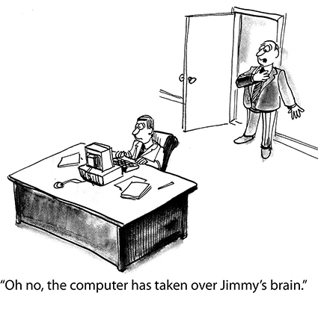

____________________________________________________________________________
____________________________________________________________________________
____________________________________________________________________________
____________________________________________________________________________
____________________________________________________________________________
____________________________________________________________________________

II
Now read the following text carefully.
Sir Richard Branson will fly into space

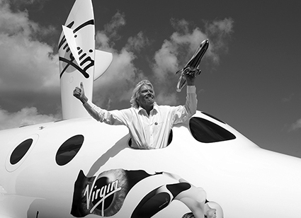
Sir Richard Branson announced today that he and his children will be the first passengers when his space tourism programme begins.
Sir Richard and son Sam and daughter Holly are expected to be flying 60 miles up into space on the SpaceShipTwo (SS2) aircraft by the end of next year.
5
Today, Sir Richard joined around 120 other tourists who have signed up for the two-hour flights, at £128,000 a trip. As the travellers and Sir Richard posed at Farnborough Air Show beside a replica of SS2, Sir Richard also announced that the WhiteKnightTwo aircraft that will help launch SS2 into space will also be used for a new launch vehicle – LauncherOne – which will take small satellites into space for around a tenth of the present cost.
15
10
From a spaceport built in New Mexico, USA, by UK architect Lord Foster, WhiteKnightTwo will take the SS2, with six passengers and two pilots, to a point about 50,000ft up before the SST rockets into space.
20
Sir Richard and the other passengers will be able to float around the cabin due to weightlessness before the SS2 effectively becomes a glider for its return to the spaceport.
It has also been announced today that a total of 529 people – including, it is believed, Brad Pitt and Angelina Jolie – have signed up for an SS2 trip.
Branson went on: ‘Going into space is a hard business. It keeps my mind buzzing.
He added that he would have loved to have taken WhiteKnightTwo and SS2 to Farnborough.
25
And in a jokey remark concerning his big airline rival, Sir Richard said: ‘It would have been nice to have flown over the Olympic Games, especially as British Airways is one of the (Games) sponsors.’
Another space tourist at Farnborough today was businessman Grant Roberts, 36, formerly from Lewes in East Sussex but now based in Dubai.
He was with his father, Michael, 65, and his grandfather Frank Roberts, 90, who was an RAF pilot who flew on missions over Germany in the Second World War.
30
‘I was inspired by the exploits of my grandfather, as was my father,’ said Grant Roberts, who paid for his space trip in 2007.
He went on: ‘I can’t wait to go up. The whole family plans to travel out to New Mexico with me.’
From: www.dailymail.co.uk
(abridged and adapted)

A. Complete the following sentences according to the text.
1. The first space tourists ____________________________________________________
2. The list of space tourists include____________________________________________
3. One of Sir Richard Branson’s airline rival ___________________________________

B. Answer the following questions on the text.
1. How many spaceships is Sir Richard Branson planning to build and what for?
___________________________________________________________________________
2. Will the SS2 land on any planet? Why?
___________________________________________________________________________
3. Explain the following expression in your own words: “It keeps my mind buzzing.”.
___________________________________________________________________________
4. Why did Grant Robert decide to take his first trip to space and why?
___________________________________________________________________________
C. Match the sentences according to the text.
1. Sir Richard Branson is a) in search of adrenaline and adventure.
2. Tourists have signed up for the space flight b) is time consuming and expensive.
3. Space tourism c) sponsored the recent Olympic Games.
4. British Airways d) a creative and adventurous entrepreneur.
D. Find synonyms in the text for the following words.
1. copy ____________________________________________________________________
2. constructed ______________________________________________________________
3. price_____________________________________________________________________
4. previously _______________________________________________________________
III
A. Put the verbs in brackets in the correct verb tense.
Man (1) _________________ (always dream) of escaping from Earth and travelling to other parts of the universe. This dream (2) _____________ (contribute) to the phenomenal growth in the use of satellites for international communications. Some decades ago a satellite system for communications (3) ____________ (be) nothing else than science fiction. Today, a major portion of all overseas communications
(4) _______________ (go) by satellite.
However, all these advances in technology, global warming and holes in the ozone layer (5) ______________(force) scientists to rethink the focus of their research.
From: www.wired.com (adapted)
B. Rephrase the following sentences.
1. "Space tourism is my ambition in life."
Richard Branson said________________________________________________________
2. The tickets have been bought by Thomas.
Thomas ____________________________________________________________________
3. “Where will I get the money to buy a ticket?
The journalist wanted to know________________________________________________
4. A robot can do many tasks in a short time but it can’t be creative.
Although ___________________________________________________________________

IV
Choose ONE of the topics and write about 100-120 words on it.
A. Comment on the following quote.
All of the biggest technological inventions created by man – the airplane, the automobile, the computer – say little about his intelligence, but speak volumes about his laziness.
Mark Kennedy
B. Comment on the following cartoon.
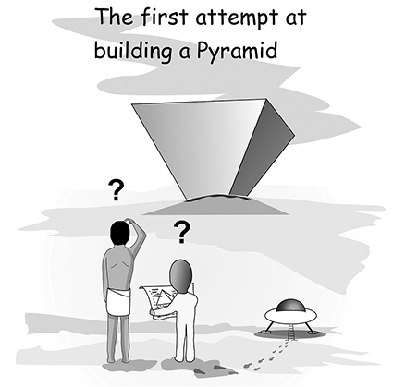
____________________________________________________________________________
____________________________________________________________________________
____________________________________________________________________________
____________________________________________________________________________
____________________________________________________________________________
____________________________________________________________________________
____________________________________________________________________________
____________________________________________________________________________
____________________________________________________________________________
____________________________________________________________________________
____________________________________________________________________________
____________________________________________________________________________

MOCK EXAM 3
COTAÇÕES
I.
A. 16 pontos
B. 14 pontos
30 pontos

II
A. 18 pontos
B. 36 pontos
C. 20 pontos
D. 16 pontos
90 pontos
III.
A. 10 pontos
B. 20 pontos
30 pontos
IV.
A or B 50 pontos
Total 200 pontos
CRITÉRIOS ESPECÍFICOS DE CORREÇÃO
II.
A.
Completar frases.
1. | …on Sir Branson’s Space tourism programme will be himself and his family. | 6p. x 3 =18
2. | …celebrities like Brad Pitt and Angelina Jolie. | 6p. x 3 =18
3. | …is British Airways. | 6p. x 3 =18
Dedução de 1 ponto por erros gramaticais.
Dedução de 1 ponto por informação incompleta.
Dedução de 1 ponto por erros ortográficos.

I.
A.
Preenchimento de texto lacunar.
1. | brothers | 2p. x 8 =16
2. | astronaut | 2p. x 8 =16
3. | Earth | 2p. x 8 =16
4. | younger | 2p. x 8 =16
5. | Einstein’s | 2p. x 8 =16
6. | relativity | 2p. x 8 =16
7. | space | 2p. x 8 =16
8. | time | 2p. x 8 =16
Certo/Errado
B.
Comentário a um cartoon.
Personal answer | 14p.

B.
Resposta a perguntas sobre o texto.
1. | He’s going to build two space ships. One for his passengers to travel on (SS2) and another one to launch SS2 and to send satellites into space | 9p. x 4 =36
2. | No it won’t. The passengers will only experience weightlessness. | 9p. x 4 =36
3. | This project keeps his brain working and figuring out how he will overcome the unexpected obstacles that might arise. | 9p. x 4 =36
4. | He decided to travel to space inspired by his grandfather who was an adventurous and courageous RAF pilot. | 9p. x 4 =36
Dedução de 1 ponto por erros gramaticais.
Dedução de 1 ponto por informação incompleta.
Dedução de 1 ponto por erros ortográficos.
C.
Exercício de correspondência vocabular.
1. | d) | 5p. x 4 =20
2. | a) | 5p. x 4 =20
3. | b) | 5p. x 4 =20
4. | c) | 5p. x 4 =20
Certo/Errado
D.
Encontrar sinónimos no texto das palavras dadas.
1. | replica | 4p. x 4 =16
2. | built | 4p. x 4 =16
3. | cost | 4p. x 4 =16
4. | formerly | 4p. x 4 =16
Certo/Errado
III.
A.
Completamento de espaços com as formas corretas dos verbos.
1. | has always dreamed/dreamt | 2p. x 5 =10
2. | has contributed | 2p. x 5 =10
3. | was | 2p. x 5 =10
4. | go | 2p. x 5 =10
5. | have forced | 2p. x 5 =10
Certo/Errado

B
Reescrita de frases.
1. | Richard Branson said space tourism was his ambition in life. | 5p. x 4 =20
2. | Thomas has bought the tickets. | 5p. x 4 =20
3. | The journalist wanted to know where he would get the money to buy a ticket. | 5p. x 4 =20
4. | Although a robot can do many tasks in a short time, it can’t be creative. | 5p. x 4 =20
Certo/Errado
IV
Níveis de proficiência:
O examinando trata o tema de forma clara, apresentando boa organização e desenvolvimento crítico das ideias. Apresenta correção morfossintática e vocabulário rico e apropriado. Escreve com muito poucos ou nenhuns erros de grafia e pontuação. | 40 a 50  Pontos
O examinando trata o tema de forma clara, apresentando uma sequência de ideias coerente, revelando algum espírito crítico e criatividade. Apresenta alguma correção morfossintática, embora com falhas ocasionais ao nível das estruturas básicas da língua. Emprega vocabulário comum, mas apropriado. Escreve com poucos erros de grafia e pontuação. Os erros que ocorrem não prejudicam a compreensão da mensagem. | 18 a 39  Pontos
O examinando trata o tema de forma deficiente, revelando dificuldade de comunicação e de organização das ideias. Apresenta muitos erros de estrutura morfossintática. Escreve com muitos erros de grafia e de pontuação. Utiliza vocabulário muito pobre, pouco adequado. | 0 a 17  pontos

