1.º MOMENTO
Intervenientes e tempos | Descrição das Atividades
Professor | Hello. We’re going to talk about technology?  What’s your favourite tech gadget? [O professor dirige-se ao aluno A.]  And what’s yours? [O professor dirige-se ao aluno B.]  For about three minutes, I would like you both to answer some questions so that I can learn a bit more about you.  Please answer the questions, but do not interrupt your partner.  [1. O professor usa a lista que se segue, escolhendo o número de estímulos adequados ao tempo.  2. As perguntas são colocadas seguindo uma linha vertical (entrevistando um aluno de cada vez). ]
Professor  Alunos  Total: +/– 3 minutos | A  Have you ever been without your mobile?  (negative response)  For how long? Why?  (positive response)  If you were given an ultimatum saying  you could only use one tech gadget for a  month, which would you choose? Why?  How important is technology to you?  Why do you think many teens are more apt to deal with technology? | B  And what about you? What’s the longest  you’ve been without your mobile phone?  (positive response)  How did you keep in touch with your friends?  Was it easy?  (negative response)  If you were given the opportunity to choose  a tech gadget as a birthday present,  what would you choose? Why?  Would you like to have a job in technology in the future? Why? Why not?  What tech gadgets do your grandparents know nothing about? Why?
ORAL ASSESSMENT 1

Duração da prova: 15 a 20 minutos

Guião adaptado de Prova construída pelos formandos e validada pelo GAVE, no âmbito da Ação de Formação Avaliação da Expressão Oral no Ensino Secundário, Línguas Estrangeiras, 2009

2.º MOMENTO
Intervenientes e tempos | Descrição das Atividades
Professor  Cada aluno  1 minuto  Professor  Cada Aluno  +/– 2 minutos  Professor  Total:  +/– 6 minutos | Right, now each of you will have to talk on your own for about two minutes.  You have one minute to prepare.  You mustn’t interrupt your partner while he/she is speaking.  Here is a sheet of paper and a pen in case you want to make some brief notes.  Please do not write a text.  [O professor entrega uma folha em branco e uma caneta aos dois alunos. Se o aluno A iniciou o 1.º momento, será o aluno B a iniciar o 2.º.]
 | A.  B, you’ll be first.  [O professor entrega o material: Imagem 1.] | B.  Now it’s your turn, A.  [O professor entrega o material: Imagem 1.]
Look at this picture. I’d like you to talk about it. There are some prompts to help you.
You have a minute to prepare and then I’ll ask you to start talking.
[O aluno prepara o seu discurso.]
 | Please begin now, B. | Please begin now, A.
 | [Prestação do aluno. Caso o seu discurso seja insuficiente, revele pouco conteúdo ou o aluno tenha dificuldade em começar a falar, o professor deverá ajudá-lo com as/algumas das seguintes perguntas:
 | What can you see in the picture?  How would you describe the woman in the picture?  Does she look happy? Explain.  What’s the message of it? | What can you see in the picture?  What conclusions can you draw?  What languages do you consider the most important?  Is communication among people important? State reasons.
[O professor poderá também ajudar o/a aluno/a expandir o seu discurso, usando, por exemplo:]

Can you give me your own opinion about the different languages people can speak in the world? Can you tell me more information about that?
[O professor poderá ainda lembrar o/a aluno/a da tarefa, dizendo, por exemplo:
Remember you have to…]
 | Thank you, B. | Thank you, A.

3.º MOMENTO
Intervenientes e tempos | Descrição das Atividades
Professor  Cada Aluno  1 minuto  Professor  Cada Aluno  +/– 2 minutos  Professor  Total:  +/– 6 minutos | Now I’d like you to talk to each other for about three minutes while I listen.  After that I’ll ask you some questions.  You have to speak clearly and loud enough so that we can hear you both.  Here is a text for you to read.  [O professor entrega o material aos dois alunos: text 1]
 | Remember you have to talk to each other.
 | A  B, you’ll be first.  [O professor entrega o material: Texto 1.] | B  Now it’s your turn, A.  [O professor entrega o material: Texto 2.]
[ Prestação dos alunos. Os alunos podem usar algum tempo para tomarem conhecimento do material.]
O professor poderá ainda:
– repetir as instruções
“Could you start, please?”, caso nenhum dos alunos tome a iniciativa e tenham decorrido mais de 30 segundos.
“Remember you have to …” para lembrar os alunos da tarefa, caso se verifique um grande desvio ao tema.
“Remember you have to talk to each other.” para lembrar os alunos de que devem interagir um com o outro.
Thank you.

A, What is the importance of learning English?

B, do you agree with A? Why (not)?
[Caso o aluno A não tenha fornecido um discurso suscetível de ser comentado, devido à pouca qualidade ou extensão, a pergunta inicial poderá ser adaptada e dirigida ao aluno B, substituindo aquela que pede a sua reação. Por exemplo, o professor poderá dizer:]
Well, B, people say that English is a world language. What does this mean?
B, Are you interested in learning English? Why?/Why not?
A, And you? Do you consider learning English essential nowadays?
[Caso o aluno B não tenha fornecido um discurso suscetível de ser comentado, devido à pouca qualidade ou extensão, a pergunta inicial poderá ser adaptada e dirigida ao aluno A, substituindo aquela que pede a sua reação. Por exemplo, o examinador poderá dizer:]
What conclusions can you draw after reading these texts?
 | Fim de Prova

Imagem 1

PROMPTS
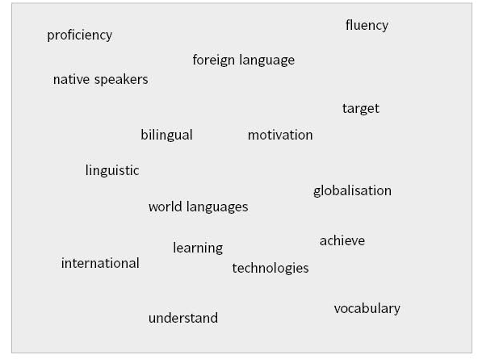

Imagem 2
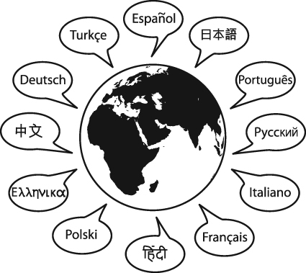
Facts and figures – Languages in the world
The most popular language in the world
Do you know what language is the most widely spoken one? If you think it is English, you are badly mistaken. Look at the table below.

Mandarin Chinese – about 880 million
Spanish – about 325 million
English – about 315-380 million
Arabic – about 205-425 million
Hindu – about 185 million
Portuguese – about 180 million
Bengali – about 175 million
Russian – about 145 million
Japanese – about 130 million
German – about 95 million

Texto 1
The importance of learning English
English is an official language in 53 countries and it is one of the official languages in many important international organisations such as UN, EU and WTO. It is also one of the working languages at most international businesses and meetings.
If you want to know more about the world and modern technology, English is a great bridge. Most books, magazines, newspapers and movies are in English. Going online, most of the world's stored information and web pages are in English. English is also the most commonly used language in science. 95% of scientific articles were written in English, even though only half of them came from authors in English-speaking countries.
From: www.studymode.com (adapted)
The importance of learning English
English is widely used in the world. It has often been referred to as a "world language".
If you would like to travel all over the world, you must realise English is spoken as a first language by about 400 million, as a second language by around 1 billion. And it is the language most often studied as a foreign language in the world. So, if you do not understand English, you may miss your flight, lose your way, and fail to communicate with people.
In a word, learning English is essential in today’s global world.
From: www.studymode.com (adapted)

