1.º MOMENTO
Intervenientes e tempos | Descrição das Atividades
Professor | Hello. We’re going to talk about technology?  What’s your favourite tech gadget? [O professor dirige-se ao aluno A.]  And what’s yours? [O professor dirige-se ao aluno B.]  For about three minutes, I would like you both to answer some questions so that I can learn a bit more about you.  Please answer the questions, but do not interrupt your partner.  [1. O professor usa a lista que se segue, escolhendo o número de estímulos adequados ao tempo.  2. As perguntas são colocadas seguindo uma linha vertical (entrevistando um aluno de cada vez). ]
Professor  Alunos  Total: +/– 3 minutos | A  Have you ever been without your mobile?  (negative response)  For how long? Why?  (positive response)  If you were given an ultimatum saying  you could only use one tech gadget for a  month, which would you choose? Why?  How important is technology to you?  Why do you think many teens are more apt to deal with technology? | B  And what about you? What’s the longest  you’ve been without your mobile phone?  (positive response)  How did you keep in touch with your friends?  Was it easy?  (negative response)  If you were given the opportunity to choose  a tech gadget as a birthday present,  what would you choose? Why?  Would you like to have a job in technology in the future? Why? Why not?  What tech gadgets do your grandparents know nothing about? Why?

ORAL ASSESSMENT 2

Duração da prova: 15 a 20 minutos

Guião adaptado de Prova construída pelos formandos e validada pelo GAVE, no âmbito da Ação de Formação Avaliação da Expressão Oral no Ensino Secundário, Línguas Estrangeiras, 2009

2.º MOMENTO
Intervenientes e tempos | Descrição das Atividades
Professor  Cada Aluno  1 minuto  Professor  Cada Aluno  +/– 2 minutos  Professor  Total:  +/– 6 minutos | Right, now each of you will have to talk on your own for about two minutes.  You have one minute to prepare.  You mustn’t interrupt your partner while he/she is speaking.  Here is some paper and a pen in case you want to make some brief notes.  Please do not write a text.  [O professor entrega o papel e a caneta aos dois alunos. Se o aluno A iniciou o 1.º momento, será o aluno B a iniciar o 2.º. ]
 | A  B, you’ll be first.  [O professor entrega o material: Cartoon 1.] | B  Now it’s your turn, A.  [O professor entrega o material: Cartoon 2.]
Look at this cartoon. I’d like you to talk about it. There are some prompts to help you.
You have a minute to prepare and then I’ll ask you to start talking.

[O aluno prepara o seu discurso.]
 | Please begin now, B. | Please begin now, A.
 | [Prestação do aluno. Caso o seu discurso seja insuficiente, revele pouco conteúdo ou o aluno tenha dificuldade em começar a falar, o professor deverá ajudá-lo com as/algumas das seguintes perguntas:]
 | What can you see in the cartoon?  What are most people doing while on the bus/train?  How do you think they feel about the people surrounding them?  What’s the message of the cartoonist? | What can you see in the cartoon?  How is the old dog a metaphor for the way older generations deal with new technology?  How do you think the younger “dogs” can help?  Do you agree that you can’t teach an old dog new tech? Why?
[ O professor poderá também ajudar o/a aluno/a expandir o seu discurso, usando, por exemplo:
Can you give me some adjectives to describe their personalities and state of mind? Can you tell me more about that?]
[O professor poderá ainda lembrar o/a aluno/a da tarefa, dizendo, por exemplo:
Remember you have to… ]
 | Thank you, B. | Thank you, A.

3.º MOMENTO
Intervenientes e tempos | Descrição das Atividades
Professor  Cada Aluno  1 minuto  Professor  Cada Aluno  +/ – 2 minutos  Professor  Total:  +/– 6 minutos | Now I’d like you to talk to each other for about three minutes while I listen.  After that I’ll ask you some questions.  You have to speak clearly and loud enough so that we can hear you both.  An old lady is confused at the supermarket.  She has to send an SMS to her granddaughter to pick her up.  She is confused and doesn’t know what to do. You have decided to help her. Discuss together how to do so.  Here is a card for you.  [ O professor entrega o material aos dois alunos: [text 1]  Remember you have to talk to each other.
 | A  B, you’ll be first.  [O professor entrega o material: Card 1.] | B  Now it’s your turn, A.  [O professor entrega o material: Card 1.]
Os alunos podem usar algum tempo para tomarem conhecimento do material. O professor poderá ainda:
– repetir as instruções
Could you start, please?, caso nenhum dos alunos tome a iniciativa e tenham decorrido mais de 30 segundos.
Thank you.
A, are there any reasons why you would refuse to help this person? What are they? Why?
B, do you agree with A? Why (not)?
[Caso o aluno A não tenha fornecido um discurso suscetível de ser comentado, devido à pouca qualidade ou extensão, a pergunta inicial poderá ser adaptada e dirigida ao aluno B, substituindo aquela que pede a sua reação. Por exemplo, o professor poderá dizer:
Well, B, would you help this person, for instance, if you were in a hurry? Why (not)?
B, if this happened to you, what would you do?
A, would you do the same? Why (not)?]
[Caso o aluno B não tenha fornecido um discurso suscetível de ser comentado, devido à pouca qualidade ou extensão, a pergunta inicial poderá ser adaptada e dirigida ao aluno A, substituindo aquela que pede a sua reação. Por exemplo, o examinador poderá dizer:
If you were in this situation, who would you ask for help? Why?]
Thank you both. That is the end of your oral assessment.
 | Fim de Prova

Cartoon 1
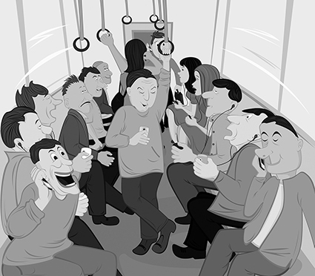
Prompts:
Describe the cartoon.
Explain the message conveyed.
Describe your feelings/emotions about the scene.
What got these people into this situation?
Cartoon 2
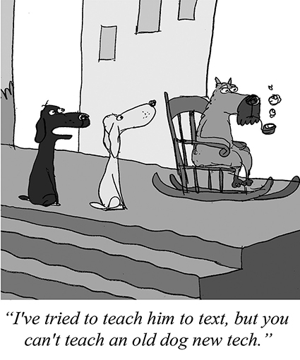
Prompts:
Describe the cartoon.
Explain the message conveyed.
Describe your feelings/emotions about the characters.
How would this dialogue continue?

Card 1

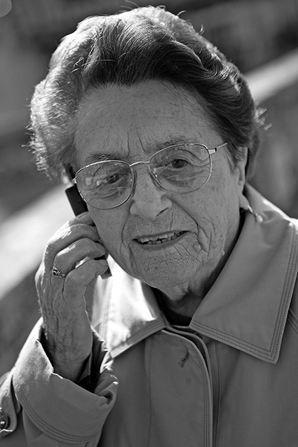
An old lady in trouble
An old lady went shopping for gloves and told
her granddaughter to pick her up at the supermarket when she had finished her shopping.
Outside the supermarket she isn’t able to send an SMS to her granddaughter to ask her to pick her up.

She:
– has lost her glasses
– has no money on her cell phone
– she’s tired and confused
– doesn’t know her granddaughter’s phone number.

Useful language:
Asking for help:
1. Can you give me a hand with this, please?
2. Could you help me for a second?
3. I wonder if you could help me with this?
4. I can't manage. Can you help?
5. I need some help, please.

Offering help:
1. I would be happy to help you.
2. May I help you? Do you need my help?
3. Could I be of any help?
4. Would you like me/us to help you?
5. Is there anything that I can do for you?
6. I’ll do it for you.

