1.º MOMENTO
Intervenientes e tempos | Descrição das Atividades
Professor | Hello. We’re going to be talking about media, its pros and cons.  Which celebrities do you like reading about in the magazines and newspapers? [O professor dirige-se ao aluno A.]  And what about you? [O professor dirige-se ao aluno B.]  _____________________________________________________  For about three minutes, I would like you both to answer some questions so that I can learn a bit more about you.  Please answer the questions, but do not interrupt your partner.  [1. O professor usa a lista que se segue, escolhendo o número de estímulos adequados ao tempo.  2. As perguntas são colocadas seguindo uma linha vertical (entrevistando um aluno de cada vez).]
Professor  Alunos  Total: +/– 3 minutos | A  Have you ever wanted to have lunch with your favourite celebrity?  (positive response)  With who? Why? Where would you go?  (positive response)  If you were given the opportunity of being a paparazzo for a day, who would you photograph? Why?  How important are magazines for you?  Why do you think gossip magazines sell so well? | B  And what about you? Is there a celebrity  you would like to meet one day?  (negative response)  Why? Do you think it’s possible? Where would you like to meet him/her?  (negative response)  If you were given money to follow and photograph a celebrity you don’t like for a week, would you do it?  Why? Why not?  Would you like to be a paparazzo in the future? Why? Why not?  Does money justify taking a photo of someone in an awkward or embarrassing position? Why? Why not?

ORAL ASSESSMENT 3

Duração da prova: 15 a 20 minutos

Guião adaptado de Prova construída pelos formandos e validada pelo GAVE, no âmbito da Ação de Formação Avaliação da Expressão Oral no Ensino Secundário, Línguas Estrangeiras, 2009

2.º MOMENTO
Intervenientes e tempos | Descrição das Atividades
Professor  Cada Aluno  1 minuto  Professor  Cada Aluno  +/– 2 minutos  Professor  Total:  +/– 6 minutos | Right, now each of you will have to talk on your own for about two minutes.  You have one minute to prepare.  You mustn’t interrupt your partner while he/she is speaking.  Here is some paper and a pen in case you want to make some brief notes.  Please do not write a text.  [O professor entrega o papel e a caneta aos dois alunos. Se o aluno A iniciou o 1.º momento, será o aluno B a iniciar o 2.º.]
 | A  B, you’ll be first.  [O professor entrega o material: Picture1.] | B  Now it’s your turn, A.  [O professor entrega o material: Picture 2.]
Look at this picture. I’d like you to talk about it. There are some prompts to help you.
You have a minute to prepare and then I’ll ask you to start talking.

[O aluno prepara o seu discurso.]
 | Please begin now, B. | Please begin now, A.
 | [Prestação do aluno. Caso o seu discurso seja insuficiente, revele pouco conteúdo ou o aluno tenha dificuldade em começar a falar, o professor deverá ajudá-lo com as/algumas das seguintes perguntas:
 | Describe the picture.  Describe the feelings/emotions of the celebrity.  What got him into this situation?  Explain the message conveyed. | Describe the two photos of Madonna.  Describe the feelings/emotions of Madonna when seeing the second photo published in a magazine.  What do the two photos do to her self-esteem?  Explain the message conveyed.
[ O professor poderá também ajudar o/a aluno/a expandir o seu discurso, usando, por exemplo:
Can you give me some adjectives to describe his/her feelings? Can you tell me more about that?]
[O professor poderá ainda lembrar o/a aluno/a da tarefa, dizendo, por exemplo: Remember you have to…]
 | Thank you, B. | Thank you, A.

3.º MOMENTO
Intervenientes e tempos | Descrição das Atividades
Professor  Cada Aluno  1 minuto  Professor  Cada Aluno  +/ – 2 minutos  Professor  Total:  +/– 6 minutos | Now I’d like you to talk to each other for about three minutes while I listen.  After that I’ll ask you some questions.  You have to speak clearly and loud enough so that we can hear you both.  A school colleague of yours secretly took a photo of you kissing a girl/boy who isn’t your girlfriend/boyfriend.  He is part of the school newspaper staff and tells you he’s going to publish the incriminating photo of you and the girl/boy.  Discuss together the arguments you are going to use in the conversation.  Here is a card for you.  [O professor entrega o material aos dois alunos: [Card1 ]]  Remember you have to talk to each other.
 | A.  B, you’ll be first.  [O professor entrega o material: Card 1.] | B.  Now it’s your turn, A.  [O professor entrega o material: Card 2.]
[Os alunos podem usar algum tempo para tomarem conhecimento do material. O professor poderá ainda:
– repetir as instruções
Could you start, please?”, caso nenhum dos alunos tome a iniciativa e tenham decorrido mais de 30 segundos.]
Thank you.
A, are there any reasons why you would refuse to help this person? What are they? Why?
B, do you agree with A? Why (not)?
[Caso o aluno A não tenha fornecido um discurso suscetível de ser comentado, devido à pouca qualidade ou extensão, a pergunta inicial poderá ser adaptada e dirigida ao aluno B, substituindo aquela que pede a sua reação. Por exemplo, o professor poderá dizer:
Well, B, would you print this picture, for instance, if you were his best friend? Why (not)?
B, if this happened to you, what would you do?
A, would you do the same? Why (not)?
[Caso o aluno B não tenha fornecido um discurso susceptível de ser comentado, devido à pouca qualidade ou extensão, a pergunta inicial poderá ser adaptada e dirigida ao aluno A, substituindo aquela que pede a sua reação. Por exemplo, o examinador poderá dizer:
“If you were in this situation who would you ask for help? Why?”]
Thank you both. That is the end of your oral assessment.
 | Fim de Prova

Picture 1
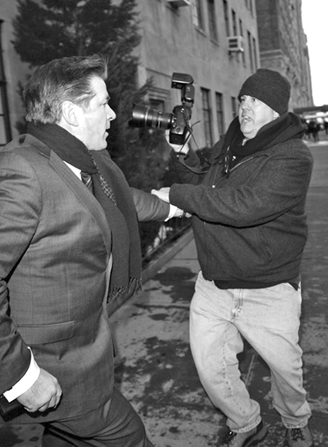
Prompts:
Describe the picture.
Describe the feelings/emotions of the celebrity?
What got him into this situation?
Explain the message conveyed.
Picture 2

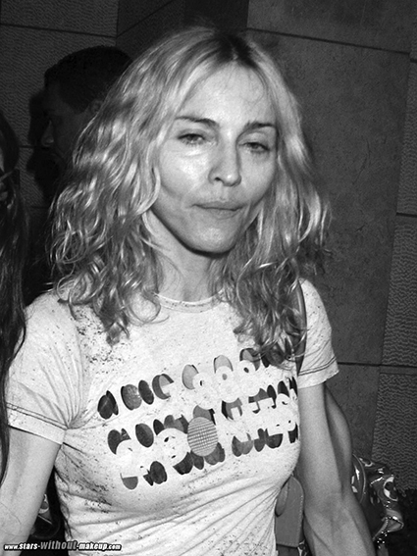
Prompts:
Describe the two photos of Madonna.
Describe the feelings/emotions of Madonna when seeing the first photo published in a magazine.
What do the two photos do to her self-esteem?
Explain the message conveyed.

Card 1
A student in trouble…
A school mate of yours secretly took a photo of you kissing a girl/boy who isn’t your girlfriend/boyfriend.

He is part of the school newspaper staff and tells you he’s going to publish the incriminating photo of you and the girl/boy.

Useful language:
Informing:
1. There are many kinds of…
2. What I am most interested in is…
3. The pleasure I find in…
4. If you want to… then you need to…
5. Some people enjoy…

Persuading:
1. Just this time, please.
2. I am sure/certain you will do it for me.
3. My situation will be pitiful if you fail to help me.
4. Won’t you let me…
5. Won’t you mind helping me from…
6. Please consider…

