1.º MOMENTO
Intervenientes e tempos | Descrição das Atividades
Professor | Are you worried about your looks?  Are you influenced by magazines in the way you look? [O professor dirige-se ao aluno A.]  And what about you? Do you see media influence on young people with the same eyes? [O professor dirige-se ao aluno B.]  For about three minutes, I would like you both to answer some questions so that I can learn a bit more about you.  Please answer the questions, but do not interrupt your partner.  [ 1. O professor usa a lista que se segue, escolhendo o número de estímulos adequados ao tempo.  2. As perguntas são colocadas seguindo uma linha vertical (entrevistando um aluno de cada vez). ]
Professor  Alunos  Total: +/– 3 minutos | A  Are you concerned about your image?  (positive response)|  (students talk about the importance of image)  What is the difference between obesity and being overweight?  (explains the Body Mass Index Table (BMI) is used to differentiate between these two.)  If you were given the chance to choose a job in fashion, which would you choose? Why?  When you look in the mirror, do you like what you see?  Are you for or against plastic surgery? | B  And what about you? What do you do to be fit?  (names some sports)  Do you eat the right food?  (talks about the food he/she eats every day)  If you were given the chance to write an article about obesity in your school, what would you write?  Would you like to be a top model? Why? Why not?  If you had the opportunity to change anything in your body, what would you change?

ORAL ASSESSMENT 4

Duração da prova: 15 a 20 minutos

Guião adaptado de Prova construída pelos formandos e validada pelo GAVE, no âmbito da Ação de Formação Avaliação da Expressão Oral no Ensino Secundário, Línguas Estrangeiras, 2009

2.º MOMENTO
Intervenientes e tempos | Descrição das Atividades
Professor  Cada Aluno  1 minuto  Professor  Cada Aluno  +/– 2 minutos  Professor  Total:  +/– 6 minutos | Right, now each of you will have to talk on your own for about two minutes.  You have one minute to prepare.  You mustn’t interrupt your partner while he/she is speaking.  Here is some paper and a pen in case you want to make some brief notes.  Please do not write a text.  [O professor entrega o papel e a caneta aos dois alunos. Se o aluno A iniciou o 1.º momento, será o aluno B a iniciar o 2.º.]
 | A  B, you’ll be first.  [O professor entrega o material: Cartoon 1.] | B  Now it’s your turn, A.  [O professor entrega o material: Cartoon 2.]
Look at this cartoon. I’d like you to talk about it. There are some prompts to help you.
You have a minute to prepare and then I’ll ask you to start talking.
[O aluno prepara o seu discurso.]
 | Please begin now, B. | Please begin now, A.
[ Prestação do aluno. Caso o seu discurso seja insuficiente, revele pouco conteúdo ou o aluno
tenha dificuldade em começar a falar, o professor deverá ajudá-lo com as/algumas das seguintes perguntas:]
 | What can you see in the cartoon?  What message does it convey?  What do the children think about the man? Why?  What are the main causes of obesity? | What can you see in the cartoon?  Why should the icons go on a diet?  Look at the two Minnies, which one do you prefer? State your reasons.  Does fashion influence people to go on diets? Explain.
[O professor poderá também ajudar o/a aluno/a expandir o seu discurso, usando, por exemplo:
Can you give me the idea of a pretty or handsome person?]
[O professor poderá ainda lembrar o/a aluno/a da tarefa, dizendo, por exemplo:
Remember you have to…]
 | Thank you, B. | Thank you, A.

3.º MOMENTO
Intervenientes e tempos | Descrição das Atividades
Professor  Cada Aluno  1 minuto  Professor  Cada Aluno  +/ – 2 minutos  Professor  Total:  +/– 6 minutos | Now I’d like you to talk to each other for about three minutes while I listen.  After that I’ll ask you some questions.  You have to speak clearly and loud enough so that we can hear you both.  Look at the card and tell your partner what message the card conveys.  Here is a card for you.  [ O professor entrega o material aos dois alunos: [Card 1 ]  Remember you have to talk to each other.
 | A  B, you’ll be first.  [O professor entrega o material: Card 1.] | B  Now it’s your turn, A.  [O professor entrega o material: Card 2.]
[Os alunos podem usar algum tempo para tomarem conhecimento do material. O professor poderá ainda:
– repetir as instruções
Could you start, please?”, caso nenhum dos alunos tome a iniciativa e tenham decorrido mais de 30 segundos.]
Thank you.
A, How can advertise change the food habits of young people?
B, do you agree with A? Why (not)?
[Caso o aluno A não tenha fornecido um discurso suscetível de ser comentado, devido à pouca qualidade ou extensão, a pergunta inicial poderá ser adaptada e dirigida ao aluno B, substituindo aquela que pede a sua reação. Por exemplo, o professor poderá dizer:
Well, B, Why does obesity rise every day?
B, if you were overweight, what would you do?
A, would you do the same? Why (not)?]
[Caso o aluno B não tenha fornecido um discurso susceptível de ser comentado, devido à pouca qualidade ou extensão, a pergunta inicial poderá ser adaptada e dirigida ao aluno A, substituindo aquela que pede a sua reação. Por exemplo, o examinador poderá dizer:
What is necessary to do to be healthy and have a good image?
Thank you both. That is the end of your oral assessment.
 | Fim de Prova

Card 1
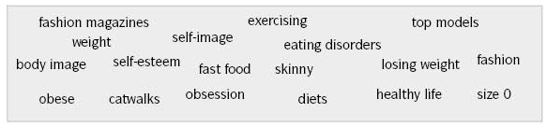
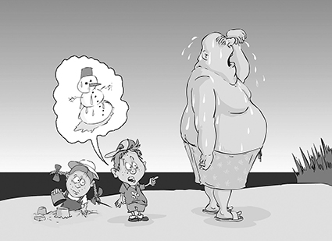
Prompts:
Card 2
Cartoons go on a diet for fashion. Is Minnie too skinny?
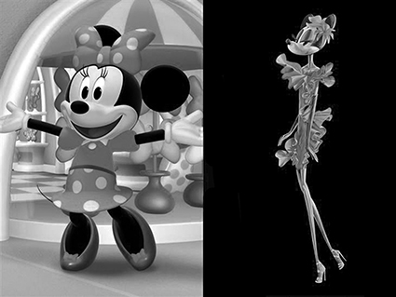

Texto 1
“We know that children and adolescents are highly exposed to fast-food restaurant advertising, particularly on television. This study links obesity in young people to familiarity with this advertising, suggesting that youth who are aware of and receptive to televised fast-food marketing may be at risk for health consequences," said lead author Auden C. McClure, MD, MPH, FAAP, assistant professor in the Department of Pediatrics at Children's Hospital at Dartmouth, Dartmouth-Hitchcock Medical Center.
From: www.news-medical.net (adapted)
Texto 2
In terms of body image, the media bombards the young girls’ minds with images of skinny models. This makes them feel that if they are a few pounds heavier than these images on the magazine then they are unacceptable to the society. As time passes, it has been observed that the girls who are becoming weight conscious get younger and younger — for instance, about 80% of nine-year-olds are on diets and that the number of eating disorder cases has been rising.

