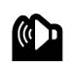
I
LISTENING*
MODULE 0 – PROGRESS TEST 1

Escola Secundária: __________________________________________________
Name: _______________________________________ No. _____ Class: _________
Date: ____/____/____ Mark: _______________ Teacher: ___________________
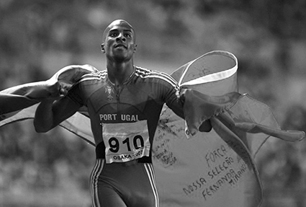
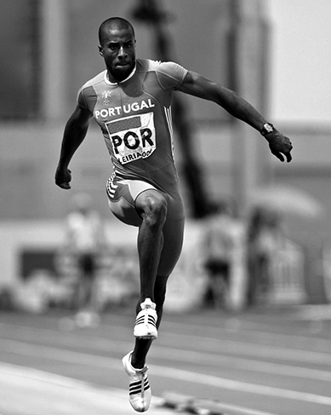
A. Listen to the text and complete the blank spaces with the correct words.
Leading up to the 2008 Beijing Summer Olympics, Men’s Triple (1) _______ World Champion Nelson Évora said he felt no (2) ________ going into the opening rounds of Olympic (3) ________ and expected to improve upon his personal best of 17.74 meters.
Weather conditions at Beijing's Bird's Nest Stadium most likely kept Nelson from achieving a new (4) ________ best at the Olympics. But in the end, his 4th jump of 17.67 metres in the triple jump Olympic (5) ________ was good enough to (6) _______ Olympic Gold.
* Audio recording available at Manual Interativo.
• win • personal • jump • finals • pressure • competition
II
READING
Read the text carefully.
NELSON ÉVORA
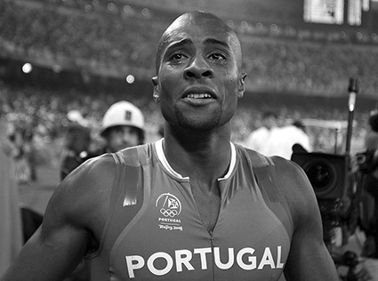
Nelson Évora was born in Côte d'Ivoire, where his parents lived at the time after leaving Cape Verde. When Nelson was five years old, he and his parents came to live in Portugal. He still holds the Cape Verdean records in both the long jump (7,57 m) and the triple jump (16,15 m).
5
Évora's family fixed in Odivelas, on the floor above João Ganço’s, former Portugal record-holder and first man in Portugal to pass over 2 m in the high jump. David Ganço, one of three sons of João Ganço, one year older than Nelson, became Évora's best friend. One day, João Ganço, seeing them playing in the street, suggested that Nelson start practising athletics, following David's example, and, just like that, Nelson sports career started. João Ganço then became Évora's coach.
15
10
Nelson began, like almost everyone in Portugal, to participate in road competitions. At the age of 10, Nelson joined Odivelas Futebol Clube, and jumped 1,64 m in high jump… when his height was around 1,40 m.
At the age of 13 he improved his mark in high jump to 1,75 m and in long jump to 5,50 m. That meant no rivals at his level… not even in combined events.
20
When Nelson turned 18 years old in 2002, he chose to become Portuguese and he got dual nationality. He justified that because his life is all here…, he feels more Portuguese than any other nationality.
25
Nelson Évora became the triple jump World champion at the 2007 World Championships, in Osaka, Japan, establishing his personal best, the Portuguese national record and the second best world mark of the year at 17,74 m.
Évora won the Olympic gold medal at Beijing 2008 with a jump of 17,67 m on his 4th attempt beating silver medalist Phillips Idowu of Great Britain by 5 centimetres (17,62 m).
Nelson Évora has already won the major titles that an athlete can achieve during a lifetime but, don’t think that Nelson Évora will stop here… the show must go on…
30
From: wikipedia.org (adapted)
A. Complete the table with notes about the topics.
1. Name
2. Birthplace
3. Records in Cape Verde
4. Nelson’s best friend
5. First competitions
6. Nelson’s first coach
7. First club
8. Nelson’s titles

B. Complete the following sentences according to the text.
1. Côte d’ Ivoire was ________________________________________________________.
2. Nelson Évora was five years old when ______________________________________.
3. João Ganço was ____________________________________________________________.
4. When he was ten years old he _____________________________________________.
5. In 2002 he ______________________________________________________________.
6. He achieved his personal best in ______________________________________________.
C. Write a definition for the following words.
1. long jump _______________________________________________________________
2. triple jump ______________________________________________________________
3. high jump _______________________________________________________________
D. Match the words on the left with the equivalents on the right.
1. fixed (l.08) a) securing, landing
2. joined (l.17) b) result
3. improved (l.19) c) became a member
4. mark (l.19) d) attain, earn
5. establishing (l.25) e) an effort to accomplish something
6. attempt (l.27) f) made or became better
7. achieve (l.29) g) placed permanently
III
GRAMMAR
A. Complete with the present simple of the verbs in brackets.
1. Nelson Évora __________________ (practise) every day.
2. He ________________ (follow) a healthy diet.
3. Nelson____________________ (get up/never) late.
4. He ________________ (not like) being alone at home.
5. ________you__________ (practise) any sport?
6. _________they ________________ (go) to the Olympic stadium?
B. Complete with the present continuous of the verbs in brackets.
1. Nelson Évora __________________ (work out) hard today.
2. His coach ________________ (control) his leaps.
3. Nelson____________________ (watch) his Olympic performance on video with a friend today.
4. He ________________ (not eat) at his favourite restaurant, because he’s on a diet.
5. ________you__________ (practise) the long jump today?
6. _________Nelson ________________ (go) to compete for the gold medal?

C. Complete with the present simple or the present continuous.
1. The athletes __________________ (enter) the Olympic stadium now.
2. His coach ________________ (control) what Nelson eats.
3. Nelson and his friends____________________ (drink) juice at the local café today.
4. He ________________ (not drive) his car to the stadium. He usually walks.
5. ________you__________ (watch) athletics on TV? – No, I’m watching a film.
6. _________he ________________ (compete) every weekend?

IV
WRITING
Choose theme one OR two and write 120 to 150 words on it.
A. The importance of sports.
Sports are very important not only for kids but also for young people and adults. When you play sports, you meet so many people you probably wouldn't if you didn't. You get to know people that enjoy playing the same sport you do. Sports aren't only fun, they keep you in shape too. You improve your agility, endurance, and overall strength.

B. If you set a goal for yourself and you are able to achieve it, you have won your race. Your goal can be to come in first, to improve your performance, or just finish the race, it's up to you.
Dave Scott
American tri-athlete and six-time Ironman World Champion.


MODULE 0
PROGRESS TEST 1
COTAÇÕES
I. 18 pontos
II.
A. 24 pontos
B. 24 pontos
C. 15 pontos
D. 14 pontos
77 pontos
III
A. 18 pontos
B. 18 pontos
C. 24 pontos
60 pontos
IV. 45 pontos
Total 200 pontos
CRITÉRIOS ESPECÍFICOS DE CORREÇÃO
Grupo I – Listening
Atividade A
Completar espaços.
1. | jump | 3p. x 6 = 18
2. | pressure | 3p. x 6 = 18
3. | finals | 3p. x 6 = 18
4. | personal | 3p. x 6 = 18
5. | competition | 3p. x 6 = 18
6. | win | 3p. x 6 = 18
Certo/errado
Grupo II – Reading
Atividade A
Perguntas de interpretação.
1. | Name | Nelson Évora | 3p. X 8 = 24
2. | Birthplace | Côte d’Ivoire | 3p. X 8 = 24
3. | Records in Cape Verde | Long jump (7.57 m); triple jump (16.15 m) | 3p. X 8 = 24
4. | Nelson’s best friend | David Ganço | 3p. X 8 = 24
5. | First competitions | Road competitions | 3p. X 8 = 24
6. | Nelson’s first coach | João Ganço | 3p. X 8 = 24
7. | First club | Odivelas Futebol clube | 3p. X 8 = 24
8. | Nelson’s titles | Triple jump world champion at the 2007 World Championships and Olympic gold medal at Beijing 2008 | 3p. X 8 = 24
Certo/errado

Atividade B
Utilizar os verbos no present continuous.
1. | is working | 3p. x 6 = 18
2. | is controlling | 3p. x 6 = 18
3. | is watching | 3p. x 6 = 18
4. | isn’t eating | 3p. x 6 = 18
5. | Are…practicing | 3p. x 6 = 18
6. | Is…going | 3p. x 6 = 18
Certo/errado
Atividade C
Utilizar os verbos no present simple e no present continuous.
1. | are entering | 4p. x 6 = 24
2. | controls | 4p. x 6 = 24
3. | are drinking | 4p. x 6 = 24
4. | doesn’t drive | 4p. x 6 = 24
5. | are…watching | 4p. x 6 = 24
6. | does …compete | 4p. x 6 = 24
Certo/errado
Grupo III – Writing
Níveis de proficiência:
O aluno trata o tema de forma clara, apresentando boa organização e desenvolvimento crítico das ideias. Apresenta correção morfossintática e vocabulário rico e apropriado. Escreve com muito poucos ou nenhuns erros de grafia e pontuação. | 40 a 50  pontos
O aluno trata o tema de forma clara, apresentando uma sequência de ideias coerente, revelando algum espírito crítico e criatividade. Apresenta alguma correção morfossintática, embora com falhas ocasionais ao nível das estruturas básicas da língua. Emprega vocabulário comum, mas apropriado. Escreve com poucos erros de grafia e pontuação. Os erros que ocorrem não prejudicam a compreensão da mensagem. | 18 a 39  pontos
O aluno trata o tema de forma deficiente, revelando dificuldade de comunicação e de organização das ideias. Apresenta muitos erros de estrutura morfossintática. Escreve com muitos erros de grafia e de pontuação. Emprega vocabulário muito pobre, pouco adequado. | 0 a 17  pontos

Atividade B
Completar frases.
1. | … Nelson Évora’s birthplace. | 4p. x 6 = 24
2. | … he came to Portugal. | 4p. x 6 = 24
3. | … the first person in Portugal to pass over 2 m in the high jump. | 4p. x 6 = 24
4. | … joined Odivelas Futebol clube. | 4p. x 6 = 24
5. | … became a Portuguese citizen. | 4p. x 6 = 24
6. | … in 2007 in the World Championship, in Osaka. | 4p. x 6 = 24
Dedução de 1 ponto por erros gramaticais.
Dedução de 1 ponto por informação incompleta.
Dedução de 1 ponto por erros ortográficos.
Atividade C
Definição de palavras/expressões.
1. | An athletic event in which competitors jump as far as possible along the ground in one leap. | 5p. x 3 = 15
2. | An athletic event in which competitors attempt to jump as far as possible by performing a hop, a step, and a jump from a running star. | 5p. x 3 = 15
3. | An athletic event in which competitors try to jump over a bar supported on two poles. | 5p. x 3 = 15
Dedução de 1 ponto por erros gramaticais.
Dedução de 2 pontos por informação incompleta.
Dedução de 1 ponto por erros ortográficos
Atividade D
Correspondência de vocabulário.
1. | g) | 2p. x 7 = 14
2. | c) | 2p. x 7 = 14
3. | f) | 2p. x 7 = 14
4. | b) | 2p. x 7 = 14
5. | a) | 2p. x 7 = 14
6. | e) | 2p. x 7 = 14
7. | d) | 2p. x 7 = 14
Certo/errado
Grupo III – Grammar
Atividade A
Utilizar os verbos no present simple.
1. | practises | 3p. X 6 = 18
2. | follows | 3p. X 6 = 18
3. | never gets up | 3p. X 6 = 18
4. | doesn’t like | 3p. X 6 = 18
5. | do…practise | 3p. X 6 = 18
6. | do… go | 3p. X 6 = 18
Certo/errado

