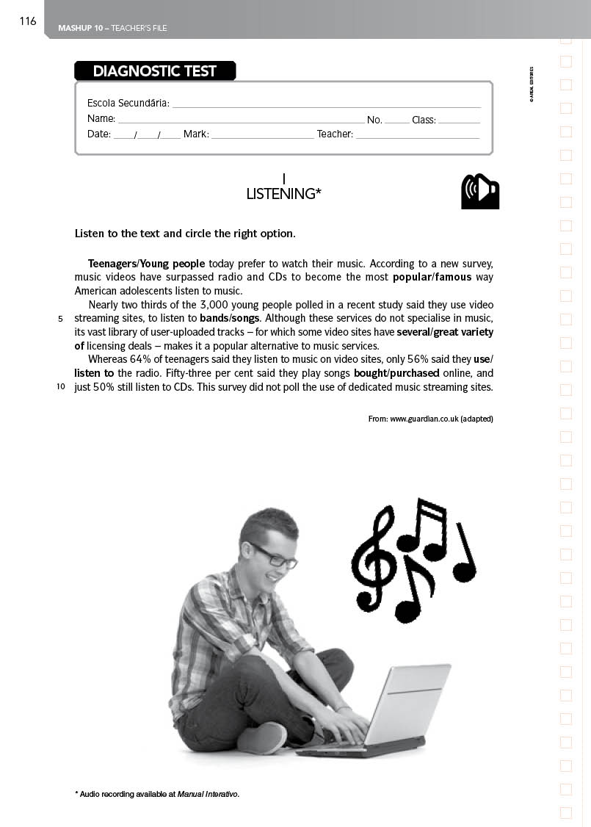
LISTENING*
MODULE 4 – PROGRESS TEST 5

Escola Secundária: __________________________________________________
Name: _______________________________________ No. _____ Class: _________
Date: ____/____/____ Mark: ________________ Teacher: ___________________
A. Listen to the text and complete it with the words given.

resistant | process | search | alien | style
fashion | product | maintream | society | culture

It may be difficult to identify certain subcultures because their (1) _______ (particularly clothing and music) may be adopted by mass (2) _______ for commercial purposes. Businesses often seek to capitalize on the subversive allure of subcultures in (3) _______ of Cool, which remains valuable in the selling of any
(4) _______. This process of cultural appropriation may often result in the death or evolution of the subculture, as its members adopt new styles that appear (5)_______ to mainstream (6) _______.
Music-based subcultures are particularly vulnerable to this (7) _______, and so what may be considered a subculture at one stage in its history – such as jazz, goth, punk, hip hop and rave cultures—may represent (8) _______ taste within a short period of time. Some subcultures reject or modify the importance of style, stressing membership through the adoption of an ideology which may be much more
(9) _______ to commercial exploitation. The punk subculture's distinctive (and initially shocking) style of clothing was adopted by mass-market (10) _______ companies once the subculture became a media interest.
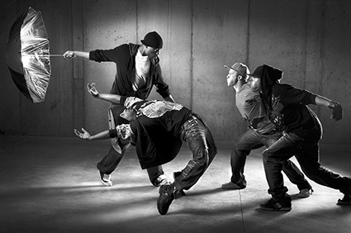
From: en.wikipedia.org (adapted)
* Audio recording available at Manual Interativo.

II
READING

Read the following text carefully.

Jocks, Preps, Punks, Goths. They may sit in separate tables in the cafeteria, but they all belong to the same generation. There are 31 million kids in the 12 to 19 age group, and demographers predict that there will be at least 40 million teens by 2015 a population growth bigger than even the baby boom at its peak. In many ways, these teens are uniquely privileged. They’ve grown up in a period of prosperity and haven’t had to worry about the draft (as theirs fathers did) or cataclysmic global conflicts (as their grandparents did). Cable and the Internet have given them access to an almost infinite amount of information. Most expect to go to college, and girls, in particular, have unprecedented opportunities; they can dream of careers in everything from professional sports to politics, with plenty of female role models to follow.
15
10
5
But this positive image of American adolescence is a little like yearbook photos that represent every kid as happy and blemish free. It’s clear that there’s another dimension to this picture, and it’s far more troubled. In survey after survey, many kids say they feel increasingly alone and alienated, unable to connect with their parents, teachers and sometimes even classmates. They’re desperate for guidance, and when they don’t get what they need at home or at school, they immerse themselves in a universe out of their parents’ reach, a world defined by computer games, TV and movies where brutality is so common it has become commonplace. The parents of Eric Harris and Dylan Klebold have told friends they never dreamed their sons could kill. It’s an extreme case, but it has made a lot of parents wonder: do we really know our kids?
25
20
Many teens say they feel overwhelmed by pressure and responsibilities. They are juggling part-time jobs and hours of homework every night; sometimes they are so exhausted that they’re nearly asleep in early-morning classes. Sixty-three percent are in households where both parents work outside the home, and many look after young siblings in the afternoon. Still others are home by themselves after school.
30
From: Newsweek (adapted)

A. Complete the sentences according to the text.
1. Nowadays the number of teenagers _____________________________________________
____________________________________________________________________________
2. Teenagers are luckier than previous generations ___________________________________
____________________________________________________________________________
3. Lack of guidance from parents may______________________________________________
____________________________________________________________________________
4. Some teens not only________________________, but also__________________________
____________________________________________________________________________

B. Answer the following questions on the text.
1. What urban tribes does the text refer to? Describe one of them.
2. Why are teens so troubled nowadays?
3. Who do teens turn to for guidance?
4. Are you of the opinion that TV and games can make teens violent? Explain.
C. Find synonyms in the text for the following words.
1. highest point _____________________________________________________________
2. blessed __________________________________________________________________
3. help and advice __________________________________________________________
4. vulgar ___________________________________________________________________
5. think about something ___________________________________________________
III
VOCABULARY
A. Fill in the gaps with the appropriate word.
Teenagers are generally (1)__________ at computers. They like to (2)_______ hours surfing the Net or talking in chat rooms. I think this attitude is (3)________ because youngsters find in chat rooms what they can’t find in their (4)________ life. But it’s important to be aware of the problems or (5)________ it can cause. Starting Internet friendships can lead to (6)________ situations. You may find friends there, but what kind of friends could they (7)________ if you don’t even know them? You may get so involved with some (8)________ that it can make you do crazy things. You shouldn’t use the Internet too much or (9)________ yourself dangerously. It is advisable to have friends from school or other places rather than (10)________ friends.
• real • expose • be • good • virtual • consequences • spend
• dangerous • youngsters • unreal
IV
GRAMMAR
A. Fill in the gaps using the right form of the verbs in brackets.
1. Give me a few minutes. I __________ (not/decide) about your offer yet.
2. Polly __________ (keep) a diary since she was eleven years old.
3. The baby usually __________ (listen) to some melodies before falling asleep.
4. Charles can’t come. He __________ (work) at the moment.
5. We __________ (join) them in a few weeks.
6. I __________ (see) her yesterday but I __________ (not/see) her today.
B Rephrase the following sentences.
1. She was late because her car broke down.
If __________________________________________________________________________
2. If it doesn’t stop raining, I won’t go to the party.
Unless _____________________________________________________________________

3. “It will be difficult to finish this project this week.”
The students said___________________________________________________________
4. Mike lives on the first floor. He is very handsome.
Mike_______________________________________________________________________
5. “My girlfriend went with me to the theatre yesterday.”
John said___________________________________________________________________
6. An Olympic champion teaches them gymnastics.
They_______________________________________________________________________
7. I lost my glasses so I didn’t read the book.
If I _________________________________________________________________________
8. He needs a complete change. It would be good for him.
He_________________________________________________________________________
V
WRITING
Choose ONE of the following topics and write about 110-150 words on it.
A. Comment on the statement.
B. Comment on the cartoon.
“Being a teenager can be one of the happiest times of your life, but it’s also a time when you go through many difficult situations.”
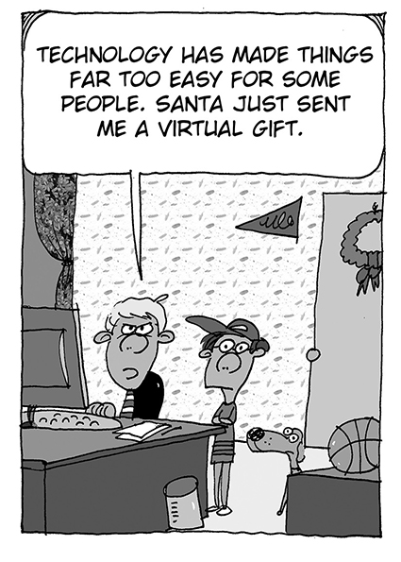

MODULE 4
PROGRESS TEST 5
COTAÇÕES
I. 20 pontos
II.
A. 16 pontos
B. 32 pontos
C. 15 pontos

63 pontos

III
A. 20 pontos
IV.
A. 21 pontos
B. 24 pontos
45 pontos
V. 52 pontos
Total 200 pontos
CRITÉRIOS ESPECÍFICOS DE CORREÇÃO
Atividade B
Perguntas de interpretação.
1. | The text refers to Jocks, Preps, Punks, Goths. (Open answer) | 8p. x 4 = 32
2. | They are so troubled nowadays, because they lack their parents’ guidance and they spend too much time alone in front of the TV and computer. | 8p. x 4 = 32
3. | They turn to the world of TV, movies and computers for guidance. | 8p. x 4 = 32
4. | Open answer. | 8p. x 4 = 32
Dedução de 2 ponto por erros gramaticais.
Dedução de 4 ponto por informação incompleta.
Dedução de 1 ponto por erros ortográficos
Atividade C
Encontrar sinónimos no texto.
1. | peak | 3p. x 5 = 15
2. | privileged | 3p. x 5 = 15
3. | guidance | 3p. x 5 = 15
4. | common | 3p. x 5 = 15
5. | wonder | 3p. x 5 = 15
Dedução de 1 ponto por erros gramaticais.
Dedução de 1 ponto por informação incompleta.
Dedução de 1 ponto por erros ortográficos.

Grupo I – Listening
Atividade A
Corrigir palavras erradas.
1. | style | 2p. x 10 = 20
2. | culture | 2p. x 10 = 20
3. | search | 2p. x 10 = 20
4. | product | 2p. x 10 = 20
5. | alien | 2p. x 10 = 20
6. | society | 2p. x 10 = 20
7. | process | 2p. x 10 = 20
8. | mainstream | 2p. x 10 = 20
9. | resistant | 2p. x 10 = 20
10. | fashion | 2p. x 10 = 20
Certo/errado
Grupo II – Reading
Atividade A
Completar frases de acordo com o texto.
1. | … has increased. | 4p. x 4 = 16
2. | … because they have grown up in a period of prosperity. | 4p. x 4 = 16
3. | … make them violent. | 4p. x 4 = 16
4. | … work but also study. | 4p. x 4 = 16
Dedução de 1 ponto por erros gramaticais.
Dedução de 1 ponto por informação incompleta.
Dedução de 1 ponto por erros ortográficos.

Grupo V – Writing
Níveis de proficiência:
O aluno trata o tema de forma clara, apresentando boa organização e desenvolvimento crítico das ideias. Apresenta correção morfossintáctica e vocabulário rico e apropriado. Escreve com muito poucos ou nenhuns erros de grafia e pontuação. | 42 a 52  pontos
O aluno trata o tema de forma clara, apresentando uma sequência de ideias coerente, revelando algum espírito crítico e criatividade. Apresenta alguma correção morfossintáctica, embora com falhas ocasionais ao nível das estruturas básicas da língua. Emprega vocabulário comum, mas apropriado. Escreve com poucos erros de grafia e pontuação. Os erros que ocorrem não prejudicam a compreensão da mensagem. | 19 a 41  pontos
O aluno trata o tema de forma deficiente, revelando dificuldade de comunicação e de organização das ideias. Apresenta muitos erros de estrutura morfossintáctica. Escreve com muitos erros de grafia e de pontuação. Emprega vocabulário muito pobre, pouco adequado. | 0 a 18  pontos

Grupo III – Vocabulary
Atividade D
Completamento de um texto com vocábulos dados.
1. | good | 2p. x 10 =20
2. | spend | 2p. x 10 =20
3. | dangerous | 2p. x 10 =20
4. | real | 2p. x 10 =20
5. | consequences | 2p. x 10 =20
6. | unreal | 2p. x 10 =20
7. | be | 2p. x 10 =20
8. | youngsters | 2p. x 10 =20
9. | expose | 2p. x 10 =20
10. | virtual | 2p. x 10 =20
Certo/errado
Grupo IV – Grammar
Atividade A
Preenchimento de espaços com os tempos verbais corretos.
1. | haven’t decided | 3p. x 7=21
2. | has kept / has been keeping | 3p. x 7=21
3. | listens | 3p. x 7=21
4. | is working | 3p. x 7=21
5. | will join | 3p. x 7=21
6. | saw; haven’t seen | 3p. x 7=21
Certo/errado
Atividade B
Reescrita de frases começando com as palavras dadas.
1. | If her car hadn’t broken down, she wouldn’t have been late. | 3p. x 8 =24
2. | Unless it stops raining, I won’t go to the party. | 3p. x 8 =24
3. | The students said it would be difficult to finish that project that week. | 3p. x 8 =24
4. | Mike, who lives on the first floor, is very handsome. | 3p. x 8 =24
5. | John said that his girlfriend had gone with him to the theatre the day before. | 3p. x 8 =24
6. | They are taught gymnastics by an Olympic champion. | 3p. x 8 =24
7. | If I hadn’t lost my glasses, I would have read the book. | 3p. x 8 =24
8. | He needs a complete change, which would be good for him. | 3p. x 8 =24
Dedução de 1 ponto por erros gramaticais.
Dedução de 1 ponto por informação incompleta.
Dedução de 0,5 pontos por erros ortográficos

