SPORTS
VOCABULARY WORKSHEET 1

Escola Secundária: _______________________________________________
Name: ____________________________________ No. _____ Class: _________
Date: ____/____/____ Mark: _______________ Teacher: _________________
A. Complete with the missing words. Choose from the box.
Healthy Development of Children and Young People through Sport
• physical • health • life-long • potential • spectators • messages • young
• losing • educational • participants • development • motor • competition • skills
Physical education and sport have an (1) _________ impact. Changes can be seen in
(2) ________ skills development and performance and educational (3) _________. This shows the positive relationship between being involved in (4) _________ activities and psychosocial (5) _________.
Sport and physical education is fundamental to the early development of children and youth and the skills learned during play, physical education and sport contribute to the holistic development of (6) _________ people. Through participation in sport and physical education, young people learn about the importance of key values such as:
• honesty;
• teamwork;
• fair play;
• respect for themselves and others;
• adherence to rules.
It also provides a forum for young people to learn how to deal with (7) _________ and how to cope with both winning and (8) _________. These learning aspects highlight the impact of physical education and sport on a child’s social and moral development in addition to physical (9) _________ and abilities.
In terms of physical and (10) _________ aspects of child and youth development, there is an overwhelming amount of evidence that focuses on the (mostly positive) effects of sport and exercise on physical health, growth and development.

Long-term involvement in physical activity
Physical education and sport also build health activity habits that encourage (11) _________ participation in physical activity. This extends the impact of physical education beyond the schoolyard and highlights the potential impact of physical education on public health.

Sport as a 'hook'
Sport is an attractive activity for young people, and is often used as a draw card to recruit children and young people to health and education programmes. Sport and development projects that focus on educational outcomes use sport as a means to deliver educational
(12) _________ to (13) _________, and (14) _________ in some cases.
From: www.sportanddev.com (adapted)

SPORTS
VOCABULARY WORKSHEET 2

Escola Secundária: __________________________________________________
Name: _______________________________________ No. _____ Class: _________
Date: ____/____/____ Mark: ________________ Teacher: ___________________
A. Can you find thirteen sports in this word square? They may appear horizontally, diagonally or vertically.

B. PLAY, GO or DO? Fill in with the appropriate verb.
S | C | R | I | C | K | E | T | Q | G | W | E
U | J | L | P | O | I | U | Y | P | O | T | R
R | H | C | Y | C | L | I | N | G | L | G | S
F | I | S | H | I | N | G | D | L | F | F | K
R | O | W | I | N | G | E | A | R | T | Y | Y
N | I | F | O | O | T | B | A | L | L | U | D
G | O | P | L | K | T | E | N | N | I | S | I
S | A | I | L | I | N | G | I | N | G | S | V
H | O | C | K | E | Y | H | G | O | F | A | I
J | K | S | L | Z | X | C | V | B | L | Q | N
H | A | N | D | B | A | L | L | W | Y | O | G
B | S | R | A | F | T | I | N | G | B | N | P

1. ______ soccer
2. ______ judo
3. ______ swimming
4. ______ yoga
5. ______ kung fu
6. ______ hiking
7. ______ golf
8. ______ aerobics
9. ______ fishing
10. ______ baseball
11. ______ karate

MUSIC
VOCABULARY WORKSHEET 3

Escola Secundária: _______________________________________________
Name: ____________________________________ No. _____ Class: _________
Date: ____/____/____ Mark: ______________ Teacher: __________________
A. Complete with the missing words to identify the objects related to music.

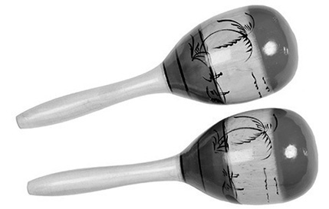
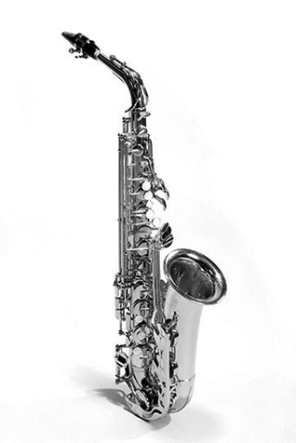
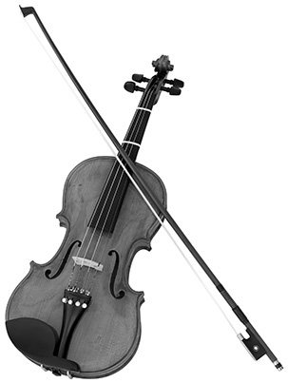
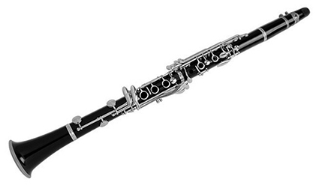
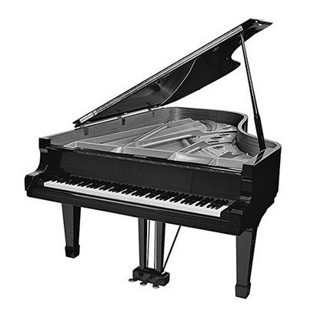
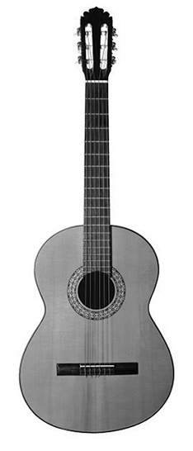


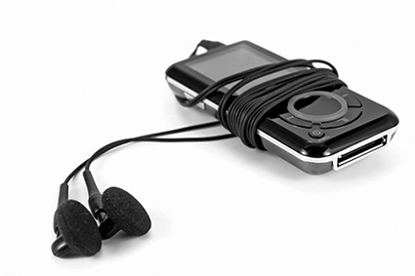


1.______

2. _______________

3. _______________

4. _______________

5. _______________

6. _______________

7. _______________

8. _______________

9. _______________

10. _______________

11. _______________

12. _______________

Languages around the world
VOCABULARY WORKSHEET 4

Escola Secundária: _________________________________________________
Name: ______________________________________ No. _____ Class: _________
Date: ____/____/____ Mark: ________________ Teacher: __________________

A. Write the official language of each country.
COUNTRY | OFFICIAL LANGUAGE(S)
Finland
France
India
Ireland
Israel
Italy
Jamaica
Japan
Mexico
Mozambique
Netherlands
New Zealand
Norway
Portugal

COUNTRY | OFFICIAL LANGUAGE(S)
Angola
Argentina
Australia
Austria
Belgium
Brazil
Bulgaria
Canada
Chile
China
Cuba
Czech Republic
Denmark
Egypt

Cyberfriends
VOCABULARY WORKSHEET 5

Escola Secundária: ________________________________________________
Name: _____________________________________ No. _____ Class: _________
Date: ____/____/____ Mark: ________________ Teacher: _________________
A. Complete the blank spaces in the poem with the following words.
• whenever • if • though • what (3 x) • that • who • whether • and
It doesn't matter (1) ______ you wear,
(2) ______ you eat or (3) ______ you weigh.
(4) ______ cares if your hair's a total mess
Or (5) ______ you're hundreds of miles away?

To see you in my contact list
(6) ______ you're online
Reminds me of how glad I am
(7) ______ you're all friends of mine!

Whenever I need to rant or rave
You're always there for me,
You hear me out on everything
And we so rarely disagree!

(8) ______ there's a problem to solve
Or a funny story to tell,
(9) ______ we listen with our eyes,
We understand each other so well.

We've got games right at our fingertips
And funny greetings too,
Whenever I'm at my computer,
There's always something to do!

So here's to you, my cyberfriends,
You really are the best!!
You make the web sure feel like home
(10) ______ for that I feel so blessed!
From: www.cyberfriends.com (adapted)
British English and American English
VOCABULARY WORKSHEET 6

Escola Secundária: _________________________________________________
Name: ______________________________________ No. _____ Class: _________
Date: ____/____/____ Mark: _______________ Teacher: ___________________
A. Complete the tables with the corresponding words.


American English | British English
to rent
quotation marks
elevator
truck
laid off
candy store
pants

American English | British English
track and field
cookie
apartment
parking lot
druggist
garbage can
grade (school)

B. British English uses the present perfect where American English often uses the past simple. Complete the sentences
BrE – Have you seen this exhibition yet?
AmE – __________________________________________________________________?
BrE – I've already seen that film.
AmE – __________________________________________________________________.
BrE – I have lost my keys.
AmE – __________________________________________________________________.
C. The prepositions are also differently used. Complete the following.
BrE – fill in a form
AmE – __________________________________________________________________.
BrE – in a team
AmE – __________________________________________________________________.
BrE – Tuesday to Thursday
AmE – __________________________________________________________________.
BrE – to enrol on a course
AmE – __________________________________________________________________.
BrE – stay at home
AmE – __________________________________________________________________.

Computer terms
VOCABULARY WORKSHEET 7

Escola Secundária: __________________________________________________
Name: _______________________________________ No. _____ Class: _________
Date: ____/____/____ Mark: _______________ Teacher: ____________________
The Computer Poem
A. Complete this poem with the words on the right.
A Computer was something on TV
From a Science Fiction show of note
• Crash
• File
• Web
• Ram
• Cursor
• Garbage
• Window
• Drive
• Mouse
• Virus
• Meg
• Bytes
• Unzipped
• Backup
• Paste
• Gig
• Keyboard
(1) ____________ was something you hated to clean
And (2) ____________ was the father of a goat.
(3) ____________ was the name of a girlfriend
And (4) ____________ was a job for the nights
Now they all mean different things
And that really Mega (5) ____________.
An Application was for employment
A Programme was a TV show
A (6) ____________ used profanity
A (7) ____________ was a piano.
Compress was something you did to the (8)____________
Not something you did to a (9) ____________
And if you (10) ____________ anything in public
You'd be in jail for a while.
Log on was adding wood to the fire
Hard (11) ____________ was a long trip on the road
A (12) ____________ pad was where a mouse lived
And a (13) ____________ happened to your commode.
Cut you did with a pocket knife
(14) ____________ you did with glue
A (15) ____________ was a spider's home
And a (16) ____________ was the flu.
I guess I'll stick to my pad and paper
And the Memory in my head.
I hear nobody's been killed in a Computer (17) ____________
But when it happens they wish they were dead.
From: www.wowfunny.com

Computer terms
VOCABULARY WORKSHEET 8

Escola Secundária: ___________________________________________________
Name: ________________________________________ No. _____ Class: _________
Date: ____/____/____ Mark: ________________ Teacher: ____________________
A. Complete the blank spaces with terms related to computers and Internet.

1. _______________: the part of the computer with letter and number buttons that you use for typing.
2. _______________: what you use to move the arrow around the computer screen.
3. _______________: the arrow or little flashing line on your computer screen that points to things.
4. _______________: the computer screen where you see words, pictures and videos.
5. _______________: a small computer that is easy to move and carry. It has the computer, monitor, mouse, and keyboard all together.
6. _______________: a worldwide system of millions of computers that are connected together in a network.
7. _______________: the world that connects computers with the Internet. When you send an e-mail to friends it goes through cyberspace to reach them.
8. _______________: a place to “talk by typing” to the other people. But be careful! People are not always who they say they are. Never give any personal information like your name, address, phone number, or the name of your school.
9. _______________: a name that you pick to use when you’re on the Internet. It identifies you without telling strangers your real name.
10. _______________: junk mail sent to your e-mail box that is usually advertising something.
11. _______________: a hidden computer programme that sneaks into your computer through e-mail or the Internet.
12. _______________: a secret word that only you and your parents should know. You use it to check your e-mail and log into websites.

Computers and the Internet
VOCABULARY WORKSHEET 9

Escola Secundária: ________________________________________________
Name: _____________________________________ No. _____ Class: _________
Date: ____/____/____ Mark: ________________ Teacher: _________________
A. Fill in with the words from the box.
The opening or main page of a website, intended chiefly to greet visitors and provide information about the site or its owner.
2. __________________

1. __________________

• Template • Loop • Homepage • Upload • Folder • Spam
• Database • Download • Browser • Icon

A directory in the sense of a collection of computer files.
To transfer (data or programmes) from a server or host computer to one's own computer or device.
3. __________________

A collection of data arranged for ease and speed of search and retrieval.
7. __________________

6. __________________

5. __________________

4. __________________

A programme that accesses and displays files and other data available on the Internet and other networks.
To keep information on a computer or on another electronic device, i.e. a disk, a pen drive, a CD, etc.
To transfer (data or programmes), usually from a peripheral computer or device to a central, often remote computer.
A picture on a screen that represents a specific file, directory, window, option, or programme.
8. __________________

A document or file having a preset format, used as a starting point for a particular application so that the format does not have to be recreated each time it is used.
10. ________________

9. __________________

A sequence of instructions that repeats either a specified number of times or until a particular condition is met.

Television
VOCABULARY WORKSHEET 10

Escola Secundária: ________________________________________________
Name: _____________________________________ No. _____ Class: _________
Date: ____/____/____ Mark: _______________ Teacher: __________________
A. Complete with the missing words. Choose words from the box.

The importance of TV
• shows • TV • convince • music • society • channels
• effective • laugh • movie • expensive • dollars
• services • communication • relaxation • mediums
Television is considered to be the most effective means of (1) ___________________ in our world today. Young people spend around two hours of their time just sitting in front of the (2) ___________________.
Commercial ads on television really make a lot of difference in today's (3) ____________. Companies use billions of (4) ________________ each day just for advertising products and services. It is (5) _______________ but we have to admit that it is truly an (6) ___________ way of reaching out to people. Compared to other advertising (7) ________________, TV is known to be the most effective option to
(8) ________________ people to purchase some products and (9) ________________.
You can also watch movies on TV. Movies are shown every minute of the day. It is never too late to catch a (10) ________________. You can either refer to the TV guide, or just catch a random movie.
When you have had a long day, it is necessary to get some sort of (11) ________________. It is very important to put a smile on our faces. Watching TV gives people an opportunity to (12) ________________ with comedy some shows available to some (13) _______________. There are hundreds of them played at a specific time. You can enjoy the (14) ____________ as long as you want to.
These days, there are many artists who create great music videos. TV is once again known to be the best medium for (15) ________________ development and marketing. It is true that the radio can let us hear the artists' music but it is a lot different when you see them together with their music videos.
From: www.articleonlinedirectory.com/ (adapted)

Text messages and chat abbreviations
VOCABULARY WORKSHEET 11

Escola Secundária: ______________________________________________
Name: ___________________________________ No. _____ Class: _________
Date: ____/____/____ Mark: _______________ Teacher: ________________
A. Match the abbreviations with their meanings.
1. AAP a. See you later
2. ADR b. Get back to work
3. AFAIK c. Laugh out loud
4. B4N d. Tomorrow is another day
5. BB e. Address
6. BHL8 f. I’ll be late
7. CUL8R g. Be back
8. CYO h. Always a pleasure
9. DIKY i. As far as I know
10. DIS j. Do I know you?
11. DIY k. Bye four now
12. DTRT l. I don’t think so
13. EOD m. For your information
14. FYI n. Be home late
15. GBTW o. See you online
16. HAU p. Did I say?
17. IDTS q. End of discussion
18. ILBL8 r. How about you?
19. LOL s. Do the right thing
20. TIAD t. Do it yourself


