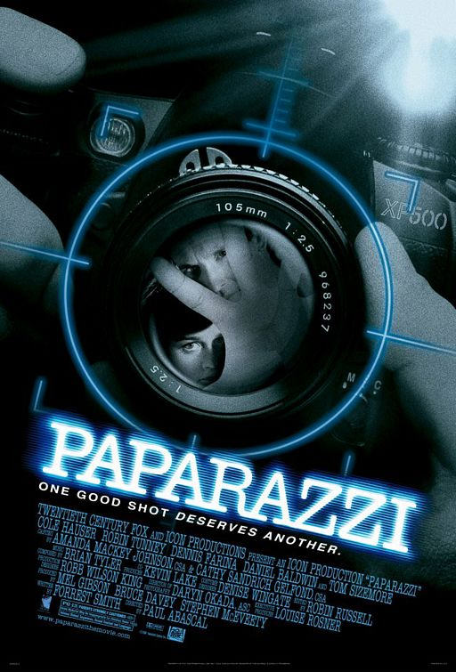
Learn by viewing

Paparazzi

A. PRE-VIEWING

1. Look at the pictures and answer the questions below.
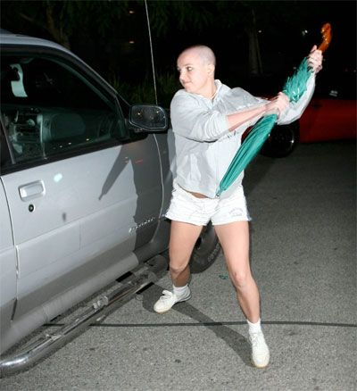 | Picture 1  1. Why do you think Britney Spears is trying to bash the car window with her umbrella?  2. What might be the cause for her fury?
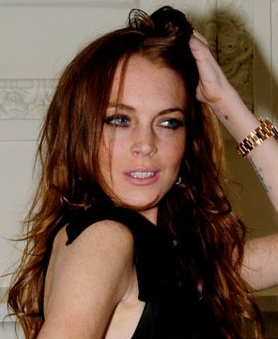 | Picture 2  3. Lindsey Lohan is posing for the photo. Why?  4. Do you think it’s lucrative for her image or her career?
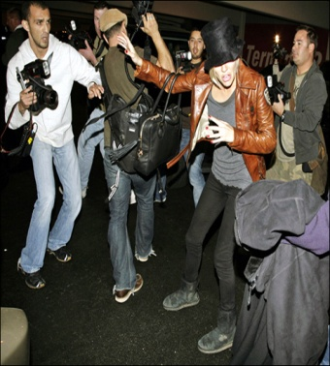 | Picture 3  5. What’s happening in the picture?  6. Why do you think celebrities have a love/hate relationship with the media?

B. WHILE VIEWING

1. Order these images according to the story in the film.

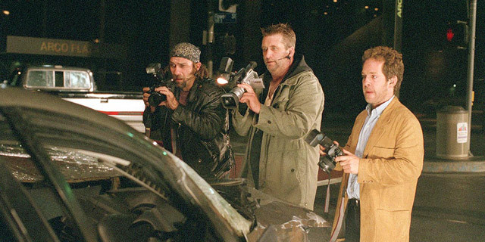  a) | 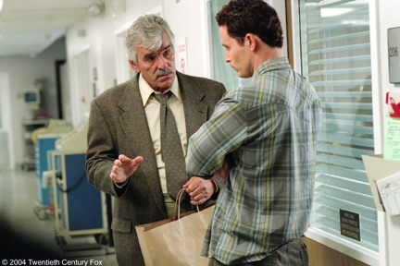  b) | 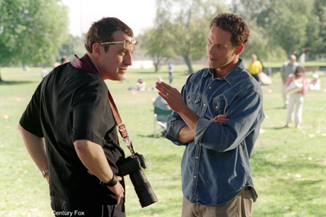  c)
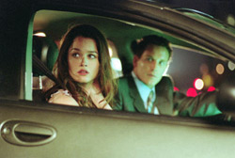  d) | 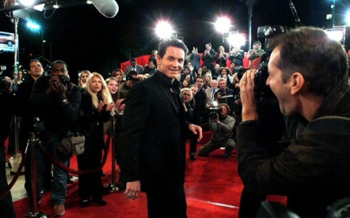  e) | 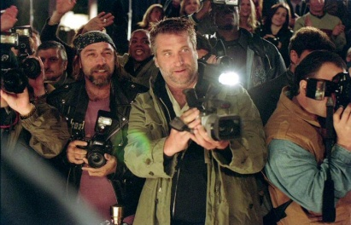  f)

2. Complete the following sentences according to the film.

a) Bo Laramie is initially overwhelmed _____________________________________
b) But success comes at a price, in the form of ______________________________
c) The day after the big premiere of Bo's new movie, Bo takes Zach to soccer practice where ______________________________________________________________
d) Bo, who's been pushed too far, punches Rex in the face and one of these shots ___________________________________________________________________
e) Later, while Abby is quietly lounging in the patio, Leonard ___________________
f) As Bo and Abby are in the hospital on their way to visit Zach, they notice a tabloid with _______________________________________________________________

3. Complete the synopsis of the film with the missing words given below.

Rising action star Bo Laramie seems to have it all: beautiful wife, adoring son and a__________ beach house. Life couldn't be better. But his ____________ fame comes with a price. He's become a target of a team of four ____________ bent on making Bo and his family fodder for the ___________, to nearly ruinous effect for the Laramies.
The paparazzi and their weapons of choice - long __________ - stalk Bo everywhere. He accepts the veritable invasion of his life... until ___________ of his wife, Abby, and his son, Zach, begin appearing on ____________ of one particularly sleazy tabloid called Paparazzi. All efforts to convince the photographers to spare his family are ignored, and Bo has a __________ altercation with one _____________ paparazzo, Rex. The actor is sentenced to anger-management therapy - while Rex walks away unpunished. The paparazzi become increasingly relentless, ruthless - even ___________.
From: www.filmjabber.com

newfound tabloids photos Malibu criminal
paparazzi lenses covers "superstar" physical

C. POST-VIEWING

1. Read what the following celebrities have to say about the paparazzi.

What I've learned is that you really don't need to be a celebrity or have money or have the paparazzi following you around to be famous.
Lady Gaga

I can't go to war with paparazzi.
Daniel Craig

I don't really resent being on the red carpet as much as I do having to deal with the paparazzi.
Megan Fox

What did the paparazzi do to Diana? They chased her and they killed her.
Heather Mills

I've been... chased by paparazzi, and they run lights, and they chase you and harass you the whole time. It happens all over the world, and it has certainly gotten worse. You don't know what it's like being chased by them.
Tom Cruise
From: www.brainyquote.com

2. Choose a celebrity that you admire and find out what type of relationship he/she has with the paparazzi. Present your findings to the rest of your class.

