TESTE DE AVALIAÇÃO DE INGLÊS
10.º ano • Módulo 2 • Unidade 1
MATRIZ
Estratégias/  Processos  cognitivos  Componentes | Reconhecer/  Identificar | Compreender/  Aplicar | Interpretar/  Analisar | Criar | Total de  itens/pontos
A. Compreensão do oral | 2 itens  (10 pontos) | 6 itens  (30 pontos) |  |  | 8 itens /  40 pontos
B. Leitura | 1 item  (5 pontos) | 4 itens  (35 pontos) | 1 item  (15 pontos) |  | 6 itens /  55 pontos
C. Uso da língua |  | 2 itens  (45 pontos) |  |  | 2 itens /  45 pontos
D. Produção escrita |  |  |  | 1 item  (60 pontos) | 1 item /  60 pontos
Total de itens/pontos | 3 itens /  15 pontos | 12 itens /  110 pontos | 1 item /  15 pontos | 1 item /  60 pontos | 17 itens /  200 pontos

ENGLISH TEST
Module 2 • Unit 1
Name: Year: :_______ Class: :_______ Number: :_______ Mark:_______
Part A – Listening

You are going to listen to a text about artificial intelligence (AI) and neuroscience, the science
of the brain. You are going to listen twice. Read all the items first.
1. Choose the correct option (A, B or C) to complete the sentences according to what you hear.
[8 x 5 pontos]
1.1 One of the ways neuroscience inspires artificial intelligence systems design is by
(A) replicating the human brain.

(B) building human-like brains.

(C) producing brain-like structures.

1.2 Some machines work better than humans
(A) and that is dangerous for our workforce in the future.

(B) but only at the tasks they are programmed to do.

(C) because artificial intelligence is inspired by neuroscience.

1.3 Artificial intelligence systems are
(A) as biological as human systems.

(B) different from human systems in some ways.

(C) as close to human beings as possible.

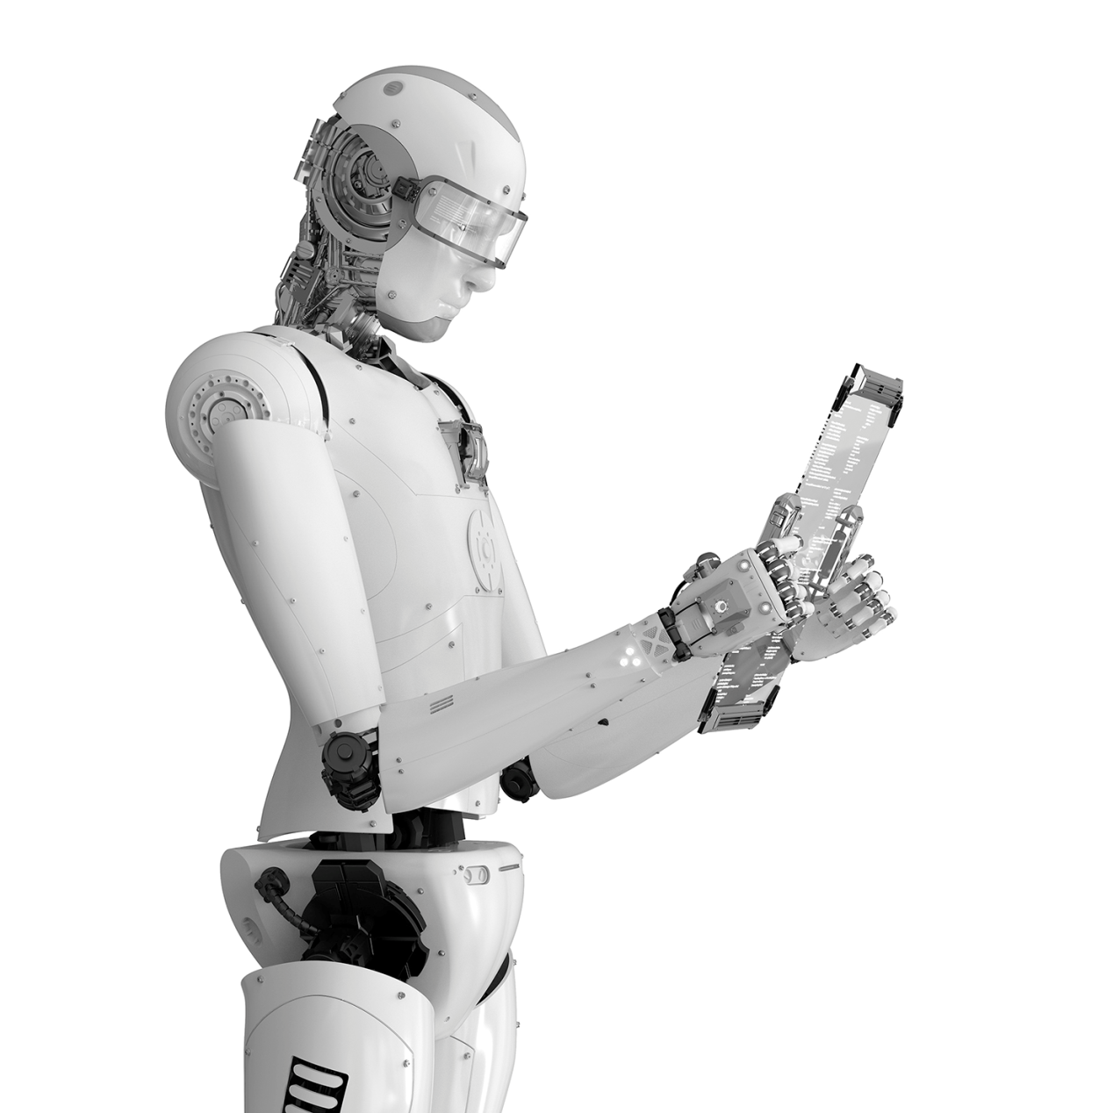
1.4 For a machine to think like a human being, it would have to be able to
(A) design problems.

(B) learn new things.

(C) explain and generalize.

1.5 One of the most difficult human characteristics to copy is
(A) the ability to make decisions.

(B) the capacity to feel emotions.

(C) the possibility to produce language.

1.6 Human beings are also able to
(A) play musical instruments by heart.

(B) function in a new environment.

(C) work with things without looking at them.

1.7 AI is helping neuroscience understand how
(A) to drive cars.

(B) humans move.

(C) brains develop.

1.8 The advancement of AI can help neuroscience
(A) understand the brain better.

(B) keep the brain secret.

(C) be fitter and grow bigger.

 © ASA, STEP UP 10, Teacher’s Resource File 187
Part B – Reading
You are going to read a text about the impact of artificial intelligence in society.
THE FUTURE IS NOW

 | 5  10  15  20  25 | There’s virtually no major industry that hasn’t already been affected by modern artificial intelligence (AI). That’s especially true in the last few years, as data collection and analysis has ramped up considerably thanks to robust IoT* connectivity, the proliferation of connected devices and ever-speedier computer processing.  Some sectors are at the start of their AI journey while others are veteran travellers. Both  have a long way to go. Even so, the impact AI is having on our present day lives is hard to ignore.  Transportation: Although it could take a decade or more to perfect them, autonomous cars will one day carry us from place to place.  Manufacturing: AI-powered robots work alongside humans to perform a limited range of tasks like assembling and stacking, and predictive analysis sensors keep equipment running smoothly.  Healthcare: In the comparatively AI-initial field of healthcare, diseases are more quickly and accurately diagnosed, drug discovery is sped up and modernized, virtual nursing assistants monitor patients and big data analysis helps to create a more personalized experience.  Education: Textbooks are digitized with the help of AI, early-stage virtual tutors assist human instructors and facial analysis determines the emotions of students to help find out who’s struggling or bored and better adjust teaching to their individual needs.  Media: Journalism is using AI, too, and will continue to benefit from it. Bloomberg uses cyborg technology to help make quick sense of complex financial reports. The Associated Press employs the natural language abilities of Automated Insights to produce 3,700 report stories per year — nearly four times more than in the recent past.  Customer service: Google, for instance, is working on an AI assistant that can place human-like calls to make appointments at, for example, your neighbourhood hair salon. In addition to words, the system understands context and voice tone.  But these advances (and numerous others) are only the beginning. There’s much more to come — more than anyone, even the most visionary human being, can guess.
 |  | https://builtin.com (adapted, accessed in February 2021)
 |  | * IoT (Internet of Things) refers to the rapidly growing network of connected objects and devices, such as refrigerators, cars, etc.

1. Match the ideas in column A with the corresponding paragraph in column B. Two options do not apply. [5 pontos]
A | B
a. You can book a haircut with a virtual call  b. Your face can be read to help you learn more  c. The influence of AI is here already | Paragraph 1  Paragraph 2  Paragraph 5  Paragraph 6  Paragraph 8
2. Find synonyms for these words in paragraph 1. [2 × 5 pontos]
a. expanded ________________________
b. multiplication ________________________
3. Complete the sentences according to paragraph 5. Use no more than three words in each space. [3 × 5 pontos]
AI allows diseases to be a. ___________________________________________ earlier and better;
b. ____________________________________ are available to improve monitoring of sick people
although AI is still an c. ___________________________________________ subject in healthcare.
4. Choose the correct option (A, B, C or D) to complete the sentences according to the text.
[2 × 5 pontos]
4.1 Robots are
(A) replacing human workers.

(B) helping humans work better.

(C) working together with humans.

(D) as efficient as human workers.

4.2 In the field of media, journalists are
(A) using AI to understand reports.

(B) happy not to write reports any more.

(C) afraid AI will make them lose their jobs.

(D) creating a new language for their stories.

5. Find evidence for the statements in the last four paragraphs. [3 × 5 pontos]
a. AI will help teachers know best how to understand their students.
b. Google’s AI assistant will process more than language.
c. The future of AI is very difficult to foresee.

Part C – Use of language
1. Complete the sentences with the past perfect of the verbs in brackets. [5 × 3 pontos]
a. Robots ___________ (be) a reality before AI developed.
b. My uncle Robert ___________ (already / talk) when I arrived at the neuroscience conference.
c. Some students ___________ (choose) to be neuroscientists even before they entered college.
d. It was 10 o’clock, but the conference ___________ (not start) yet.
e. My niece failed her Biology exam. It wasn’t a surprise because she ___________ (not study).
2. Complete the sentences with the past simple or the past perfect of the verbs in brackets.
[6 x 5 pontos]
I a. _______________ (think) about becoming a doctor when I b. _____________ (start) year 10 at high school, but my science teacher c. ______________________ (make) me change my mind.
He d. ______________ (see) my potential for scientific research and, before I e. ______________ (know) it, he f. _______________ (already / arranged) an internship for me at a neuroscience lab.
Part D – Writing
Can you guess the future of AI? Can you tell what areas of life AI will influence the most?
Write a text answering the questions (100 to 120 words).
Remember to:
• mention at least two areas;
• give one example for each area. [60 pontos]

Critérios de classificação
Parte A – Compreensão do oral
1.1 a 1.8 …….............................................……………......………………………….………. (8 × 5 pontos) 40 pontos
Itens | 1.1 | 1.2 | 1.3 | 1.4 | 1.5 | 1.6 | 1.7 | 1.8
Chave | C | B | B | C | A | B | B | A
Parte B – Leitura
1. …………………………………………………….....................................................................................… 5 pontos
Chave:
a. Paragraph 8 b. Paragraph 6 c. Paragraph 2
2. ………………..……………................................................……………………………..….… (2 × 5 pontos) 10 pontos
Chave:
a. ramped up b. proliferation
3. ………………..……………................................................……………………………..….… (3 × 5 pontos) 15 pontos
Níveis | Descritores de desempenho | Pontuação
2 | Completa a frase de acordo com o texto e com correção gramatical. Pode escrever com incorreções de grafia e de pontuação não impeditivas da compreensão. | 5
1 | Completa a frase de acordo com o texto. Pode escrever com incorreções linguísticas não impeditivas da compreensão. | 3
Exemplo:
a. diagnosed b. virtual nursing assistants c. initial
4.1 e 4.2 .………………………………………………..…...............................................…… (2 × 5 pontos) 10 pontos
Itens | 4.1 | 4.2
Chave | C | A
5. …………...….….……………..…….................................................………..……………… (3 × 5 pontos) 15 pontos
Chave:
a. “early-stage virtual tutors assist human instructors and facial analysis determines the emotions of students to help find out who’s struggling or bored and better adjust teaching to their individual needs.” (lines 16-18)
b. “In addition to words, the system understands context and voice tone.” (lines 24-25)
c. “There's much more to come – more than anyone, even the most visionary human being, can guess” (lines 26-27)
NOTA: Não são penalizadas as incorreções de transcrição não impeditivas da compreensão.
Parte C – Uso da língua
1. …………………….……………..……….………….................................................………… (5 × 3 pontos) 15 pontos
Chave:
a. had been b. had already talked c. had chosen d. hadn’t started e. hadn’t studied
2. …………………….……………..……….………….................................................………… (6 x 5 pontos) 30 pontos
Chave:
a. had thought b. started c. made d. saw / had seen e. knew f. had already arranged

Parte D – Produção escrita
Nível/  Pontuação | Conteúdo | Funções  comunicativas | Coerência  e coesão | Correção  linguística
N4  15 pontos | • O conteúdo é adequado, revelante e suficiente face à tarefa proposta. | • O aluno cumpre os objetivos de comunicação da tarefa proposta, utilizando as funções previstas e adequadas ao texto pretendido. | • O texto é estruturalmente organizado e coerente, com utilização dos elementos de ligação adequados. | • O vocabulário é variado e adequado à tarefa.  • Erros linguísticos eventuais não impedem a compreensão ou deturpam o sentido.
N3  11 pontos | • O conteúdo é geralmente adequado, relevante e suficiente face à tarefa proposta, embora possa apresentar pequenos lapsos ou irrelevâncias. | • O aluno cumpre os objetivos de comunicação da tarefa proposta, embora nem sempre utilize as funções previstas e adequadas ao texto pretendido. | • O texto é estruturalmente organizado e coerente, embora nem sempre os elementos de ligação utilizados sejam adequados. | • O vocabulário é geralmente variado e adequado à tarefa.  • Erros linguísticos eventuais não impedem a compreensão, embora possam deturpar o sentido pretendido.
N2  7 pontos | • O conteúdo nem sempre é adequado, relevante e/ou suficiente face à tarefa proposta, revelando algum grau de incompreensão da tarefa. | • O aluno cumpre parcialmente os objetivos de comunicação da tarefa proposta, pois não utiliza as funções adequadas ao texto pretendido. | • O texto revela alguma incoerência estrutural e nem sempre os elementos de ligação utilizados são adequados. | • O vocabulário nem sempre é variado e/ou adequado à tarefa.  • Erros linguísticos podem impedir a compreensão e/ou deturpar o sentido pretendido.
N1  3 pontos | • O conteúdo é maioritariamente inadequado, irrelevante e/ou insuficiente face à tarefa proposta. | • Os objetivos de comunicação da tarefa proposta não são cumpridos maioritariamente, pelo que o texto produzido é funcionalmente pouco adequado. | • O texto é maioritariamente incoerente e estruturalmente pouco organizado. | • O vocabulário é maioritariamente repetitivo e/ou inadequado à tarefa.  • Erros linguísticos frequentes impedem a compreensão e/ou deturpam o sentido pretendido.

GRELHA DE CLASSIFICAÇÃO
SCHOOL: |  |  |  |  |  |  |  |  |  |  |  |  | Class:
N.º | Name | Part A (40 p) |  | Part B (55 p) |  |  |  |  |  | Part C (45 p) |  |  | Part D (60 p) |  | Total  (200 p)
N.º | Name | 1 | Total | 1 | 2 | 3 | 4 | 5 | Total | 1 | 2 | Total | 1 | Total | Total  (200 p)
N.º | Name | 8 × 5 p | Total | 5 p | 2 × 5 p | 3 × 5 p | 2 × 5 p | 3 × 5 p | Total | 5 × 3 p | 6 × 5 p | Total | 60 p | Total | Total  (200 p)
1
2
3
4
5
6
7
8
9
10
11
12
13
14
15
16
17
18
19
20
21
22
23
24
25
26
27
28
29
30

