TESTE DE AVALIAÇÃO DE INGLÊS
10.º ano • Módulo 2 • Unidade 2
MATRIZ
Estratégias/  Processos  cognitivos  Componentes | Reconhecer/  Identificar | Compreender/  Aplicar | Interpretar/  Analisar | Criar | Total de  itens/pontos
A. Compreensão do oral | 2 itens  (16 pontos) | 2 itens  (16 pontos) | 1 item  (8 pontos) |  | 5 itens /  40 pontos
B. Leitura | 2 itens  (10 pontos) | 8 itens  (40 pontos) | 2 itens  (10 pontos) |  | 12 itens /  60 pontos
C. Uso da língua |  | 2 itens  (40 pontos) |  |  | 2 itens /  40 pontos
D. Produção escrita |  |  |  | 1 item  (60 pontos) | 1 item /  60 pontos
Total de itens/pontos | 4 itens /  26 pontos | 12 itens /  96 pontos | 3 itens /  18 pontos | 1 item /  60 pontos | 20 itens /  200 pontos

ENGLISH TEST
Module 2 • Unit 2
Name: Year: :_______ Class: :_______ Number: :_______ Mark:_______
Part A – Listening

You are going to listen to two young people talking about the impact of technology. You are
going to listen twice. Read all the items first.
1. Choose the correct option (A, B or C) according to what you hear. [5 x 8 pontos]
1.1 According to Jake, in which area can technology have a positive impact?
(A) Health.

(B) Communication.

(C) Entertainment.

1.2 What does Lisa think about genetic manipulation?
(A) She thinks it’s safe.

(B) She thinks it’s imperfect.

(C) She thinks it’s uncontrollable.

1.3 How does Jake feel about Lisa’s concerns about technology?
(A) He feels she’s overreacting.

(B) He feels she’s distracted.

(C) He feels she’s manipulative.

1.4 According to Lisa, how much has temperature increased?
(A) 1.04 degrees.

(B) 1.4 degrees.

(C) 1.14 degrees.

1.5 What do Jake and Lisa have in common?
(A) They both think technology
can solve environmental problems.


(B) They both think collaboration
is essential to solve problems.

(C) They both think the right tools
are enough to solve problems.

Part B – Reading
You are going to read a text about human enhancement.
 |  | What do we mean by human enhancement?
 | 5  10  15  20  25  30 | Recent advances in human enhancement technologies offer human beings new and unique opportunities to redesign their bodies and minds. But, in reality, people have been attempting to get over their biological limitations or remove “imperfections” for millennia. This means efforts to improve ourselves have a long history, and their impact on the way our  species developed is impossible to deny.  George Church from Harvard University explained that, before the 21st century, human enhancements included anything from vaccines to cars and jets that moved people across the world at previously unimaginable speeds and distances; or to the smartphone that you may be using to read this article; or to the cup of coffee you drink every morning to help you wake up. That is why Dr Church believes the latest human enhancement efforts in areas  like genetics and artificial intelligence are only continuing this tendency and that, in the near  future, human enhancement technologies may develop immensely and provide resistance to diseases and even reverse aging by means of age-reversing gene therapies. In fact, the human enhancement scientific community seems to believe healthier, longer lives with new  tissues will be a reality sooner than we may think.  Such promises for the future of enhancement technologies are very exciting, but not without potential risk. Critics have questioned the ethics of using these technologies to fundamentally alter human biology, and have called for careful investigations of the risks and potential complications before we can safely apply these new technologies. Moreover, there may be additional considerations depending on how these new technologies are used.  Josephine Johnston, from The Hastings Center, explained: “If you have a sick person and you’re thinking about using a new treatment to help them, risk is always tolerated — because  the person’s life is in danger. But when you’re thinking about enhancement technology,  it’s slightly different because that person isn’t necessarily suffering — they’re receiving an enhancement.” She thinks that needs to be taken into account.  It is critical to discuss the ethical principles of human enhancement. Dr Church added that most universities teach about safety and security and have a strict code of ethics, so that young scientists are aware of the potentially dangerous consequences and ethical implications of their work. But, when dealing with life-changing technology, shouldn’t we, as  a society, ask whether that is enough?
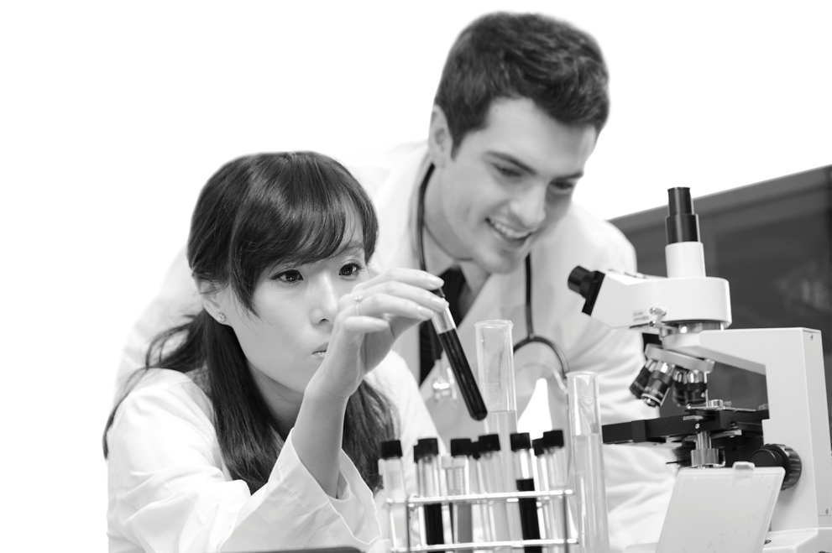
https://www.nyas.org (adapted, accesssed in January 2021)

1. Find evidence in paragraphs 1 to 3 for the statements below. [4 x 5 pontos]
a. The scientific breakthroughs of our times allow us to change our species physically and psychologically.
b. For Dr Church, human enhancements are not necessarily complex technologies.
c. Although Dr Church thinks human enhancement has a long history, he predicts its impact on human life will increase greatly.
d. It is necessary to assess the consequences of these technologies before putting them into use.
2. Choose the correct option (A, B, C or D) to complete the sentences according to the text.
[2 × 5 pontos]
2.1 According to paragraph 3, Josephine Johnston is against
(A) human enhancement technologies to improve people’s lives.

(B) critics’ considerations regarding enhancement technologies.

(C) considering different types of enhancement in the same way.

(D) tolerating risks in the application of enhancement technologies.

2.2 In paragraph 4, we can infer that the writer
(A) believes more control measures may be needed.

(B) believes scientists should listen to society.

(C) is against human enhancement.

(D) is curious about young scientists’ ethics.

3. Find synonyms for the words below in paragraphs 1 and 2. [4 × 5 pontos]
a. remarkable ________________________
b. overcome ________________________
c. extraordinary ________________________
d. fields ________________________
4. The words in column A were taken from the text. Match them with the word/expression they refer to in column B. Two options do not apply. [2 × 5 pontos]
4.1 The word “their”, in these lines, refers to:
A | B
a. their (line 2)  b. their (line 3)  c. their (line 4) | 1. human beings  2. enhancement technologies  3. people  4. impact  5. efforts

4.2 The word “that”, in these lines, refers to:
A | B
a. that (line 7)  b. that (line 8)  c. that (line 10) | 1. Dr Church’s explanation of the 21st century  2. human enhancements including many things  3. smartphone  4. cars and jets  5. vaccines
Part C – Use of language
1. A student reporter from your school went to a human enhancement conference. Complete the paragraph about it with a suitable future form of the verbs in brackets. [5 × 5 pontos]
Judging from the scientific advances we see happening now, human enhancements, such as brain implants, a. ____________ (surely / be) a reality. At the conference, the scientists promised that people b. ____________ (have) longer and more comfortable lives in the future before long. The second day of the conference c. ____________ (take) place tomorrow. According to the schedule, an expert in genetics d. ___________ (open) the conference at 9 o’clock. I hope I e. ___________ (be able) to interview her for our school newspaper.
2. Rewrite the sentences below using the expressions in brackets. [3 x 5 pontos]
a. Scientists are working hard on new enhancement technologies. They want people to have a better and more comfortable life. (so that)

b. Some scientists want to make sure these technologies are tested. They want to protect us from unintended consequences. (in order to)

c. They say we need to be careful. We can’t let these technologies have negative effects. (in order not to)

Part D – Writing
Your school newspaper is publishing a special issue on human enhancement.
Write an argumentative text (100 to 120 words) on the topic:
Human enhancement: solution or threat?
Don’t forget to:
• present three arguments;
• support your arguments with examples. [60 pontos]

Critérios de classificação
Parte A – Compreensão do oral
1.1 a 1.5 …….............................................……………......………………………….………. (5 × 8 pontos) 40 pontos
Itens | 1.1 | 1.2 | 1.3 | 1.4 | 1.5
Chave | B | C | A | C | B
Parte B – Leitura
1. …………………………………………........................................................................… (4 × 5 pontos) 20 pontos
Chave:
a. “Recent advances in human enhancement technologies offer human beings new and unique opportunities to redesign their bodies and minds.” (lines 1-2)
b. “human enhancements included anything from vaccines to cars and jets that moved people across the world at previously unimaginable speeds and distances; or to the smartphone that you may be using to read this article; or to the cup of coffee you drink every morning to help you wake up.” (lines 6-10)
c. “in the near future, human enhancement technologies may develop immensely and provide resistance to diseases and even reverse aging by means of age-reversing gene therapies.” (lines 11-13)
d. “and have called for careful investigations of the risks and potential complications before we can safely apply these new technologies.” (lines 18-19)
NOTA: Não são penalizadas as incorreções de transcrição não impeditivas da compreensão.
2.1 e 2.2 …….............................................……………......………………………….………. (2 x 5 pontos) 10 pontos
Itens | 2.1 | 2.2
Chave | C | A
3. …………...….….……………..…….................................................………..……………… (4 × 5 pontos) 20 pontos
Chave:
a. unique b. get over c. unimaginable d. areas
4.1 e 4.2 …….............................................……………......………………………….………. (2 x 5 pontos) 10 pontos
Chave:
4.1 a. 1 b. 3 c. 5
4.2 a. 4 b. 3 c. 2
Parte C – Uso da língua
1. …………………….……………..……….………….................................................………… (5 × 5 pontos) 25 pontos
Chave:
a. are surely going to be / will surely be; b. will have; c. takes / will take; d. is going to open /
is opening / will open; e. will be able
2. …………………….……………..……….………….................................................………… (3 x 5 pontos) 15 pontos
Exemplo:
a. Scientists are working hard on new enhancement technologies so that people can have a better and more comfortable life.
b. Some scientists want to make sure these technologies are tested in order to protect us from unintended consequences.
c. They say we need to be careful in order not to let these technologies have negative effects.

Parte D – Produção escrita
Nível/  Pontuação | Conteúdo | Funções  comunicativas | Coerência  e coesão | Correção  linguística
N4  15 pontos | • O conteúdo é adequado, revelante e suficiente face à tarefa proposta. | • O aluno cumpre os objetivos de comunicação da tarefa proposta, utilizando as funções previstas e adequadas ao texto pretendido. | • O texto é estruturalmente organizado e coerente, com utilização dos elementos de ligação adequados. | • O vocabulário é variado e adequado à tarefa.  • Erros linguísticos eventuais não impedem a compreensão ou deturpam o sentido.
N3  11 pontos | • O conteúdo é geralmente adequado, relevante e suficiente face à tarefa proposta, embora possa apresentar pequenos lapsos ou irrelevâncias. | • O aluno cumpre os objetivos de comunicação da tarefa proposta, embora nem sempre utilize as funções previstas e adequadas ao texto pretendido. | • O texto é estruturalmente organizado e coerente, embora nem sempre os elementos de ligação utilizados sejam adequados. | • O vocabulário é geralmente variado e adequado à tarefa.  • Erros linguísticos eventuais não impedem a compreensão, embora possam deturpar o sentido pretendido.
N2  7 pontos | • O conteúdo nem sempre é adequado, relevante e/ou suficiente face à tarefa proposta, revelando algum grau de incompreensão da tarefa. | • O aluno cumpre parcialmente os objetivos de comunicação da tarefa proposta, pois não utiliza as funções adequadas ao texto pretendido. | • O texto revela alguma incoerência estrutural e nem sempre os elementos de ligação utilizados são adequados. | • O vocabulário nem sempre é variado e/ou adequado à tarefa.  • Erros linguísticos podem impedir a compreensão e/ou deturpar o sentido pretendido.
N1  3 pontos | • O conteúdo é maioritariamente inadequado, irrelevante e/ou insuficiente face à tarefa proposta. | • Os objetivos de comunicação da tarefa proposta não são cumpridos maioritariamente, pelo que o texto produzido é funcionalmente pouco adequado. | • O texto é maioritariamente incoerente e estruturalmente pouco organizado. | • O vocabulário é maioritariamente repetitivo e/ou inadequado à tarefa.  • Erros linguísticos frequentes impedem a compreensão e/ou deturpam o sentido pretendido.

GRELHA DE CLASSIFICAÇÃO
SCHOOL: |  |  |  |  |  |  |  |  |  |  |  | Class:
N.º | Name | Part A (40 p) |  | Part B (60 p) |  |  |  |  | Part C (40 p) |  |  | Part D (60 p) |  | Total  (200 p)
N.º | Name | 1 | Total | 1 | 2 | 3 | 4 | Total | 1 | 2 | Total | 1 | Total | Total  (200 p)
N.º | Name | 5 × 8 p | Total | 4 × 5 p | 2 × 5 p | 4 × 5 p | 2 × 5 p | Total | 5 × 5 p | 3 × 5 p | Total | 60 p | Total | Total  (200 p)
1
2
3
4
5
6
7
8
9
10
11
12
13
14
15
16
17
18
19
20
21
22
23
24
25
26
27
28
29
30

