TESTE DE AVALIAÇÃO DE INGLÊS
10.º ano • Módulo 1 • Unidade 1
MATRIZ
Estratégias/  Processos  cognitivos  Componentes | Reconhecer/  Identificar | Compreender/  Aplicar | Interpretar/  Analisar | Criar | Total de  itens/pontos
A. Compreensão do oral | 2 itens  (10 pontos) | 6 itens  (30 pontos) |  |  | 8 itens /  40 pontos
B. Leitura | 1 item  (5 pontos) | 4 itens  (35 pontos) | 1 item  (15 pontos) |  | 6 itens /  55 pontos
C. Uso da língua |  | 2 itens  (45 pontos) |  |  | 2 itens /  45 pontos
D. Produção escrita |  |  |  | 1 item  (60 pontos) | 1 item /  60 pontos
Total de itens/pontos | 3 itens /  15 pontos | 12 itens /  110 pontos | 1 item /  15 pontos | 1 item /  60 pontos | 17 itens /  200 pontos

Part A – Listening

You are going to listen to a text about actress Emma Watson and the way she sees her role as
an artist and famous person. You are going to listen twice. Read all the items first.
1. Choose the correct option (A, B or C) to complete the sentences according to what you hear.
[8 × 5 pontos]
1.1 Emma evolved from child star to
(A) a stage actress.

(B) an intellectual performer.

(C) an artist and influencer.

1.2 Emma uses her fame to support good causes because
(A) that’s what all famous people do.

(B) she thinks it’s the best use she can give it.

(C) it’s a fun way to interact with her fans.

1.3 Emma graduated from __________ University.
(A) Oxford

(B) Brown

(C) Paris

1.4 In high school, her classmates
(A) weren’t allowed to talk to her.

(B) were always asking her for autographs.

(C) were proud to be close to Harry Potter’s Hermione.

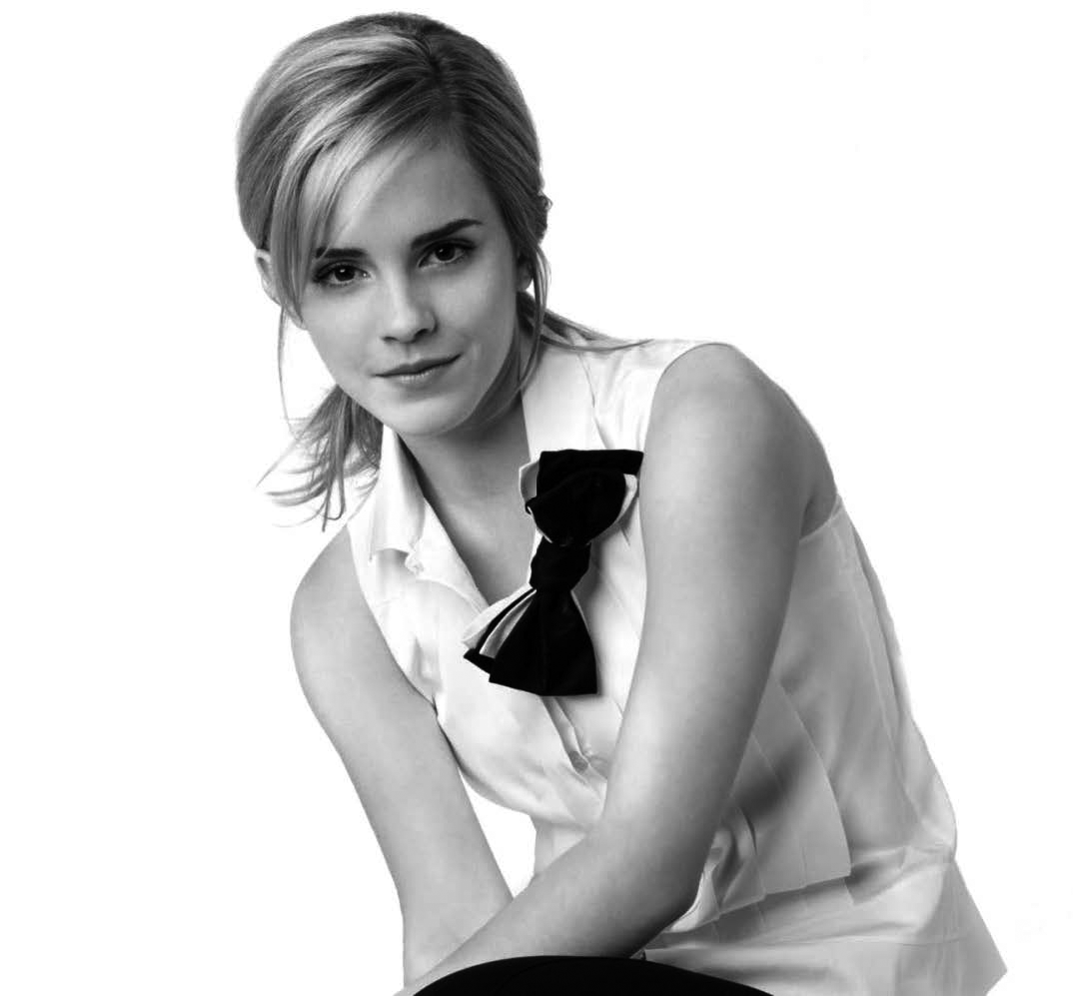
1.5 Emma collaborates with the United Nations as a
(A) goodwill ambassador.

(B) human rights activist.

(C) animal rights advocate.

1.6 One of Emma’s great concerns is women’s

ENGLISH TEST
Module 1 • Unit 1
Name: Year: :_______ Class: :_______ Number: :_______ Mark:_______
(A) rights.

(B) literature.

(C) power.

1.7 For Emma, the cause she embraces
(A) is the most important in the world.

(B) is an opportunity for fame.

(C) is close to her heart.

1.8 Emma started a book club where women
(A) can discuss any topic of their own interest.

(B) have the chance to share their personal problems.

(C) organize discussions online about books they read.

Part B – Reading
You are going to read a text about the opinion a teen has on art.
 |  | Teen opinion:
 |  | Why art is so important
 | 5  10  15  20  25  30 | As creative subjects are being abandoned in Britain, Safah, a teen, argues  that art is crucial for young people, as a means of challenging ourselves and  the world around us.  Anyone who’s been within three metres of me will know about my love of art. What’s equally predictable is that anyone above the age of 30 with a Maths degree tends to try and convince me to “study only what’s useful”. Maths is fundamental, I know. But art is such a massive part of my life, and I can say the same for so many other young people: it’s a popular choice for a secondary exam and a great introduction to the creative industries that are booming in the 21st century.  In my first ever art class, my teacher talked about how using different mediums could create different effects. I think that art is a medium in itself. It’s a medium for expression, passion and emotion, and the result? Well, it’s infinite. Art has been used to present opinions and challenge authority. It’s been used to capture important moments in history. And, just as miraculously, art has been a way for ordinary people to show what’s in their hearts without the weight of words. So long as we stay true to that, art will make us immortal.  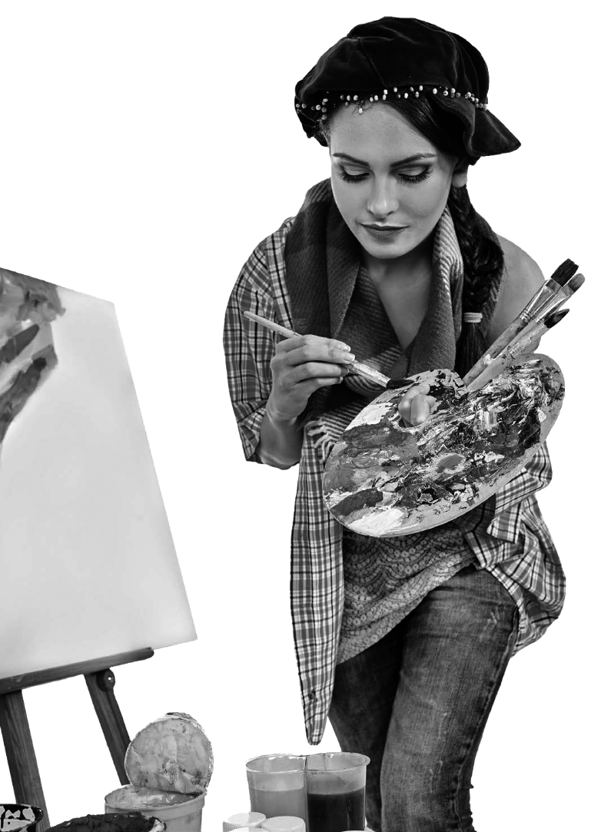  Which moves me onto my next point. What is art actually supposed to be? What is it supposed to do, exactly? If you were to ask me what kind of art I appreciate most, I’d say  it’s the art that really says something. I’m quite firmly against the old-fashioned idea that art should simply replicate nature and, sadly, it’s the idea behind most of the Art syllabus. “See how well you can capture that reflection, how best to replicate that shadow” — it’s all about perfection, repetition.  My favourite artist was, and still is with no doubt, Picasso. Odd, considering that, when I was younger, all I saw in his work were a lot of shapes and lines. Now, however, I’ve come to admire him. Not because of his style itself, but the courage behind it. Rather than painting pretty pictures of lakes  and mountains, he came up with cubism, a new, strange and occasionally mad art style. Picasso once said: “The world does not make sense, so why should I paint pictures that do?” After hearing that, I fell in love with art again.
https://www.theguardian.com
(adapted, accessed in February 2021)

1. The words in column A were taken from the text. Match them with the word/expression they refer to in column B. Two options do not apply. [5 pontos]
A | B
a. it (line 16)  b. it (line 18)  c. it (line 19) | 1. art  2. art as a replica of nature  3. art as nature  4. kind of art  5. schools of art
2. Complete the sentence according to the introduction. Use one word in each space. [3 × 5 pontos]
Safah thinks that art is a. _________________ for teens because it is a wonderful way for them to
b. _________________ themselves and because it is a c. _________________ subject.
3. Find synonyms for these words in paragraph 1. [2 × 5 pontos]
a. expected _________________ b. tremendous _________________

4. Choose the correct option (A, B, C or D) to complete the sentences according to the text.
[2 × 5 pontos]
4.1 Safah thinks that art
(A) is the best way to express an opinion.

(B) should be learnt by everyone.

(C) is given too much importance.

(D) can make us live for ever.

4.2 Safah loves Picasso’s paintings because
(A) they’re only shapes and lines.

(B) of their unique style.

(C) they don’t copy nature.

(D) of their lack of sense.

5. Find evidence for the statements in the last two paragraphs. [3 × 5 pontos]
a. Art should be a language and a way to communicate.
b. The art style you learn at school is not modern or up-to-date.
c. According to Safah, Picasso’s art is bold and brave.

Part C – Use of language
1. Complete the sentences with the present simple or the present continuous of the verbs in
brackets. [5 × 3 pontos]
a. Safah _______________ (think) art shouldn’t be taken away from school.
b. Mary, a friend of Safah’s, _______________ (take) extra painting lessons this summer.
c. Students usually _______________ (choose) the art final exam as an extra option.
d. Some research _______________ (state) art should be taught to babies.
e. “Peter, _______________ (you / practise) for the school concert? You’re playing better and better each day!”
2. Complete the paragraph with the past simple or the past continuous of the verbs in brackets.
[6 × 5 pontos]
When I was a student, there a. ____________ (be) no music lessons at school. I b. ____________ (love) the sound of the piano and was very sad that I couldn’t learn it. One day, as I c. __________ (walk) back home, I d. __________ (hear) this wonderful piano sound. It e. ____________ (come) from a nearby window. It was a music school! That’s how I f. ___________ (start) learning piano.
Part D – Writing
Do you like art? Do you have a favourite art form — music, painting, sculpture…?
Write a text answering the questions (100 to 120 words).
Remember to:
• mention your favourite art form (if you have one) and why (give two reasons);
or
• say you don’t like art and why (give two reasons). [60 pontos]

Critérios de classificação
Parte A – Compreensão do oral
1.1 a 1.8 …….............................................……………......………………………….………. (8 × 5 pontos) 40 pontos
Itens | 1.1 | 1.2 | 1.3 | 1.4 | 1.5 | 1.6 | 1.7 | 1.8
Chave | C | B | B | A | A | A | C | C
Parte B – Leitura
1. ……………………………………………………......................……........................................................…… 5 pontos
Chave:
a. 1 b. 4 c. 2
2. ………………..……………................................................……………………………..….… (3 × 5 pontos) 15 pontos
Níveis | Descritores de desempenho | Pontuação
2 | Completa a frase de acordo com o texto e com correção gramatical. Pode escrever com incorreções de grafia e de pontuação não impeditivas da compreensão. | 5
1 | Completa a frase de acordo com o texto. Pode escrever com incorreções linguísticas não impeditivas da compreensão. | 3
Exemplo:
a. crucial b. challenge c. creative
3. ……………….……………………………….................................................………………… (2 × 5 pontos) 10 pontos
Chave:
a. predictable; b. massive
4.1 e 4.2 .………………………………………………..…...............................................…… (2 × 5 pontos) 10 pontos
Itens | 4.1 | 4.2
Chave | D | C
5. …………………...……………………………………….................................................….… (3 × 5 pontos) 15 pontos
Chave:
a. “If you were to ask me what kind of art I appreciate most, I’d say it’s the art that really says something.” (lines 17-18)
b. “I’m quite firmly against the old-fashioned idea that art should simply replicate nature and, sadly, it’s the idea behind most of the Art syllabus.” (lines 18-19)
c. “but the courage behind it” (lines 26-27)
NOTA: Não são penalizadas as incorreções de transcrição não impeditivas da compreensão.
Parte C – Uso da língua
1. …………………….……………..……….………….................................................………… (5 × 3 pontos) 15 pontos
Chave:
a. thinks b. is taking c. choose d. states e. are you practising
2. …………...….….……………..…….................................................………..……………… (6 × 5 pontos) 30 pontos
Chave:
a. were b. loved c. was walking d. heard e. was coming f. started
Parte D – Produção escrita
Nível/  Pontuação | Conteúdo | Funções  comunicativas | Coerência  e coesão | Correção  linguística
N4  15 pontos | • O conteúdo é adequado, revelante e suficiente face à tarefa proposta. | • O aluno cumpre os objetivos de comunicação da tarefa proposta, utilizando as funções previstas e adequadas ao texto pretendido. | • O texto é estruturalmente organizado e coerente, com utilização dos elementos de ligação adequados. | • O vocabulário é variado e adequado à tarefa.  • Erros linguísticos eventuais não impedem a compreensão ou deturpam o sentido.
N3  11 pontos | • O conteúdo é geralmente adequado, relevante e suficiente face à tarefa proposta, embora possa apresentar pequenos lapsos ou irrelevâncias. | • O aluno cumpre os objetivos de comunicação da tarefa proposta, embora nem sempre utilize as funções previstas e adequadas ao texto pretendido. | • O texto é estruturalmente organizado e coerente, embora nem sempre os elementos de ligação utilizados sejam adequados. | • O vocabulário é geralmente variado e adequado à tarefa.  • Erros linguísticos eventuais não impedem a compreensão, embora possam deturpar o sentido pretendido.
N2  7 pontos | • O conteúdo nem sempre é adequado, relevante e/ou suficiente face à tarefa proposta, revelando algum grau de incompreensão da tarefa. | • O aluno cumpre parcialmente os objetivos de comunicação da tarefa proposta, pois não utiliza as funções adequadas ao texto pretendido. | • O texto revela alguma incoerência estrutural e nem sempre os elementos de ligação utilizados são adequados. | • O vocabulário nem sempre é variado e/ou adequado à tarefa.  • Erros linguísticos podem impedir a compreensão e/ou deturpar o sentido pretendido.
N1  3 pontos | • O conteúdo é maioritariamente inadequado, irrelevante e/ou insuficiente face à tarefa proposta. | • Os objetivos de comunicação da tarefa proposta não são cumpridos maioritariamente, pelo que o texto produzido é funcionalmente pouco adequado. | • O texto é maioritariamente incoerente e estruturalmente pouco organizado. | • O vocabulário é maioritariamente repetitivo e/ou inadequado à tarefa.  • Erros linguísticos frequentes impedem a compreensão e/ou deturpam o sentido pretendido.

GRELHA DE CLASSIFICAÇÃO
SCHOOL: |  |  |  |  |  |  |  |  |  |  |  |  | Class:
N.º | Name | Part A (40 p) |  | Part B (55 p) |  |  |  |  |  | Part C (45 p) |  |  | Part D (60 p) |  | Total  (200 p)
N.º | Name | 1 | Total | 1 | 2 | 3 | 4 | 5 | Total | 1 | 2 | Total | 1 | Total | Total  (200 p)
N.º | Name | 8 × 5 p | Total | 5 p | 3 × 5 p | 2 × 5 p | 2 × 5 p | 3 × 5 p | Total | 5 × 3 p | 6 × 5 p | Total | 60 p | Total | Total  (200 p)
1
2
3
4
5
6
7
8
9
10
11
12
13
14
15
16
17
18
19
20
21
22
23
24
25
26
27
28
29
30

