MODULE 3 THE TECHNOLOGICAL WORLD
LISTENING TEST 3

INFORMAÇÃO – TESTE DE COMPREENSÃO ORAL 3

A estrutura do teste sintetiza-se no quadro seguinte:

Ativ. | Componentes | Competências | Tipologia de Itens | Número  de Itens | Cotação  (em pontos)
A | Léxico-semântica:  Technological Advances  Social Changes  New Frontiers | Competência linguística:  - competência lexical  - competência gramatical  - competência semântica  Competência pragmática:  - competência funcional  - competência discursiva | ITENS DE SELEÇÃO  - completamento  - identificação – verdadeiro/falso  - transformação  - completamento | 2 | 100 pontos
B |  | Competência linguística:  - competência lexical  - competência gramatical  - competência semântica  Competência pragmática:  - competência discursiva  - competência funcional/ estratégica |  | 2 | 100 pontos
TOTAL |  |  |  |  |  | 200 pontos

MODULE 3 THE TECHNOLOGICAL WORLD
Name __________________________________________ No. ___________ Class __________
Date _____/_____/_____ Mark ____________ Teacher _________________________________

LISTENING TEST 3

Exercises 1 and 2
First, you will hear two songs.
Then, you will listen to a text on how computers have influenced the world of music.

ACTIVITY A

1. Complete the lyrics of the songs with the words in the box. (10 x 5 = 50 points)
sound mechanical live technical robot reality capture virtual manufacture technology

Future’s made of (1)__________ insanity now  Always seem to be governed by this love we have  For useless, twisting, our new (2)__________  Oh, now there is no sound for we all live underground  Now there is no (3)__________  If we all (4)_________ underground  And now it's virtual insanity  Forget your virtual (5)__________  Oh, there's nothing so bad  I know yeah  Jamiroquai, “Virtual Insanity” (shortened)  https://www.youtube.com/watch?v=4JkIs37a2JE | Sad (6)__________ world  They can (7)__________  what you want to (8)__________  in a robot world  Management decisions  (9)__________ provisions  It can take your breath away  the silent dedication  A (10)__________ ballet  of slow deliberation  Pet Shop Boys, “Sad Robot World” (shortened)  https://www.youtube.com/watch?v=67eX68Qd2ys

2. Complete the following text on how computers have influenced the world of music. The first letter of each word has been given. (10 x 5 = 50 points)
(1) T_______________ developments have completely transformed not only how we make music, but also how we hear it. As a means of (2) r_______________ and editing sound, the personal computer has arguably altered music profoundly. Digitization has given artists untold freedom and levels of control. Several (3) p_______________ let musicians work on recordings anywhere they can (4) p_______________ in their (5) l_______________. The proliferation of personal computers has also meant that artists can release their music in unorthodox ways: Radiohead has issued all their recordings since 2007 as (6) d_______________ first, while Beyoncé has released her last few albums and singles (7) o_______________, without warning. The iPad, that all-purpose (8) d_______________, offers more music-making (9) a_______________ than any technological platform before it. The personal (10) c_______________, in other words, has made music more participatory and more democratic.

https://www.vogue.com/article/ten-technologies-that-changed-music (abridged and adapted)

Exercises 3 and 4
You will hear an article on space travel.

ACTIVITY B

3. Listen to the first part of an article on space travel and correct the sentences according to what you hear. (5 x 10 = 50 points)
a. Dennis Tito was the world’s first tourist to pay his way to America.
___________________________________________________________________________
b. He spent almost eighteen days on an American spacecraft.
___________________________________________________________________________
c. During the next decade, sixty other space tourists followed with spacesuits reaching 40 million dollars.
___________________________________________________________________________
d. Some public companies have been working to increase the cost of space tourism.
___________________________________________________________________________
e. While spacesuit industry has made remarkable progress, the number of potential astronauts remains unclear.
___________________________________________________________________________

4. Listen to the second part of the article and complete the sentences. (5 x 10 = 50 points)
a. A recent survey found most people lack __________________________________________
b. 58 percent of surveyed U.S. adults have no interest _______________________________
c. Their concerns are related to _________________________________________________
d. Space tourism companies, like Space Adventures, promise _________________________
___________________________________________________________________________
e. Although a lot of people remain skeptical as far as space tourism is concerned, _________
___________________________________________________________________________

“Are billionaires' space travel plans out of touch with reality?”, by Christine Blau.
https://www.nationalgeographic.com/travel/features/future-of-travel/desire-interest-space-tourism/ (AmE; abridged and slightly adapted)

MODULE 3 THE TECHNOLOGICAL WORLD
TEST 3

INFORMAÇÃO – TESTE 3

A estrutura do teste sintetiza-se no quadro seguinte:

Ativ. | Componentes | Competências | Tipologia de Itens | Número  de Itens | Cotação  (em pontos)
A | Léxico-semântica:  Technological Advances  Social Changes  New Frontiers  Morfossintática:  Used to and be/get used to  Order of attributive adjectives  The future  Future continuous  Reported speech  Third conditional  Phrasal verb to take | Competência linguística  • competência lexical  • competência gramatical  • competência semântica  • competência ortográfica  Competência pragmática  • competência functional  Competência sociolinguística | ITENS DE SELEÇÃO  • completamento  • transformação  • associação /correspondência  ITENS DE CONSTRUÇÃO  • resposta curta  • resposta restrita | 3 | 40 pontos
B |  | Competência linguística  • competência lexical  • competência gramatical  • competência semântica  • competência ortográfica  Competência pragmática  • competência discursiva  • competência funcional/estratégica  Competência sociolinguística |  | 5 | 80 pontos
C |  | Competência linguística  • competência lexical  • competência gramatical  • competência semântica  • competência ortográfica  Competência pragmática  • competência discursiva  • competência funcional/estratégica | ITENS DE CONSTRUÇÃO  • resposta extensa | 1 | 80 pontos
TOTAL |  |  |  |  |  | 200 pontos

MODULE 3 THE TECHNOLOGICAL WORLD
Name __________________________________________ No. ___________ Class __________
Date _____/_____/_____ Mark ____________ Teacher _________________________________

TEST 3

The final task you are expected to complete is to write a text
discussing the way technological advances have changed our lives.
Activities A and B will provide you with input for Activity C.

ACTIVITY A

1. Complete the text using ten words from the box. (10 x 1.5 = 15 points)
devices bombastic holograms break powered robot assisted aerocar space-aged future

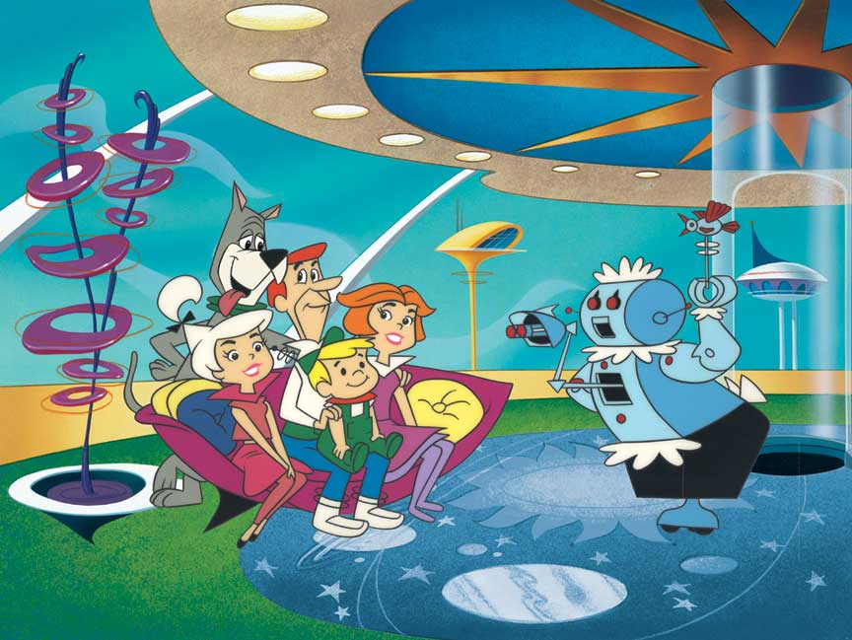
The Jetsons is an American animated series from the 60s. While the Flintstones live in a world which is a comical version of the “stone age”, with machines (1)_______________ by birds and dinosaurs, the Jetsons live in a comical version of the (2)_______________, with elaborate robotic (3)_______________, aliens, (4)_______________, and whimsical inventions. The Jetsons are a family residing in Orbit City. George Jetson lives with his family in the Skypad Apartments. His wife Jane is a homemaker, their teenage daughter Judy attends Orbit High School, and their son Elroy attends Little Dipper School. Housekeeping is seen to by a (5)_______________ maid, Rosie, which is handles the chores with the help of the diverse (6)_______________ envisioned devices. The family has a dog named Astro. George Jetson works an hour a day, two days a week. His boss is Cosmo Spacely, the (7)_______________ owner of Spacely Space Sprockets. Jetson commutes to work in an (8)_______________ with a transparent bubble top. Daily life is leisurely (9)_______________ by numerous labour-saving devices, which occasionally (10)_______________ down with humorous results.
https://en.wikipedia.org/wiki/The_Jetsons (abridged and adapted)

2. Rewrite these sentences correctly. Start as suggested. (3 x 5 = 15 points)
a. The Jetsons is a popular from the 60s series very American.
The Jetsons is _______________________________________________________________
b. Jane Jetson used to taking Judy to school, but now Judy is get used to go by aerobus.
Jane Jetson used _____________________________________________________________
c. Despite their hair colour different, Judy takes off her mother.
Despite their _________________________________________________________________

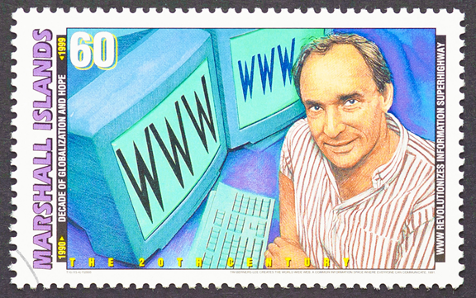
3. Name five advantages of space travel. (10 points)
ACTIVITY B

Read the following text.

Tim Berners-Lee – the Knight of the Web

The original idea for the Web was born in the early 1960s, when Tim Berners-Lee was growing up in London. His parents, both pioneers of the computer age, helped create the first commercial stored-program electronic computer. They raised their son on tales of bits and processors and the power of machines. One of his earliest memories is a conversation with his father about how computers would one day function like the human brain. As a student at Oxford in the early 1970s, Berners-Lee built his own computer using an old television and a soldering iron. He graduated with a first-class degree in physics, without any particular plans for his future. He subsequently landed a series of jobs at different companies as a programmer, but none of them lasted long. In the early 1980s, he got a consulting position at CERN (European Organization for Nuclear Research). He worked on a program to help nuclear scientists share data over another nascent system. In 1989, he came up with the idea that eventually became the Web – an open and democratic platform for all. Berners-Lee’s would be named one of the 20th century’s most important figures by Time, receive the Turing Award for achievements in the computer sciences, and be honored at the Olympics. He has been knighted by the Queen.

While Silicon Valley started ride-share apps and social-media networks without profoundly considering the consequences, Berners-Lee has spent the past three decades thinking about little else. From the beginning, Berners-Lee understood how the epic power of the Web would radically transform governments, businesses, societies. He also envisioned that his invention could, in the wrong hands, become a destroyer of worlds, so he has spent most of his life trying to guard it.

He has been working on a new platform, Solid, to reclaim the Web from corporations and return it to its democratic roots. For now, the Solid technology is still new and not ready for the masses. But the vision, if it works, could radically change the existing power dynamics of the Web. The system aims to give users a platform by which they can control access to the data and content they generate on the Web. This way, users can choose how that data gets used rather than, say, Facebook and Google doing with it as they please. Solid’s code and technology is open to all—anyone with access to the Internet can come into its chat room and start coding.

And now, as half the world joins the Web, we are at a societal inflection point: Are we headed toward a future where a handful of corporations monitor and control our lives? Or are we on the verge of creating a better version of society online, one where the free flow of ideas and information helps cure disease, expose corruption, reverse injustices?

https://www.vanityfair.com/news/2018/07/the-man-who-created-the-world-wide-web-has-some-regrets (AmE; abridged and adapted)

1. Complete the following sentences according to the text. (3 x 4 = 12 points)
a. Tim Berners-Lee’s parents were responsible for ____________________________________
b. Tim Berners-Lee has never forgotten _____________________________________________
c. Tim Berners-Lee wanted the Web to be ___________________________________________

2. Answer the following questions on the text. (3 x 6 = 18 points)
a. Why is the Web so powerful? ___________________________________________________
b. What does SOLID technology aim to? ____________________________________________
c. Are we on the verge of creating a better version of society online? _______________________
____________________________________________________________________________

3. Find in the text the words/expressions for these definitions. (5 x 2 = 10 points)
a. fictitious or true stories, especially ones that are imaginatively recounted. _________________
b. an electrical tool used for melting solder. __________________
c. after a particular thing has happened. __________________
d. imagined as a future possibility. __________________
e. a time of significant change in a situation. __________________

4. Fill in the gaps with the correct form of the future. (4 x 5 = 20 points)
a. Do you think Web users __________________ (be) protected by the new platform Solid?
b. Tim Berners-Lee lost his mobile phone, so he __________________ (buy) a new one.
c. The journalist __________________ (interview) Tim Berners-Lee tomorrow morning.
d. Don’t phone Berners-Lee tomorrow morning. He __________________ (give) an interview.

5. Rewrite the following sentences. Start as suggested. (4 x 5 = 20 points)
a. “I didn’t phone Berners-Lee yesterday.”
The journalist said she __________________________________________________________
b. “I’ve developed a platform that protects Web users.”
Tim Berners-Lee explained that ___________________________________________________
c. “Are we on the verge of creating a better version of society online?”
The journalist wondered _________________________________________________________
d. Berners-Lee didn’t profit off his invention. He didn’t become a millionaire.
If Berners-Lee had _____________________________________________________________

ACTIVITY C

Write a text (150-200 words) discussing the following topic: (80 points)
- In what ways have technological advances changed our lives?

MODULE 3 THE TECHNOLOGICAL WORLD
SPEAKING TEST 3

1.º MOMENTO
Intervenientes e tempos | Descrição das atividades
Professor  Professor e alunos  Total:  +/– 4 minutos | Hello. Could I just check your names, please?  What’s your name? [O professor dirige-se ao aluno A.]  And what’s your name? [O professor dirige-se ao aluno B.]  For about four minutes, I would like you both to answer some questions so that I can learn a bit more about you. Please answer the questions, but do not interrupt your partner.  [1. O professor usa a lista que se segue, escolhendo o número de estímulos adequados ao tempo. 2. As perguntas são colocadas seguindo uma linha vertical (entrevistando um aluno de cada vez).]
Professor  Professor e alunos  Total:  +/– 4 minutos | A  - What do you think was the best invention ever? Why?  - What can’t robots do?  - What are the advantages of mobile phones?  - Are online games bad for teenagers? Why? |  | B  - What do you think was the worst invention ever? Why?  - How can robots help humans?  - What are the disadvantages of mobile phones?  - Are online games good for teenagers? Why?
2.º MOMENTO
Professor  Cada aluno 1 minuto  Cada aluno  +/– 2 minutos  Total:  +/– 6 minutos  Professor  Cada aluno 1 minuto  Professor  Cada aluno  +/– 2 minutos  Total:  +/– 6 minutos | Right, now each of you will have to talk on your own for about two minutes.  You have one minute to prepare. You mustn’t interrupt your partner while he/she is speaking.  Here is some paper and a pen in case you want to make some brief notes.  Please do not write a text.  [O professor entrega o papel e a caneta aos dois alunos. Se o aluno A iniciou o 1.º momento, será o aluno B a iniciar o 2.º.]
 | B, you’ll be first.  [O professor entrega o material: Picture 1.] |  |  | Now it’s your turn, A.  [O professor entrega o material: Picture 2.]
Look at this picture. I’d like you to talk about it. There are some prompts to help you.
You have a minute to prepare and then I’ll ask you to start talking.
[O aluno prepara o seu discurso.]

 | Please begin now, B. | Please begin now, A.
 | [Prestação do aluno. Caso o seu discurso seja insuficiente, revele pouco conteúdo ou o aluno tenha dificuldade em começar a falar, o professor deverá ajudá-lo com as/algumas das seguintes perguntas:
 | Picture 1:  • What can you see in the picture?  • What does it represent?  • What are the benefits?  • Are there any disadvantages?  • How can it be tackled? |  |  | Picture 2:  • What can you see in the picture?  • What does it represent?  • What are the benefits?  • Are there any disadvantages?  • How can these be tackled?
[O professor pode também ajudar o aluno a expandir o seu discurso, usando, por exemplo:
• Can you give me some (more) examples/details?
• Can you tell me more about that?]
[O professor pode ainda lembrar o aluno da tarefa, dizendo, por exemplo:
• Remember you have to…]

 | Thank you, A. |  |  | Thank you, B.
3.º MOMENTO
Professor  +/– 30 segundos  Alunos  +/– 5 minutos  Total:  +/– 6 minutos | Now I’d like you to talk to each other for about three minutes while I listen.  You have to speak clearly and loud enough so that we can hear you both.  One of you thinks space travel is fascinating and beneficial and the other disagrees.  Here is a card for you.  [O professor entrega o material aos dois alunos: Card 1 e Card 2]
[Prestação dos alunos. Os alunos podem usar algum tempo para tomarem conhecimento do material de suporte.
O professor poderá ainda repetir as instruções ou dizer, por exemplo:
• “Could you start, please?”, caso nenhum dos alunos tome a iniciativa e tenham decorrido mais de 30 segundos.
• “Remember you have to…” para lembrar os alunos da tarefa, caso se verifique um grande desvio ao tema.
• “Remember you have to talk to each other.” para lembrar os alunos de que devem interagir um com o outro.]
 | Thank you both. That is the end of your test.
Total final:  +/– 16 minutos | FIM DA PROVA

PICTURE 1 |  | PICTURE 2
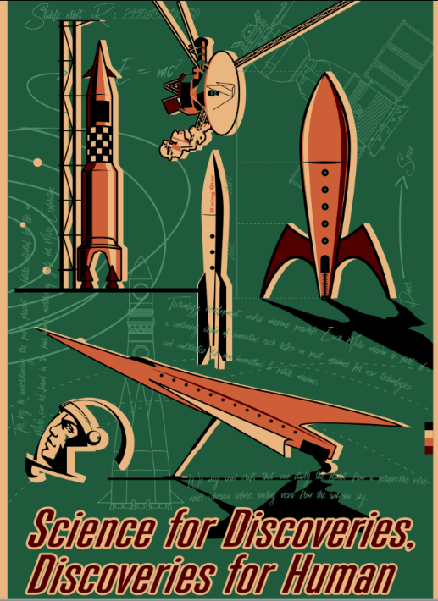  PROMPTS:  - Describe the picture  - Explain the message conveyed  - Describe your feelings/emotions towards this picture |  |   PROMPTS:  - Describe the picture  - Explain the message conveyed  - Describe your feelings/emotions towards this picture

CARD 1 |  | CARD 2
PROMPT:  You think space travel is fascinating and beneficial.  Mention:  - life-changing experience  - deeper insight about the universe  - scientific understanding  - technological advancement  - creation of jobs |  | PROMPT:  You believe space travel is risky and expensive.  Mention:  - risks, dangers and accidents  - health problems  - pollution in space  - high expenses  - less investment in food, healthcare, housing, education…

