Exam-like Test
The world of work

Casa da Aula – Centro de Explicações

English Test – Block 2: The world of work

Student: __________________________________Class: 11th ___________________ Date: ___/___/___

Your final task is to write a biography about a culturally tolerant person.
Activities A and B will provide you with input for Activity C.
_____________________________________________________________________________________________

Activity A
1 Match the expressions in column B with their corresponding functions in column A. (11 marks)

Write only the letters and numbers.

Column A | Column B
a) Agreeing  b) Disagreeing  c) Giving examples  d) Justifying a fact/ opinion | 1) This can be exemplified by the fact that…  2) Basically, I agree that…  3) I hold a different belief that…  4) The reason I state this is that…  5) I share the view that…  6) That’s why… | 7) Such as…  8) I defend the same line of  thought…  9) For instance…  10) I couldn’t disagree more…  11) To name just a few…

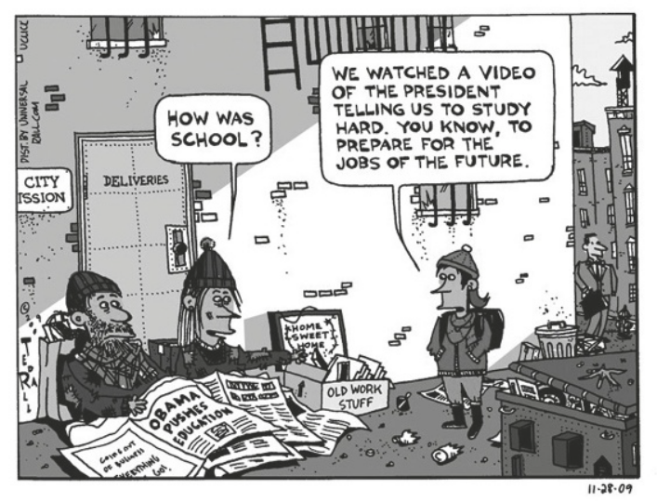
2 Look at the cartoon on the right
and explain its message, as far as
the importance of a good education
for getting a job in the future is
concerned. Write between 40-80
words. (10 marks)

3 Complete the following text about
finding a job with seven words from
the box below. (7 marks)

Use each word only once.
Write only the letters and numbers.

1. little; 2. clueless; 3. merit; 4. board; 5. exchange; 6. also; 7. only; 8. behind; 9. pay; 10. frightfully; 11. extremely
I’M LOOKING FOR a “real” job in London. No bartending. No English-speaking tour guiding or sitting at a
hostel desk in a. __________ for room and b. __________. I’d actually like someone to hire me on
c. __________ – not just because I look cute d. __________ a bar.
Not e. __________ is the London job market cutthroat right now, I’m applying for work in an
f. __________ competitive field. By competitive, I mean a bunch of g. __________ Oxford and
Cambridge graduates with no idea what they want to do with their lives are applying for the same
internships as me – a Canadian with a two-year visa that screams “I probably won’t stay here, don’t waste
your money training me!”.

4 Complete each of the sentences below with a suitable compound word formed by joining one word from column A to another from column B. Three of the words in column B do not apply. An example is provided. (12 marks)

Use each word only once.
Write only the letters and corresponding answers.

a) Last summer I got part-time job in a restaurant.
b) When you work __________ you get paid really well. Much more than your usual pay.
c) He has just been hired as the new __________. He’s going to have to work hard to run that school.
d) Mike doesn’t have a normal work schedule. You see he does __________ and it changes every
week.
e) I no longer have a boss. You see, now I am __________. I answer to myself.

Column A |  |  | Column B
school  over | self  shift | part | work  employed | ment  time | driver  master | load  time

Activity B
Read the following text.

5  10  15  20  25 | Emerging Opportunity:  Ten in-demand jobs that didn’t exist ten years ago  When my parents were in university, the Internet did not exist. Well, okay, it existed, but few  people had heard of it and almost no one accessed it at home. Nobody used email. During his  third year at university my dad had a course about the potential of the Internet. He says his  professor passionately explained how this was the medium of the future and how it would  change the way so much of the world worked.  My point is that despite the fact that my parents began studying for their Bachelor’s Degree in a  pre-Internet world, almost all of their professional jobs since have been online. The changes in  technology and culture have rapidly opened up whole new career paths that could not have  been predicted even a short time earlier.  That is why it is important for young people to keep up with the latest cultural and technological  trends as they pursue their education and first jobs. We need to be prepared for the workplace  of the future if we don’t want to face unemployment.  So what are the jobs of the future? A quick Internet search soon reveals that these are the ten  up-and-coming jobs that will continue to be in high demand in the future. Note that they didn’t  even exist a decade ago:  1. Online community manager 6. Elder-care services coordinator  2. Mobile applications developer 7. Yoga / Zumba / Pilates instructor  3. Search engine optimisation specialist 8. Big data analyst  4. Sustainability expert 9. Privacy officer  5. Web content strategist 10. User experience designer  Think of it: Just a few short years ago, Facebook and Twitter did not exist, and now people with  social media skills are amongst the most sought-after on the job market. These soft skills will  always be in demand, and having a variety of short-term or part-time jobs can be a great way to  learn them at the same time as experiencing different kinds of roles, jobs and industries in the  ever-changing world of work. That is the best way to prepare for the job market of tomorrow.  Source: http://workopolis.com

1 Identify four factors that have changed the job market over the last few years. (12 marks)

2 Find words in paragraph 1 that have the opposite meaning to the words below. (15 marks)
There is only one opposite for each.

Write only the letter of each word and its corresponding opposite.
a) unpromising b) apathetically c) maintain

3 Identify the function of “but” in line 1. (10 marks)

4 Complete the following sentences with the information given in the text: (18 marks)

a) Most of the author’s parents’ professional jobs, ____________________________________________
b) It is important for teens to keep up with __________________________________________________
c) The best way to prepare for the future workplace __________________________________________

5 Explain what the author means by “Note that they didn’t even exist a decade ago” (ll. 14-15).
(10 marks)

6 Explain why the author uses the examples of Facebook and Twitter in the text. (15 marks)

Activity C (80 marks)

Write a discursive essay on the following topic:
It is possible to prepare yourself for the job market of the future.

Write between 150 and 200 words.
You may use the input provided by Activities A and B.
Do not sign your article.
END

