Comparatives and Superlatives
of Adjectives and Adverbs Worksheet

PowerPoint – Comparatives and Superlatives

Study!

A. Look at the highlighted words in these sentences.
• I believe that tourism is the best thing for tiger conservation.
• That tiger reserve held a greater density of wild tigers than the others.

• This is by far the hardest part and the least well managed at the present time.

• Tour operators changed the passive role of tourism into a more proactive role.

• This is the most challenging project I have ever seen.

• The climate has changed; here it is as hot as in the North but it is now less humid.

1. Complete the table with the highlighted words.

Comparative form | Superlative form

2. Complete the rules with the missing information.

The word hardest is the superlative form of ; greater is the comparative form of
. The superlative of of well (and of all adjectives and adverbs) is formed by placing the least before it. The comparative form of proactive is formed with
and the superlative of challenging is formed with . The comparative
of inferiority of humid is formed by placing before it.

Adjectives/Adverbs: comparative and superlative forms
of adjectives and adverbs is formed with -er or with followed by than.
Superlatives of superiority are formed with the + or with .
The comparative of of adjectives and adverbs is formed by placing as before and after the adjective or adverb.

Practise!

B. Complete the table below with the missing words.

 | Adjective/adverb | Comparative form | Superlative form
Most one-syllable words |  | faster
Most one-syllable words | great
Two-syllable words ending in y | happy
Two-syllable words ending in y |  | easier
Two or more syllables |  | more fantastic
Two or more syllables |  |  | the most expensive
Irregular | good/well
Irregular |  |  | the worst
Irregular | far |  | the farthest/furthest

Comparatives and Superlatives of Adjectives and Adverbs

C. Complete the following sentences with suitable comparatives or superlatives formed from the words in brackets.

1. As tourists we should give ourselves chance of saving a specific habitat. (good)

2. It lends itself to independent travellers. (good)

3. The local economy is a few years ago. (developed)

4. This was done to provide guidance for ecotravel. (far)

5. You can spend as you want to. (much)
Staying to home is one affordable option. (close)

6. Ecotourism is growing three times than the tourism industry as a whole. (fast)

7. Ecotourism takes travellers on one-of-a-kind adventure to some of the world’s locales. (exotic)

8. The environment has become one of the criteria for today’s traveller. (important)

D. Study these fact files about population distribution in China, India and Russia and complete the sentences with suitable comparatives or superlatives formed from the words in brackets.
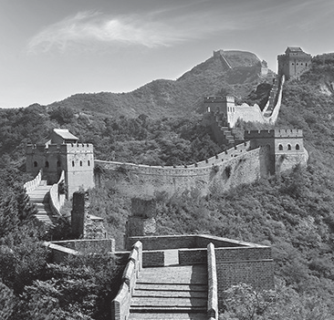



 |  |  |  | 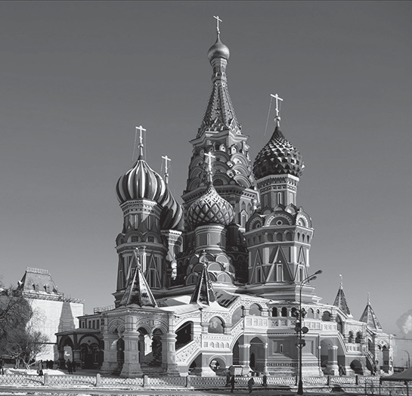
Country | China | India | Russia
Population | 1,347,350,000 | 1,210,570,000 | 143,056,000
Area | 9,706,961 km² | 3,287,590 km² | 17,098,246 km²
Population density | 134 people per square kilometre | 324 people per square kilometre | 8.4 people per square kilometre

1. Complete the sentences.

a. China has (high) number of people of the three countries.

b. The second (populous) country is India.

c. The (populous) of the three is Russia.

d. China’s population density is (great) that of Russia but (small) that of India.

e. Russia has (low) population density of the three countries.

f. Russia is (large) country by area.

2. Use information from the fact files to build four sentences using comparatives or superlatives of adjectives or adverbs.



Go online and practise comparatives and superlatives @ http://learnenglish.britishcouncil.org/en/english-grammar/adjectives/comparative- and-superlative-adjectives, http://learnenglish.britishcouncil.org/en/english-grammar/adverbials/comparative-adverbs and http://learnenglish.britishcouncil.org/en/english-grammar/adverbials/superlative-adverbs

