Xplore · 11.º ano · Extra Texts

3. Work – Text 1

How Companies Learn Your Secrets: The Power and Pitfalls of Analytics

One of the most popular stories in last week’s New York Times was provocatively entitled – how companies learn your secrets. Drawing on material for a new book by author and journalist, Charles Duhigg, the article explores behavioural science and analytics in retailing. The highlight of the article is the story of a father who comes to a Target store complaining that Target is sending his high-school daughter vouchers for discounts on
5 baby products. ‘Why are you sending my daughter these vouchers’, he screams. ‘Are you trying to encourage her to get pregnant’? A few days later the father calls the store manager to apologise – it turns out his teenage daughter is pregnant after all, she just hadn’t got round to telling her father yet!
How did Target get to know that the girl was pregnant before she’d even told her dad? Simple, through customer analytics – by looking at people’s shopping habits Target and many other retailers can make intimate
10 predictions about people’s lives. Start buying lots of meals for one and the retailers will assume a relationship breakup. Stop buying eggs and the store might assume you’ve got your own chickens! Pregnancy is particularly important because it is such a major life change that it brings many other opportunities for the store. Most of us are creatures of habit. We buy the same toothpaste, soap and deodorant year after year – simply through habit. Research suggests that pregnancy is one of the best times to break old habits and form new ones. Target’s
15 research suggests that an increase in sales of unscented lotions and vitamins is linked to pregnancy. Couple these two facts and the implications are profound. Target can predict who is and who is not pregnant, send those who are likely to be pregnant coupons and vouchers to use and try – in the process – to create new shopping habits for individual customers.
This brave new world, where big brother is watching, offers opportunities, but there are also significant
20 risks for the organisations involved. Privacy concerns and reputational damage can be significant. Just look at the comments on the New York Times article – there are a lot people who are worried about the power of analytics and the potential for abuse of the data. Clearly organisations can see the benefits of analytics, but they also have to weight up the risks and put in place some very carefully considered governance mechanisms to avoid headlines like “how companies learn your secrets”.

Source: http://cambridgeservicealliance.blogspot.pt

Text 2 – Cartoons
(Consumerism, Work, Multiculturalism)


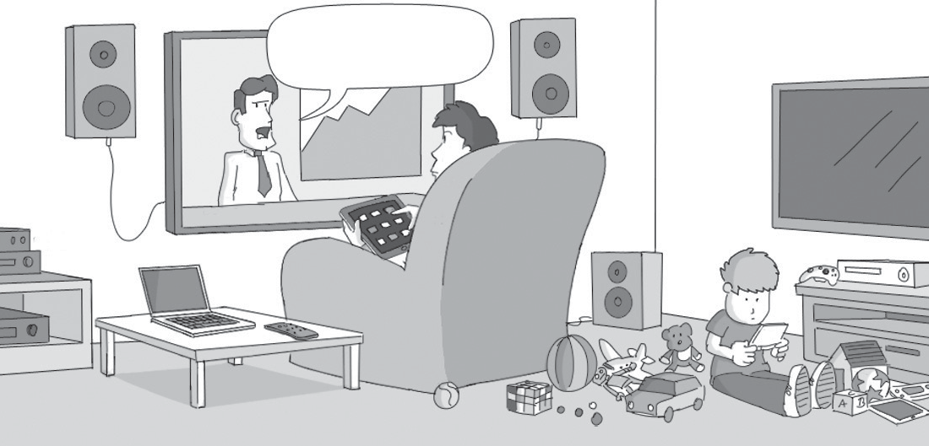

What we need at
this stage is to increase
our consumption.

GROWTH























































Extra Texts

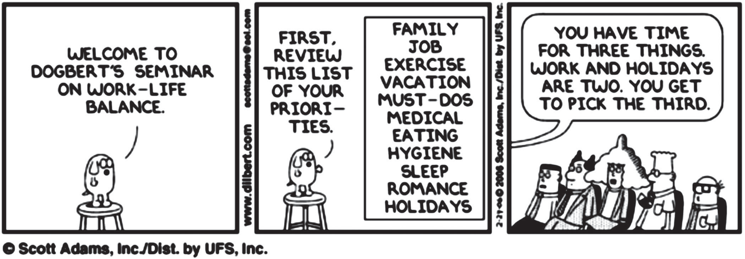

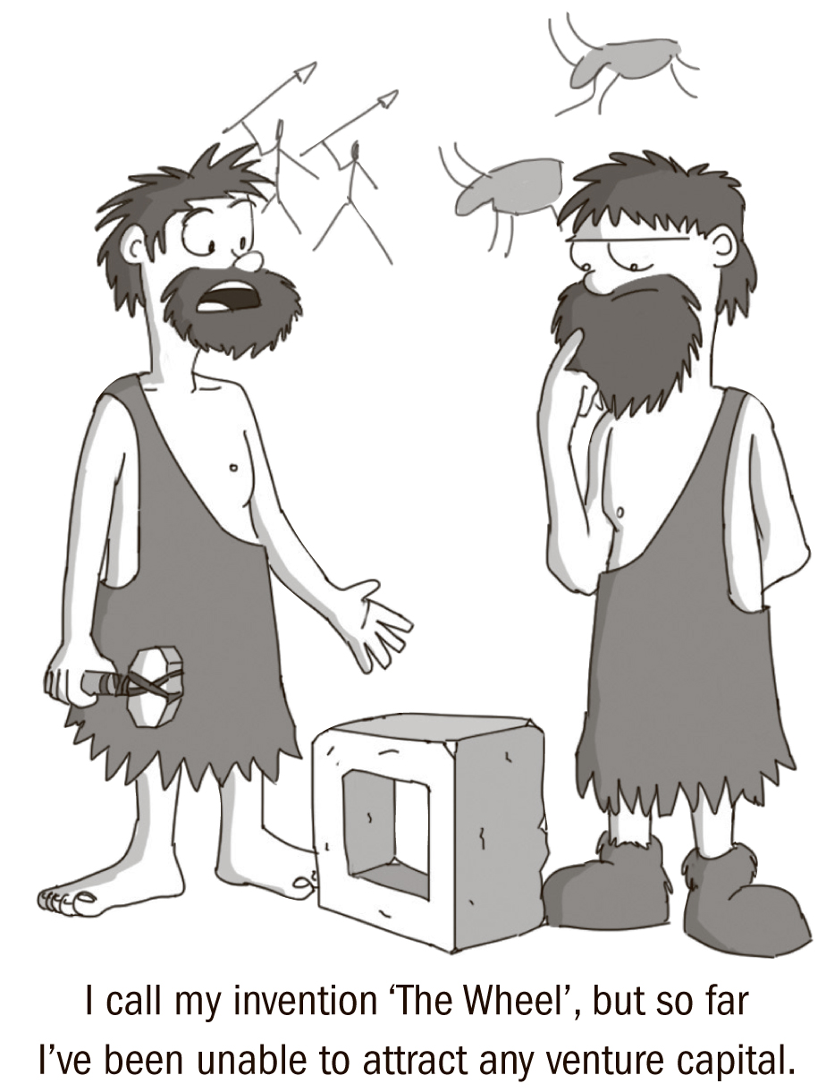


I call my invention ‘The Wheel’, but so far
I’ve been unable to attract any venture capital.

