Xplore · 11.º ano · Extra Texts

Text 2 – ADS


Support Your Local


Organization.

Local Action. Global Reaction.

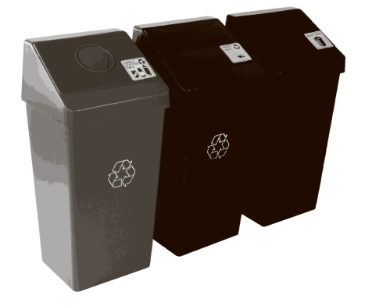
Sort it out.

Support Recycling


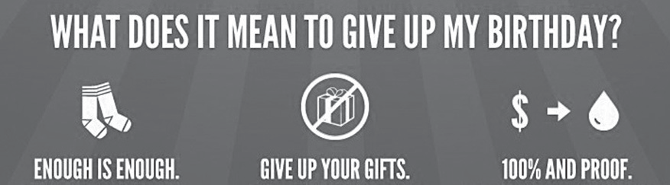

Green Hands USA

Text 3 – Cartoons
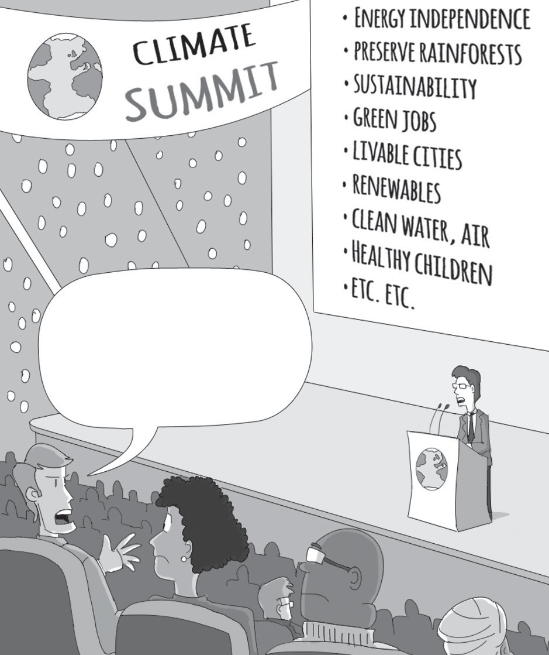

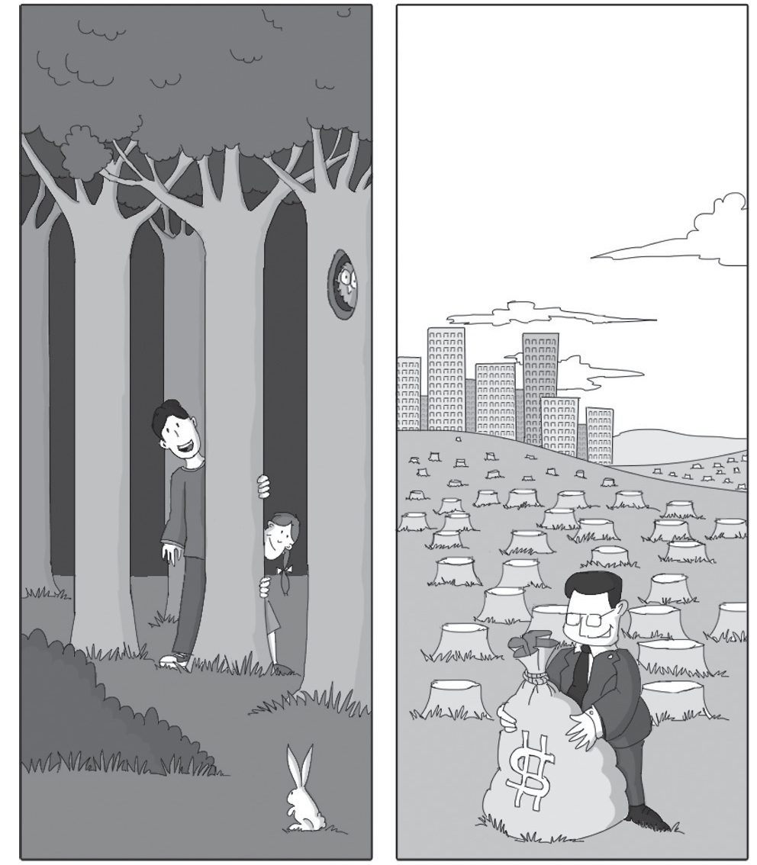

What if it’s a big hoax and we create a better world for nothing?

Extra Texts


No plastic bags, please. I don’t want to contribute to Global Warming!


VEGAN
ditora

Compassion Nonviolence For the people For the planet For the animals

2. Consumerism – Text 1
X

© P
or
to
E
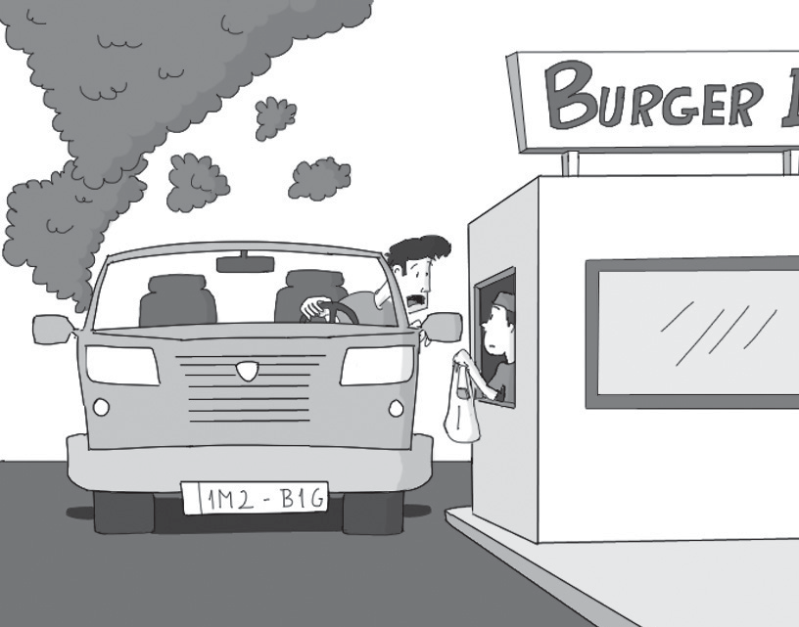




TEEN CONSUMER






Buying Goods & Services

Telemarketing
Scams

You just sat down to eat dinner and the phone starts ringing. You suspect it is a telemarketer. Although telemarketers can often be annoying, there is usually nothing illegal about what they are doing. Once in a while, however, a caller’s objective may be a little more sinister than just trying to get you to buy light bulbs. Here are some of the most common telemarketing scams.
5 Sweepstakes
‘I just wanted you to know that you’ve won a FREE Caribbean cruise,’ they say. ‘All you have to do is
send $20 so we can confirm your prize.’ Any contest in which you must pay money to win a prize is a lottery. With the exception of state-run contests, lotteries are prohibited by federal law.
If the caller asks for your credit card number, be aware that you may never see the prize and may end up
10 with bogus charges on your credit card.
To be legal, anyone promoting a contest must specify, “No purchase is necessary to win.”
Charitable contributions
Although there are some legitimate organizations that solicit funds over the telephone, some that ask for money may be fraudulent. Always make sure that you ask for more information. Scam artists will ask for (or
15 demand) a donation NOW and will refuse to send written information concerning the charity. Many of these groups will try to trick you by using a name that sounds like the name of a legitimate organization.
Protecting yourself
You can protect yourself from telemarketing scams by following a few simple rules:
• Always ask for written information.
20 • Never give out credit card numbers or other personal information unless you know exactly what you are doing.
• Ask yourself, ‘Is everything legal here?’ If the caller is breaking any law, no matter how trivial it may seem (such as calling before 8:00 AM or after 9:00 PM), beware. He or she may be breaking other laws as well.
25 • If you are uncomfortable or are annoyed by a caller, ask to be put on the “do not call” list. Once you
request this, the company cannot call you again.

Source: http://www.atg.wa.gov/teenconsumer

