Linkers (2) & Verb Tenses Worksheet

PowerPoint – Linkers & Verb Tenses

Study!
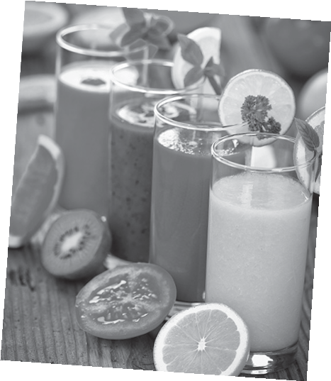

A. Look at this text that tells Maggie’s story.
To begin with, I had just seen a documentary about healthy vegetarian diets when I got a veggie recipe book for my birthday. My friends and I decided
to organise a vegetarian birthday party.
First, we all went to the supermarket and focused on buying organic ingredients. Then we came home and cooked several vegetarian dishes. While we were enjoying our meal, we felt wonderful and at ease with our conscience.

1. Identify the verb tenses by writing the verbs above under the correct heading.

We use the Past tenses to describe actions and states in the past.

Past Simple | Past Continuous | Past Perfect

2. Identify the words that help to organise the sequence of events.

Practise!

B. Fill in the blanks with the correct form of the verb in brackets and the suitable linking word from the boxes below.

then | In June 2009 | immediately | at that time | Shortly after | In short | soon after

How I became “The Vegan Mom”
Have you ever had a moment, where everything you 1. (think) you 2. (believe)
about something, was changed in an instant? I did, and that is how I 3. (become) a vegan.
I have always had a strong love for animals! Dogs, cats, sheep, hamsters… I pretty much adore them all.
As a child I 4. (have) a stronger bond with my cat than I did with my sister! I 5. (stop) eating red meat and pork for a few years in my early teens, but 6. I 7. (go back) to my meat eating ways soon enough. 8. , I 9. (see) a program based on the book “The China Study”. I 10. (learn) about the damaging effects meat and animal protein has on our bodies. It was 11. , that I also thought to myself… why 12. (I/eat) animals anyway? I mean… why? I get all of the nutrients and protein I need from plants, and when was the last time
a doctor told a patient to eat more meat? 13. my kids and I 14. (become)
vegetarians and 15. vegan. I 16. (stop) buying any animal products, and
17. (begin) to cook vegan meals daily. 18. becoming vegan, I 19. (start) this blog so I can offer support to other parents in similar shoes. 20. I love that our life is cruelty free and we are helping our health and environment, while enjoying fabulous food! And by the way, the food is DELICIOUS!!
Adapted from: http://theveganmom.com



Go online and practise the Past tenses @ http://www.englishpage.com/verbpage/verbs12.htm and http://www.tolearnenglish.com/exercises/
exercise-english-2/exercise-english-23351.php

