Progressive Tenses Worksheet

PowerPoint – Progressive Tenses

Study!

A. Look at these sentences:
a. UNICEF will be continuing several educational programmes around the world.

b. Thousands of young activists around the world are working towards a fairer society.

c. Many students have been taking school for granted.

B. Which of these meanings do the sentences above express?
1. an action that started in the past and has continued.

2. an action happening around now.

3. an action happening at a certain moment in the future.

C. Identify the tenses used in the sentences above.

Present Continuous | Present Perfect Continuous | Future Continuous
[am /are / is] + [-ing form] | [has /have] + [been] + [-ing form] | [will] + [be] + [-ing form]

Practise!


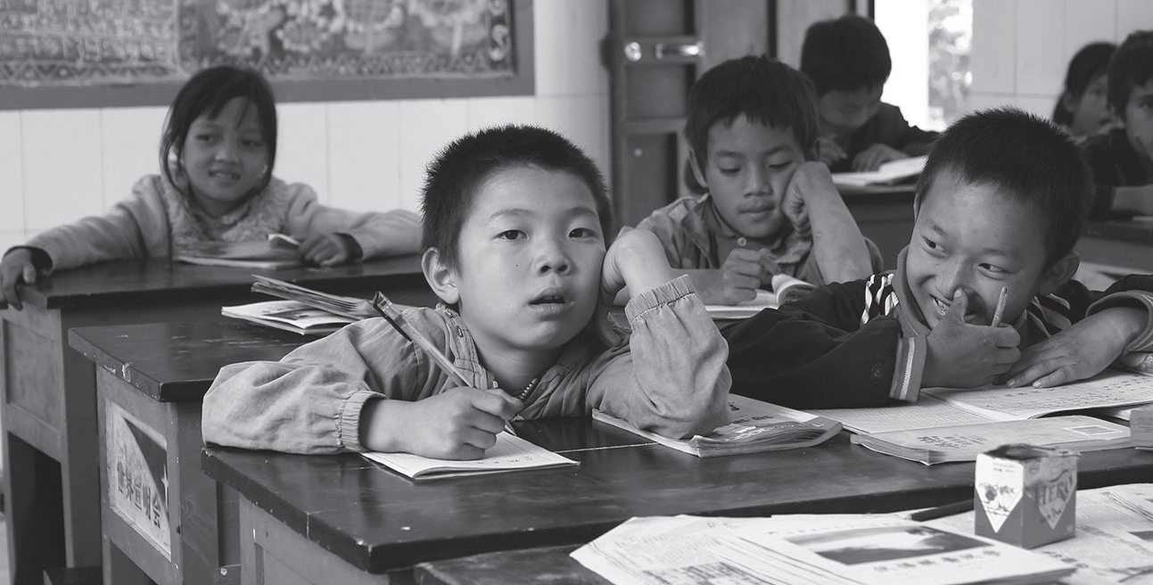

D. Put each verb in brackets into the correct progressive tense.
1. Some governments (not/work) enough to fulfil the UN Millennium goal.

2. Activists (currently/support) many organisations to ensure education for all children.

3. The United Nations (work) towards a fair and safer world since 1945.

4. The UN wants to ensure that education (reach) all children in the near future.

5. UNICEF (start) a new campaign in Africa very soon. This UN organisation
(protect) children’s basic human rights for decades.

6. Thanks to the media, people (become) more aware of the need for education.

E. Write sentences using the progressive tense in brackets.
1. millions of children / not attend /school / in many parts of the world. (Present Continuous)

2. you / read / the latest news / about UNICEF’s programmes? (Present Perfect Continuous)

3. UNICEF / offer / its support / to non-governmental organisations? (Future Continuous)

4. some governments / not follow / the UN directives on education. (Present Perfect Continuous)



Go online and practise the progressive tenses @ http://www.englishpage.com/verbpage/verbtenseintro.html and http://www.englisch-hilfen.de/
en/exercises_list/zeitformen.htm

