MODULE 1 TEENS & CONSUMERISM
LISTENING TEST 1

INFORMAÇÃO – TESTE DE COMPREENSÃO ORAL 1

A estrutura do teste sintetiza-se no quadro seguinte:

Ativ. | Componentes | Competências | Tipologia de Itens | Número  de Itens | Cotação  (em pontos)
A | Léxico-semântica:  Teens and Consumerism  Advertising | Competência linguística:  - competência lexical  - competência gramatical  - competência semântica  Competência pragmática:  - competência funcional  - competência discursiva | ITENS DE SELEÇÃO  - completamento  - identificação  - identificação de erros / correção  - completamento | 2 | 100 pontos
B | Léxico-semântica:  Teens and Consumerism  Advertising | Competência linguística:  - competência lexical  - competência gramatical  - competência semântica  Competência pragmática:  - competência discursiva  - competência funcional/ estratégica |  | 2 | 100 pontos
TOTAL |  |  |  |  |  | 200 pontos

MODULE 1 TEENS & CONSUMERISM
Name __________________________________________ No. ___________ Class __________
Date _____/_____/_____ Mark ____________ Teacher _________________________________

LISTENING TEST 1

Exercises 1 and 2
First, you will hear a song.
Then, you will hear the first part of an article on how celebrities influence modern culture.

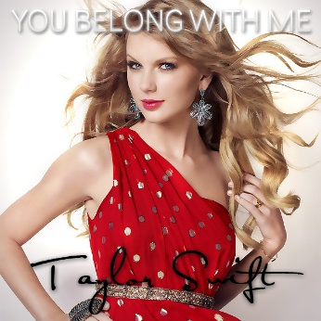
ACTIVITY A

1. Complete the lyrics according to what you hear. (5 x 10 = 50 points)
You're (1)…………………………………………………………….., she's upset
She's going off about something that you said
'Cause she doesn't get your humor like I do
I'm in my room, it's a typical Tuesday night
I'm listening (2)…………………………………………………………….. she doesn't like
And she'll never know your story like I do
But she (3)……………………………………………………………..
She's cheer captain and I'm on the bleachers
Dreaming 'bout the day when you wake up and find
That (4)…………………………………………………………….. has been here the whole time
If you could see that I'm the one who understands you
Been here all along, so (5)……………………………………………………………..?
You belong with me
You belong with me
Taylor Swift, “You belong with me” (shortened)
https://www.youtube.com/watch?v=VuNIsY6JdUw

2. Tick what the author of the article actually says. (5 x 10 = 50 points)
a. Celebrities help shape and define public opinion and consumer trends. ______
b. Celebrities are all very talented artists and stars whose success is immediate. ______
c. As famous people easily attract consumer interest, companies use them to promote their brands and products. ______
d. Both younger and older consumers are influenced by famous people when it comes to the way brands are perceived. ______
e. Taylor Swift is frequently called to participate in advertising campaigns. ______

Exercises 3 and 4
You will hear the second part of the article on how celebrities influence modern culture.

ACTIVITY B
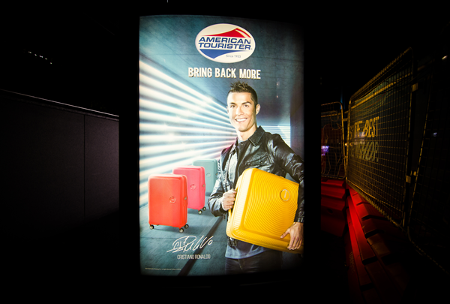
3. Correct the wrong word/expression in each sentence. (5 x 10 = 50 points)
a. It is easy to quantify the level of celebrity influence.
…………………………………………………………………………………………………………………
b. In Germany, the percentage of advertisements featuring celebrities is around 60%.
…………………………………………………………………………………………………………………
c. The celebrity culture has come to play a major part in Africa.
…………………………………………………………………………………………………………………
d. The phenomenon is newer in China and Italy.
…………………………………………………………………………………………………………………
e. Military heroes symbolise knowledge, trust and aspiration in China.
…………………………………………………………………………………………………………………

4. Listen again and complete the sentences. (5 x 10 = 50 points)
a. It is estimated that one …………………………………….….………… features celebrities in the US.
b. The percentage of advertisements featuring celebrities is much ………………..…………………….
c. In Japan its is estimated that about 70% of advertisements now …………………..………………….
d. In South Korea, entertainment companies work hand-in-hand …………………….………………… in a unique way.
e. South Korean stars are trained not only to ……………………………………, but also to promote products and brands.

MODULE 1 TEENS & CONSUMERISM
TEST 1

INFORMAÇÃO – TESTE 1

A estrutura do teste sintetiza-se no quadro seguinte:

Ativ. | Componentes | Competências | Tipologia de Itens | Número  de Itens | Cotação  (em pontos)
A | Léxico-semântica:  Teens and Consumerism  Advertising  Morfossintática:  Verb tenses  Order of attribute adjectives  Relative clauses  Contrast | Competência linguística  • competência lexical  • competência gramatical  • competência semântica  • competência ortográfica  Competência pragmática  • competência functional  Competência sociolinguística | ITENS DE SELEÇÃO  • completamento  • transformação  • associação /correspondência  ITENS DE CONSTRUÇÃO  • resposta curta  • resposta restrita | 3 | 40 pontos
B |  | Competência linguística  • competência lexical  • competência gramatical  • competência semântica  • competência ortográfica  Competência pragmática  • competência discursiva  • competência funcional/estratégica  Competência sociolinguística |  | 5 | 80 pontos
C |  | Competência linguística  • competência lexical  • competência gramatical  • competência semântica  • competência ortográfica  Competência pragmática  • competência discursiva  • competência funcional/estratégica | ITENS DE CONSTRUÇÃO  • resposta extensa | 1 | 80 pontos
TOTAL |  |  |  |  |  | 200 pontos

MODULE 1 TEENS & CONSUMERISM
Name __________________________________________ No. ___________ Class __________
Date _____/_____/_____ Mark ____________ Teacher _________________________________

TEST 1

The final task you are expected to complete is
to write a text discussing how celebrities influence teenagers and their consumer habits.
Activities A and B will provide you with input for Activity C.

ACTIVITY A

1. Farfetch is a fashion-related company and was founded by a Portuguese entrepreneur. Complete the text about this company using ten words from the box. (10 x 2 = 20 points)
brands marketplace citizenship experience fashion boutiques
cities shop individuality world consumers designers

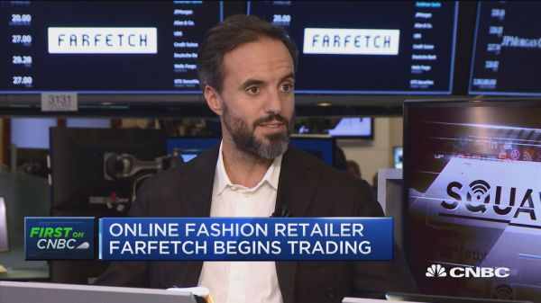
Farfetch was born out of a deep love of a)……………….…………… and a profound belief that fashion is an essential expression of b)……………….…………… and uniqueness. Our mission is to be the global technology platform, the digital c)……………….……………, for luxury fashion, connecting creators, curators and d)………………………………. Lovers of fashion anywhere in the world can e)…………………….……… for an unrivalled range of incredible products from the world’s best brands and f)……………….……………. Over 3,200 different g)…………………….……… are available on our marketplace, ranging from heritage brands to emerging h)…………………….………. Our consumers can shop across categories including Womenswear, Menswear, Kidswear, Vintage, Fine Watches and Fine Jewelry, and we ship to 190 countries around the i)…………………………………. We offer localized websites in 12 local languages, multilingual customer support and great delivery options including same-day delivery in 18 major global cities. We offer a range of services for consumers to make shopping on Farfetch a great j)…………………….……….
https://aboutfarfetch.com/about/farfetch/ (abridged and adapted)

2. There are 5 mistakes in each sentence. Correct these sentences by making the necessary changes. (2 x 5 = 10 points)
a. Many shoppers whom are money-rich but time-poor has been increasingly looked to buy from online companies fashion rather than boutiques traditional.
b. Farfetch has came a long way since it was founded. It was created by José Neves, which was the owner of a shop shoe in Portugal. It has been a highly business successful, who is great news for José Neves.

3. Name five advantages of shopping online. (10 points)

ACTIVITY B

Read the following text.

TEEN CLIQUE STYLE TRIBES REVEALED

Teenagers have come a long way in almost every way since the ‘80s and ‘90s. With more access to information than ever, teen clique style is no longer mandated by what teenagers see at school or on TV. Generation Z has grown up on technology like no other before it.
The constant access to information has gradually changed teen style and teen cliques:
Fashion jocks: Loyalty to particular brands and workout wear with visible logos are still desirable for the athlete. However, focus has shifted to form over function, at least when it comes to streetwear. Sneaker worship is a big part of the new jock’s fashion consciousness, whether the wearer is a fan of Stan Smiths or Nike Air Force 1s.
Cybergoths: Trends may come and go, but Goth teen style tribes, in some manifestation, seem to be forever. Today’s cybergoths are still wearing a lot of all black everything and have similar moody tendencies, but unlike ‘80s goths, today’s goths are very aware of contemporary fashion. These teenagers’ philosophy is all about nonconformity.
Modern mean girls: Mean girls’ style has become synonymous with the popular girl teen fashion tribe, even if these girls aren’t actually mean. Teen popularity has often been tied to ownership of the newest and most desired brands, but in today’s fashion reality, great brands are just part of creating that perfect, Instagram-worthy look. Members of this teen fashion tribe learned how to apply makeup from watching hours of YouTube videos.
GoPro girls: On the opposite end of the Instagram model spectrum are the “good vibes only” girls, whose teen style is reminiscent of the classic California girl but with more catch phrases printed on their tops. Armed with GoPro cameras, these girl squads are off taking adventures and recording all of them for their followers to see. Not that they care all that much about how many followers they have. Unlike the contour club, makeup is minimal and just enhances their glowing skin and wavy hair.
The young feminists: This teen clique is more focused on their girlfriends and important social issues than attention from boys. Their style is still very feminine, but with an edge. These girls are as interested in fashion as they are in social consciousness and consumerism-related issues.
Teenagers now are in tune with culture in a way they never were before. Teen fashion tribes are plugged into a never-ending wealth of references in the form of articles, videos and social media, and are all about taking trends and making them their own. Teen clique style is evolving faster than ever, making us wonder what the next wave of young designers from Generation Z will have in store.
https://www.farfetch.com/style-guide/trends-subcultures/teen-clique-style-tribes-revealed-which-cliche-do-you-belong-to/
(abridged and adapted)

1. Complete the following sentences according to the text. (3 x 6 = 18 points)
a. Teen style is no longer determined ……………………………………………………….....….…..……
b. Teen style has changed due to teenagers’ ….………………...…….….………..............……………..
c. Teen fashion tribes find their inspiration in ……………………………...…….….………..…………….

2. Match the halves of these sentences according to the text. (5 x 3 = 15 points)
a. Fashion jocks like particular brands ______  b. Cybergoths, unlike ‘80s goths, ______  c. Modern mean girls appreciate great brands ______  d. GoPro girls’ good vibes can be perceived ______  e. The young feminists are interested in fashion ______ |  | 1. are very aware of contemporary fashion.  2. as well as in social issues.  3. and workout wear, namely sneakers.  4. in the adventures they share with their followers.  5. as well as the right makeup, so that they can have the perfect look.

3. Find in the text synonyms for these words/ expressions. (6 x 3 = 18 points)
a. determined ……………….……………  b. small groups ……………….……………  c. has changed ……………….…………… | d. awareness ……………….……………  e. actually ……………….……………  f. interested in ……………….……………
4. Do you feel you fit in any of these cliques? Why / Why not? (20 points)

5. Rewrite the following sentences, using the word / expression in brackets. Do not change the meaning of the sentences. (9 points)
a. She is quite old, but she loves shopping online. (Even though) ………………………………………
b. He is very rich. However, he isn’t a big spender. (Despite) …………………………………………….

ACTIVITY C

Write a text on the following topic: “Are teenagers and their consumer habits influenced by celebrities and their lifestyles?”. Write about 150-200 words. (80 points)

MODULE 1 TEENS & CONSUMERISM
SPEAKING TEST 1

1.º MOMENTO
Intervenientes e tempos | Descrição das atividades
Professor  Professor e alunos  Total:  +/– 4 minutos | Hello. Could I just check your names, please?  What’s your name? [O professor dirige-se ao aluno A.]  And what’s your name? [O professor dirige-se ao aluno B.]  For about four minutes, I would like you both to answer some questions so that I can learn a bit more about you. Please answer the questions, but do not interrupt your partner.  [1. O professor usa a lista que se segue, escolhendo o número de estímulos adequados ao tempo. 2. As perguntas são colocadas seguindo uma linha vertical (entrevistando um aluno de cada vez).]
Professor  Professor e alunos  Total:  +/– 4 minutos | A  • Do you like shopping?  • What do you spend your money on?  • Do you think it’s a good idea to buy what you need during sales or at outlets?  • Do you buy things on the Internet?  • Do you think people are obsessed with shopping? |  | B  • And what about you? Do you like shopping?  • Are you a shopaholic or a smart consumer?  • Do you think celebrities influence teen fashion style?  • Do you think brands are important? Why?  • Do you think social media promote consumerism?
2.º MOMENTO
Professor  Cada aluno  +/– 3 minutos  Total:  +/– 6 minutos  Professor  Cada aluno 1 minuto  Professor  Cada aluno  +/– 2 minutos  Total:  +/– 6 minutos | Right, now each of you will have to talk on your own for about two minutes.  You have one minute to prepare. You mustn’t interrupt your partner while he/she is speaking.  Here is some paper and a pen in case you want to make some brief notes.  Please do not write a text.  [O professor entrega o papel e a caneta aos dois alunos. Se o aluno A iniciou o 1.º momento, será o aluno B a iniciar o 2.º.]
 | B, you’ll be first.  [O professor entrega o material: Picture 1.] |  |  | Now it’s your turn, A.  [O professor entrega o material: Picture 2.]
Look at this picture. I’d like you to talk about it. There are some prompts to help you.
You have a minute to prepare and then I’ll ask you to start talking.
[O aluno prepara o seu discurso.]

 | Please begin now, B. | Please begin now, A.
 | [Prestação do aluno. Caso o seu discurso seja insuficiente, revele pouco conteúdo ou o aluno tenha dificuldade em começar a falar, o professor deverá ajudá-lo com as/algumas das seguintes perguntas:
 | Picture 1:  • What can you see in the picture?  • What does it represent?  • What are the consequences?  • What do you think about that problem?  • How can it be tackled? |  |  | Picture 2:  • What can you see in the picture?  • What does it represent?  • What are the benefits?  • Are there any disadvantages?  • How can these be tackled?
[O professor pode também ajudar o aluno a expandir o seu discurso, usando, por exemplo:
• Can you give me some (more) examples/details?
• Can you tell me more about that?]
[O professor pode ainda lembrar o aluno da tarefa, dizendo, por exemplo:
• Remember you have to…]

 | Thank you, A. |  |  | Thank you, B.
3.º MOMENTO
Professor  +/– 30 segundos  +  Alunos  +/– 5 minutos  Total:  +/– 6 minutos | Now I’d like you to talk to each other for about three minutes while I listen.  You have to speak clearly and loud enough so that we can hear you both.  One of you thinks brands are important and the other is not a brand name person.  Here is a card for you.  [O professor entrega o material aos dois alunos: Card 1 e Card 2]
[Prestação dos alunos. Os alunos podem usar algum tempo para tomarem conhecimento do material de suporte.
O professor poderá ainda repetir as instruções ou dizer, por exemplo:
• “Could you start, please?”, caso nenhum dos alunos tome a iniciativa e tenham decorrido mais de 30 segundos.
• “Remember you have to…” para lembrar os alunos da tarefa, caso se verifique um grande desvio ao tema.
• “Remember you have to talk to each other.” para lembrar os alunos de que devem interagir um com o outro.]
 | Thank you both. That is the end of your test.
Total final:  +/– 16 minutos | FIM DA PROVA

PICTURE 1 |  | PICTURE 2
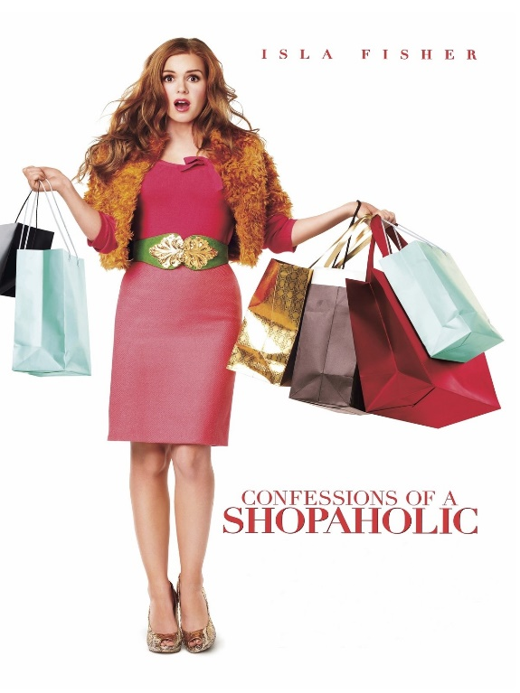  PROMPTS:  - Describe the picture  - Explain the message conveyed  - Describe your feelings/emotions towards this picture |  |   PROMPTS:  - Describe the picture  - Explain the message conveyed  - Describe your feelings/emotions towards this picture

CARD 1 |  | CARD 2
PROMPT:  You think brands are important.  Mention:  - expression of personality and uniqueness  - more fashionable items  - designer-label goods raise our self-esteem  - friends’ acceptance and respect |  | PROMPT:  You are not a brand name person.  Mention:  - importance of your own “brand-free” style  - “no-brand name” items are cheaper  - appearance is excessively valued  - people are too concerned about their looks

