Unit 2 Numbers and Dates
Listening Skills
Name: Date: - - Score:
Enc. Educação: Teacher:

1. Listen and tick ✔.
5 × 10 = 50
Example
What’s his name?
a) Mark b) ✔ Mike c) Nick

1) How old is he?
a) 10 b) 11 c) 12

2) How old is Jessica?
a) 24 b) 42 c) 34

3) What day is it today?
a) Tuesday b) Thursday c) Saturday

4) What’s his favourite day of the week?
a) Friday b) Sunday c) Monday

5) When’s his birthday?
a) October b) June c) August
EASP3TF © Porto Editora

2. Listen and circle.
5 × 10 = 50


EASP3TF © Porto Editora
Unit 2 Numbers and Dates
Reading Skills
Name: Date: - - Score:
Enc. Educação: Teacher:

1. Read and write the number.
20 × 1 = 20

zero | 0
fifteen
eleven
twenty
four
eight

five
one
nine
seventeen
thirteen

three
ten
nineteen
twelve
six

seven
two
eighteen
sixteen
fourteen

3 × 10 = 30
2. Look and circle.

It’s June / May. 1) It’s Sunday / Monday today.

2) Anna is seventeen / sixteen. 3) It’s Thursday / Friday.
EASP3TF © Porto Editora

5 × 4 = 20
3. Look at the picture. Read and write YES or NO.

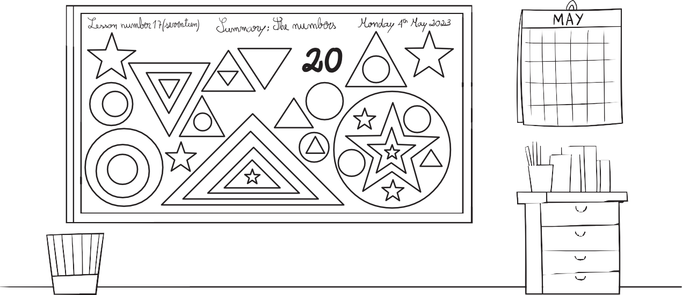

I can see ten circles. | No .
1) It’s May.
2) It’s Tuesday.
3) I can see eleven stars.
4) Number twenty is black.
5) I can see five triangles.

4. Match the questions with the answers. Write the letters.
5 × 6 = 30

How many stars can you see? A. It’s Monday.

1) How old are you? B. She is ten.

2) How old is Peter? C. It’s in September.

3) How old is Mary? D. I’m nine years old.

4) What day is it today? E. I can see three.
EASP3TF © Porto Editora

5) When’s your birthday? F. He is thirteen.

Unit 2 Numbers and Dates
Writing Skills
Name: Date: - - Score:
Enc. Educação: Teacher:

1. Put the letters in order and write.
5 × 3 = 15
15 | I E N T E F F
13 | H E N R E I T T
40 | F Y T R O
21 | W T N Y E T – N E O
50 | I Y T F F
30 | H T R Y T I

fifteen

2. Complete the tables

6 × 5 = 30

December | Friday | Thursday | Monday
January | March | October | Tuesday

Days of the week Months

Monday October

EASP3TF © Porto Editora


3. Look and write.
5 × 5 = 25

stars / can / five / I / see /. I can see five stars .

1) years / old / nine / I’m /.

2) is / old / eight / Paul / years /.

3) Monday / Today / it’s /.

4) in / My / is / June/ birthday /.

5) of / Friday/ favourite / day / the week / My / is /.












4. Complete the invitation with one of the words fro the box.
EASP3TF © Porto Editora
Sunday
August
birthday
3 × 10 = 30
It's 1)
Please come to my
2) party on 3)

Unit 2 Numbers and Dates
Speaking Skills
Name: Date: - - Score:
Enc. Educação: Teacher:

1. Look at the picture and answer.
5 × 10 = 50

1) Point to a number: What number is this?
2) Point to the calendar: What day is it today?
3) Point to the calendar: Is it October?
4) How old is Jack?
5) How old is Annie?
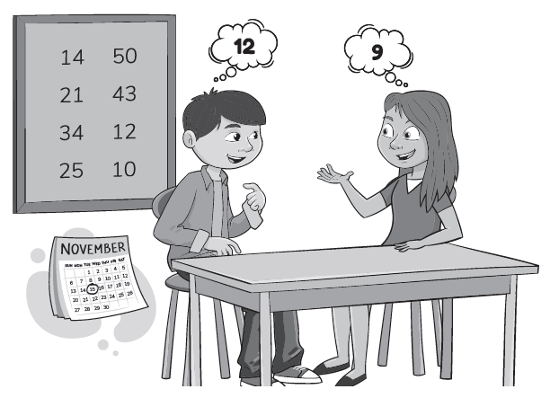

2. Answer the questions about you .
5 × 10 = 50
1) What’s your name?

2) How old are you?

3) What day is it today?

4) What’s your favourite day of the week?
EASP3TF © Porto Editora

5) When’s your birthday?




