
Nome:____________________________________________
Data______________________________________________
Estudo do Meio – 4º ano
- Indica duas provas da esfericidade da Terra.
_______________________________________________________________________________________________________________________________________________________________________________________________________________________________________

- Qual a diferença entre o planisfério e o globo?
_______________________________________________________________________________________________________________________________________________________________________________________________________________________________________

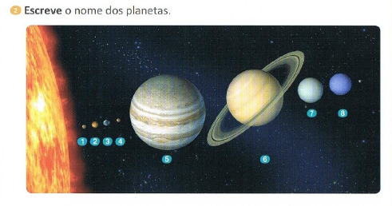
1_______________________ 2_________________ 3 _______________________
4_______________________5______________________6_______________________
7_______________________8______________________

- Como se chama o satélite natural da Terra?
_______________________________________________________________________
- Quais são as fases da Lua?
______________________________________________________________________________________________________________________________________________
- Completa o esquema seguinte usando as palavras corretas.




