SPEAKING TASK 1
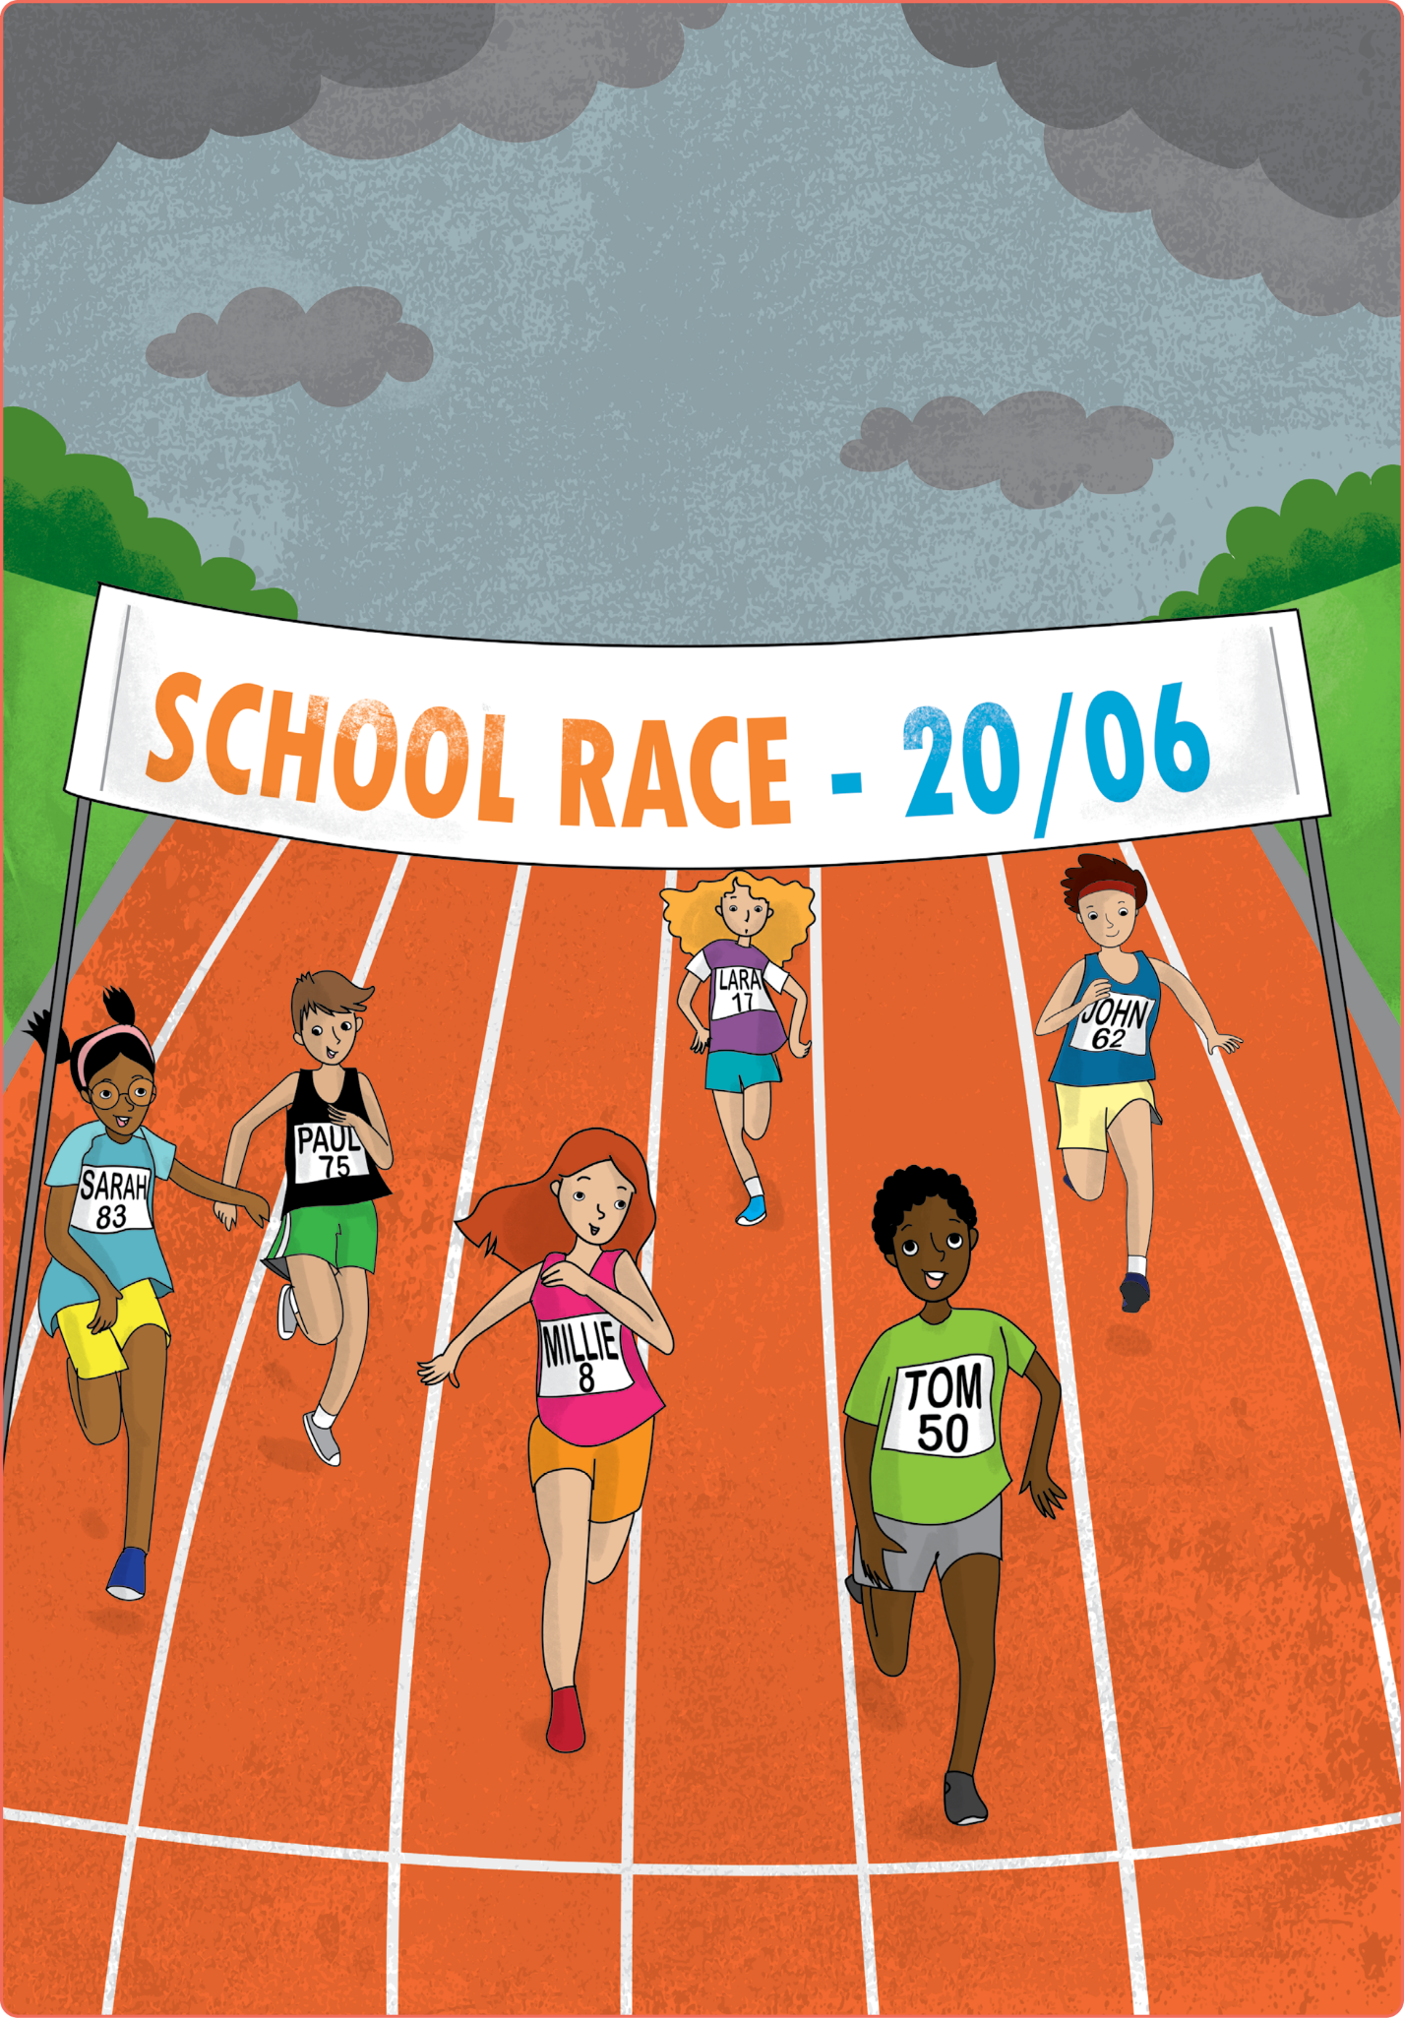

Teacher’s instructions

 Ask questions about the student(s).
- What’s your name?
- What’s your surname?
- Where are you from?
- How old are you?
- When’s your birthday?

 Familiarise the student(s) with the picture and ask them the following questions:
- When’s the race?
- What’s the weather like?
- Who’s first in the race?
- What number is Sarah?
- Who’s fifth in the race?

SPEAKING TASK 2
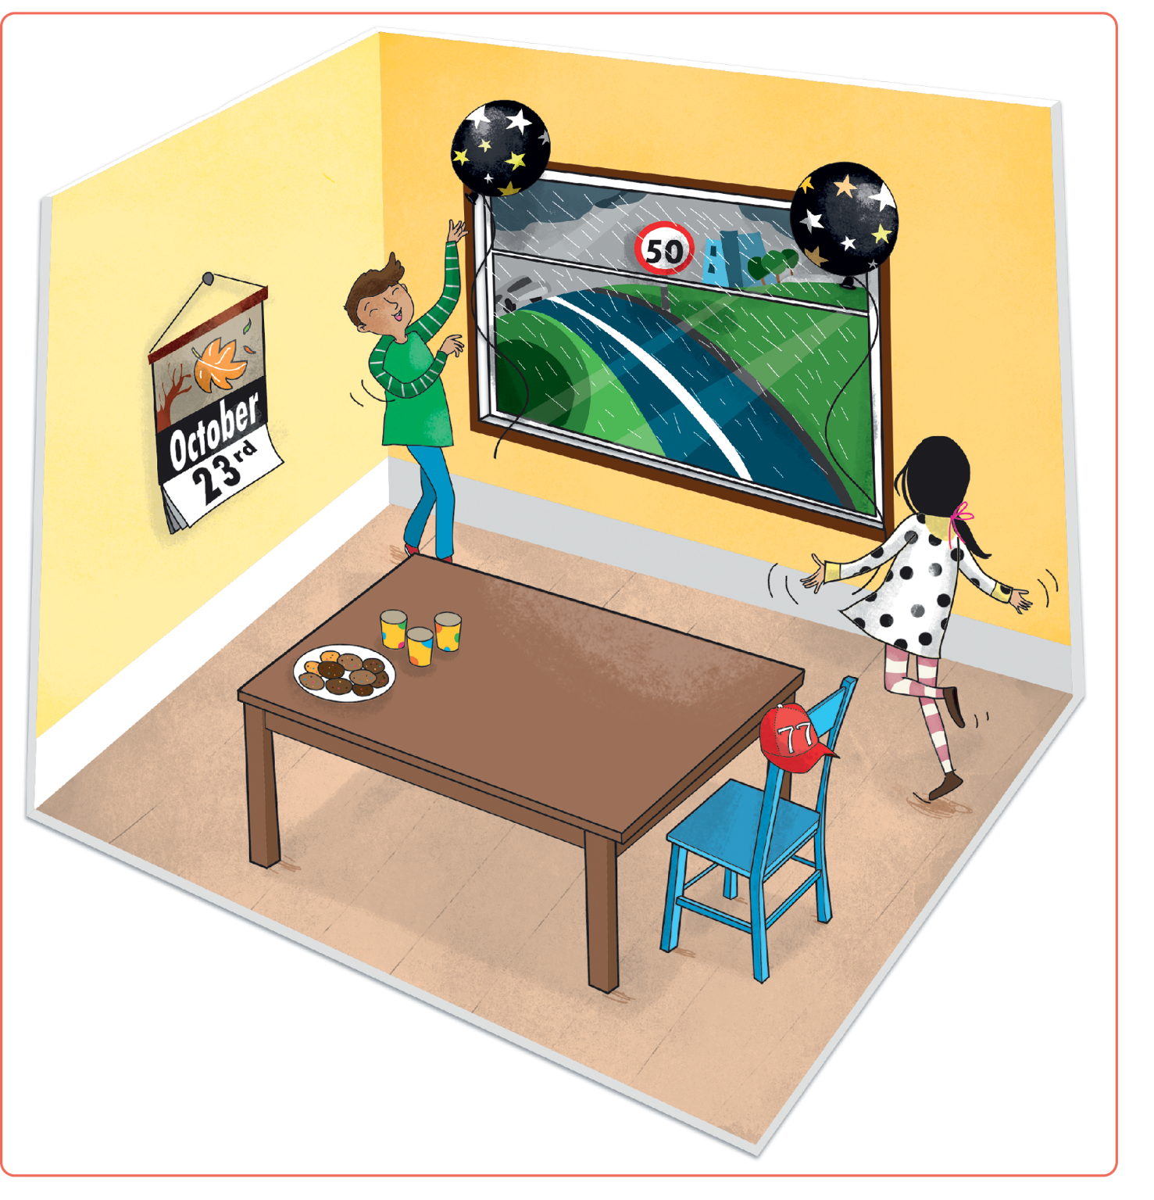
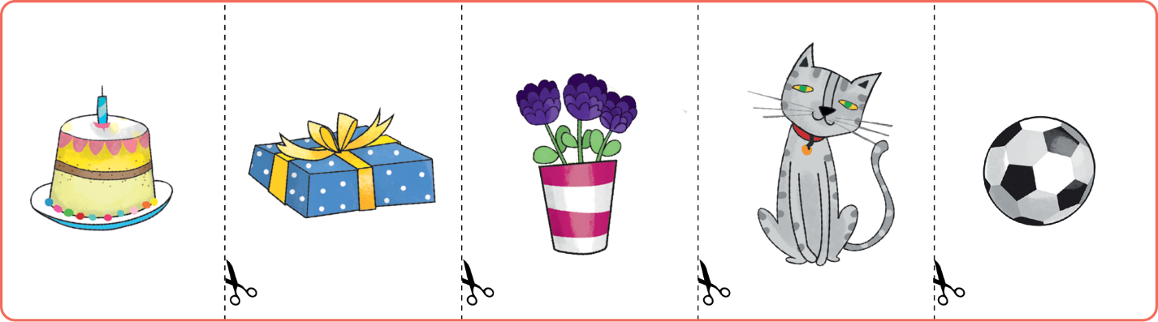

Teacher’s instructions

Familiarise the student(s) with the picture and ask them the following questions:
- What’s the weather like?
- What are the boy and the girl doing?
- What numbers can you see?
- What can you see on the black balloons?
- What day is it?

Ask the student(s) the following questions about the cards and ask them to put
the object cards in various locations on the picture.
- Which one is the cat?
- Put the cat under the table.
- What colour are the flowers?
- Put the flowers near the chair.
- Which one is the cake?
- Put the cake on the table.
- What shape is the present?
- Put the present on the chair.
- What colour is the ball?
- Put the ball near the boy.

