Listening
 Listen and draw  lines. There is one example.
 | 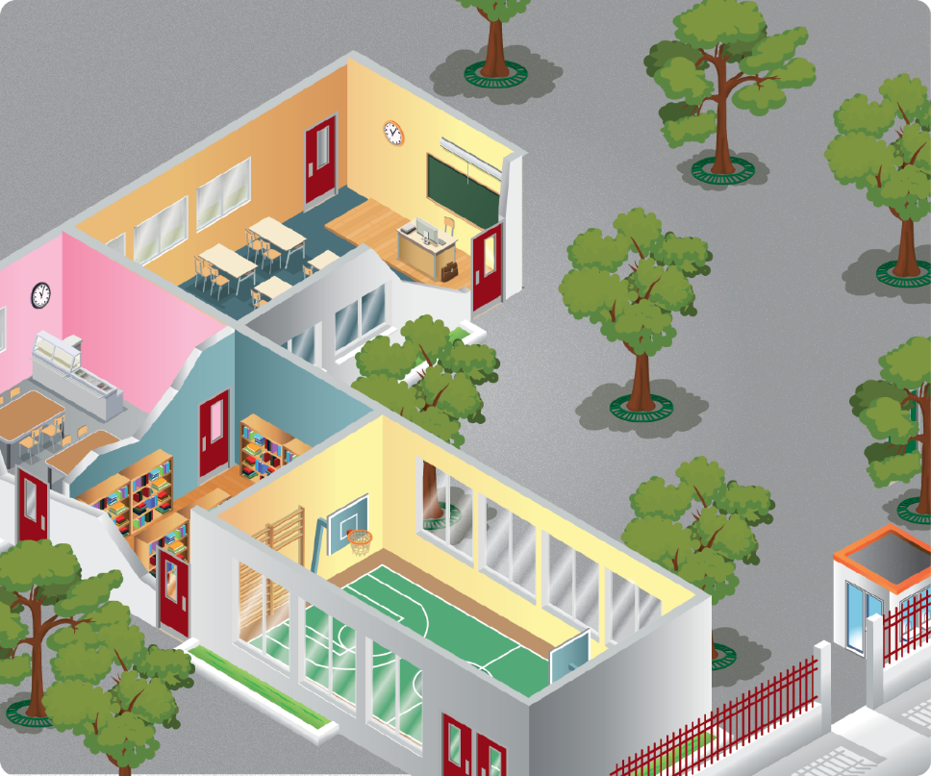
Ben |  | Emma
Alice |  | Mark
Paul |  | Olivia

 Listen and draw the time.
a) |  |  | b)
c) |  |  | d)

Reading
Read  and match . There is one extra word.

• classroom
• playground
• canteen
• gym
• library

a) | 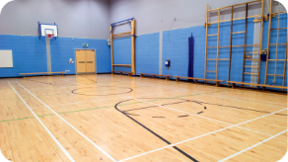 | •
b) |  | •
c) | 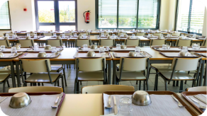 | •
d) | 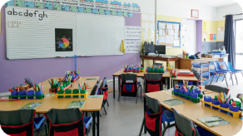 | •



Look and read . Then write yes or no.
a) |  | 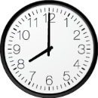 | I get up at eight o’clock. ________
b) |  |  | I have breakfast at nine o’clock. ________
c) |  | 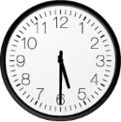 | I do my homework at half past five. ________
d) | 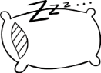 | 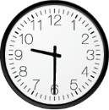 | I go to bed at ten o’clock. ________

Writing
Look at the pictures and read the questions. Write one-word answers.
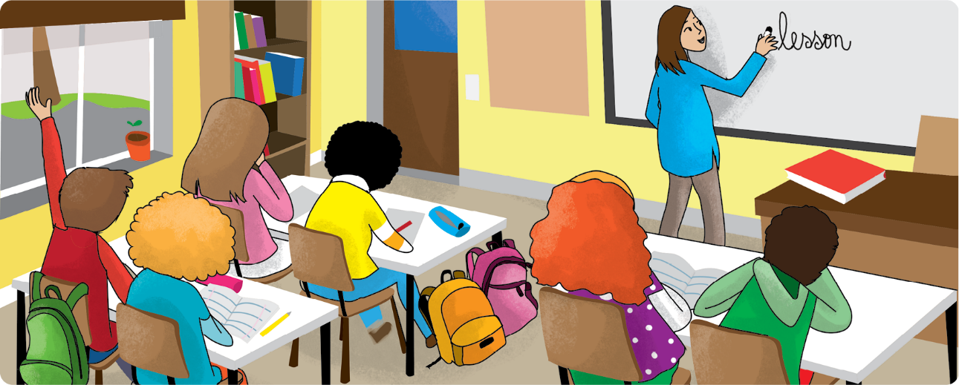
a) Where are the children? In the ___________________.
b) How many children are there? ___________________.
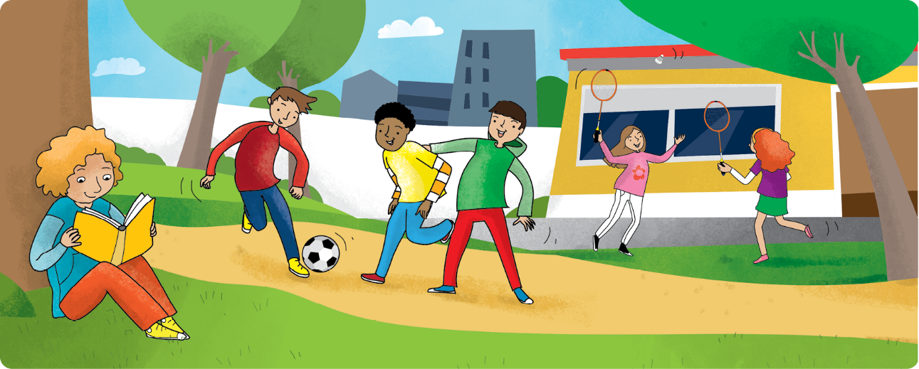
c) Who is reading a book? A ___________________.
d) Where are the children? In the ___________________.

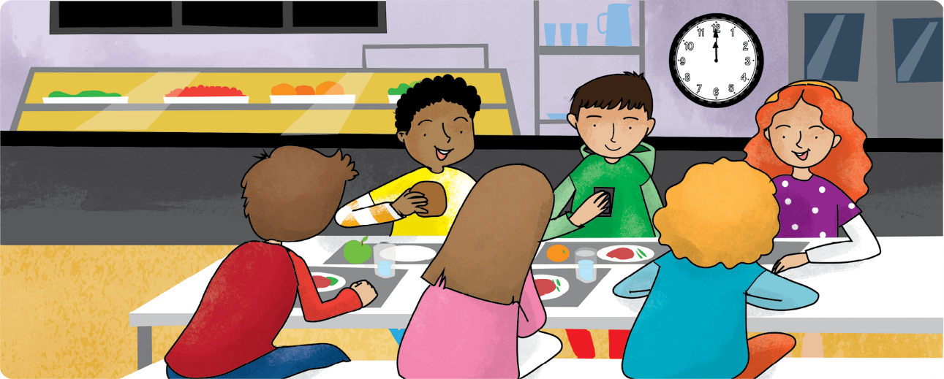
e) Where are the children? In the ___________________.
f) What time is it? It’s ___________________ o’clock.

