SPEAKING TASK 1
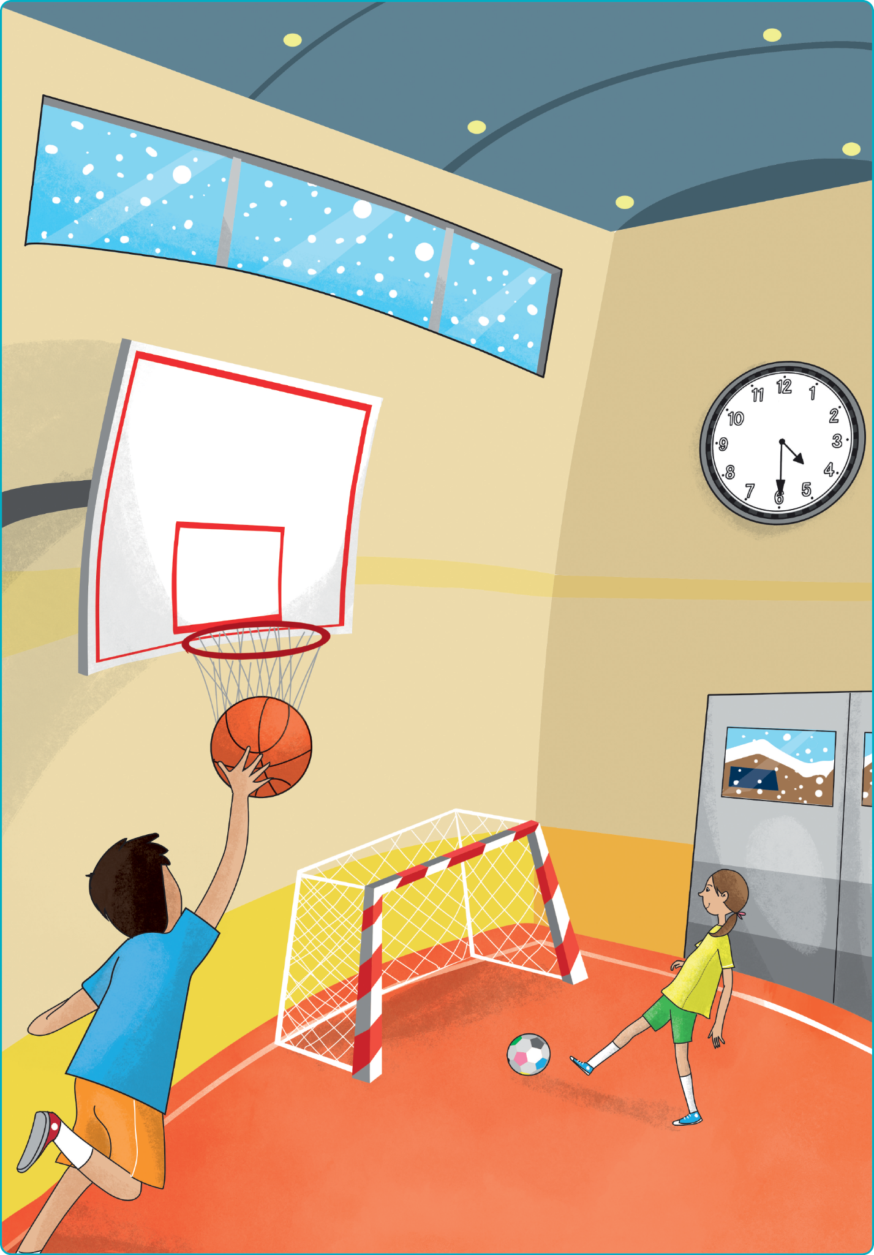

Teacher’s instructions

 Ask questions about the student(s).
- What time do you go to school?
- What’s your favourite place at school?
- What time do you do your homework?
- What’s your favourite school object?
- What time do you go to bed?

 Familiarise the student(s) with the picture and ask them the following questions:
- Where are the boy and the girl?
- What’s the weather like?
- What time is it?
- What colour is the boy’s T-shirt?
- What’s the girl doing?

SPEAKING TASK 2

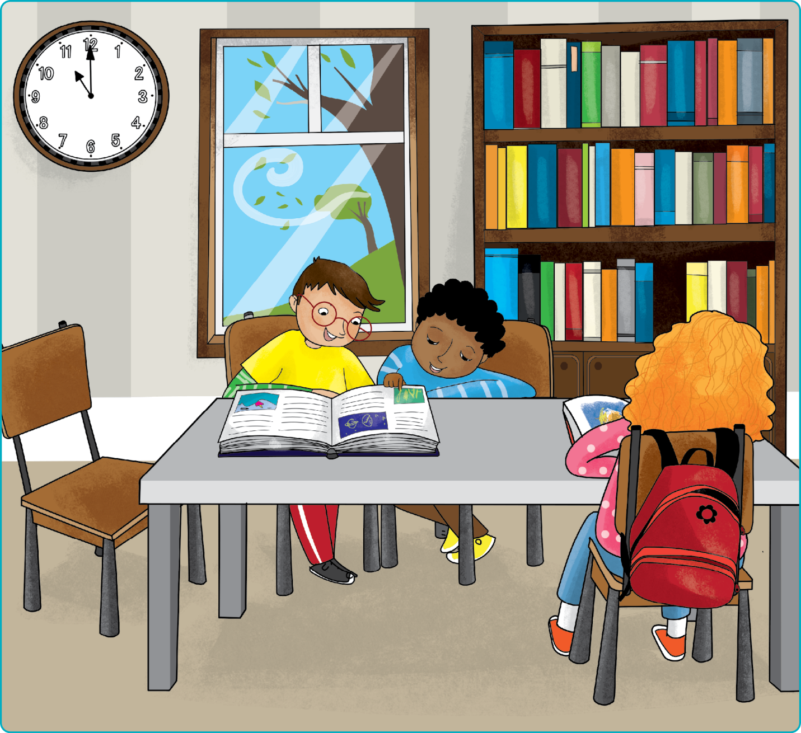

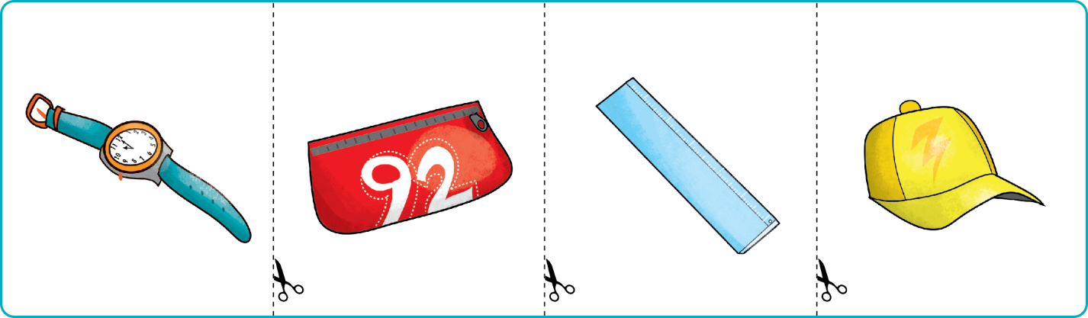

Teacher’s instructions

Familiarise the student(s) with the picture and ask them the following questions:
- Where are the children?
- What’s the weather like?
- What are the two boys doing?
- What colour is the girl's schoolbag?
- What time is it?

Ask the student(s) the following questions about the cards and ask them to put
the object cards in various locations on the picture.
- Which one is the ruler?
- Put the ruler in the schoolbag.
- What colour is the cap?
- Put the cap under the table.
- Which one is the watch?
- Put the watch on the chair.
- What's the number on the pencil case?
- Put the pencil case near the girl.

