Listening
 Listen and tick the box.
a) Who is Emily?
 | 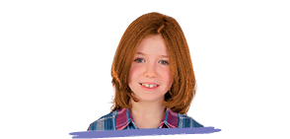 | 
b) What colour are Tom’s eyes?
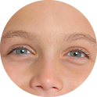 | 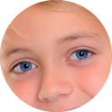 | 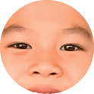
c) What’s Mark’s favourite monster?
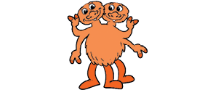 | 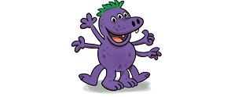 | 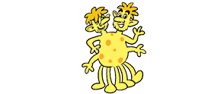
d) Who is Lucy’s father?
 |  | 
e) Which is Emma’s monster?
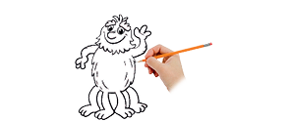 | 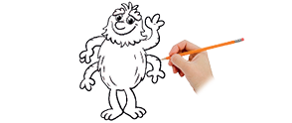 | 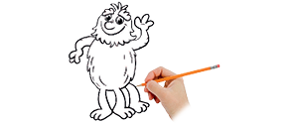

Reading
Look and read . Then circle .
a) |  | legs | eyes | ears
b) |  | arms | knees | teeth
c) | 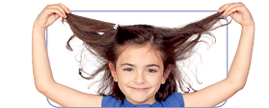 | hand | mouth | hair
d) |  | fingers | shoulders | feet
e) | 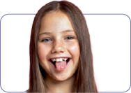 | tongue | head | nose
 Look and read . Then write yes or no.
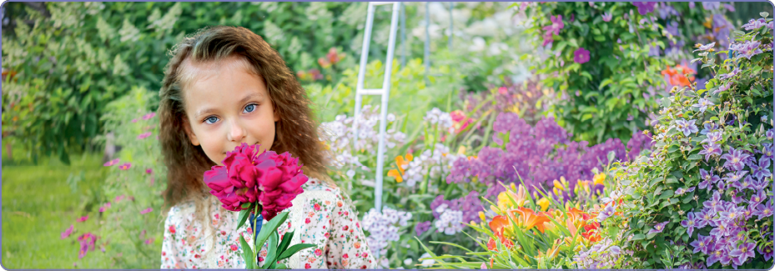

a) The girl has got blonde hair. __________
b) Her eyes are blue. __________
c) She can smell with her eyes. __________

Writing
Look . Then order  and write . There is one example.
 | 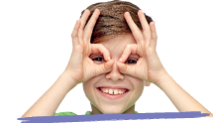 | __ __ __ __ | y e  s e
a) | 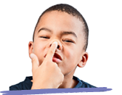 | __ __ __ __ | o s  e n
b) | 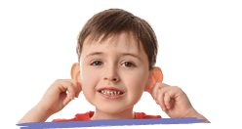 | __ __ __ __ | r a  s e
c) | 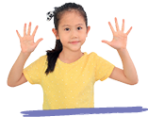 | __ __ __ __ __ | d a h  s n
d) | 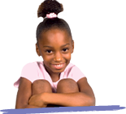 | __ __ __ __ __ | e s n  e k
e) | 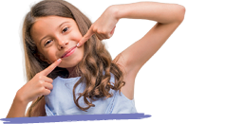 | __ __ __ __ __ | o h m  u t
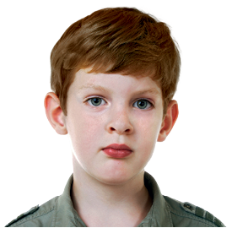
Read . Then choose a word and write .
ears hair
nose eyes hands
Hi! My name is Adam.
I have got short brown a) _______________________.
My b) _______________________ are big and green.
I can hear with my c) _______________________.
I can smell with my d) _______________________.
I can touch with my e) _______________________.

 Read and write .

a) What colour is your hair?
b) What colour are your eyes?

