SPEAKING TASK 1
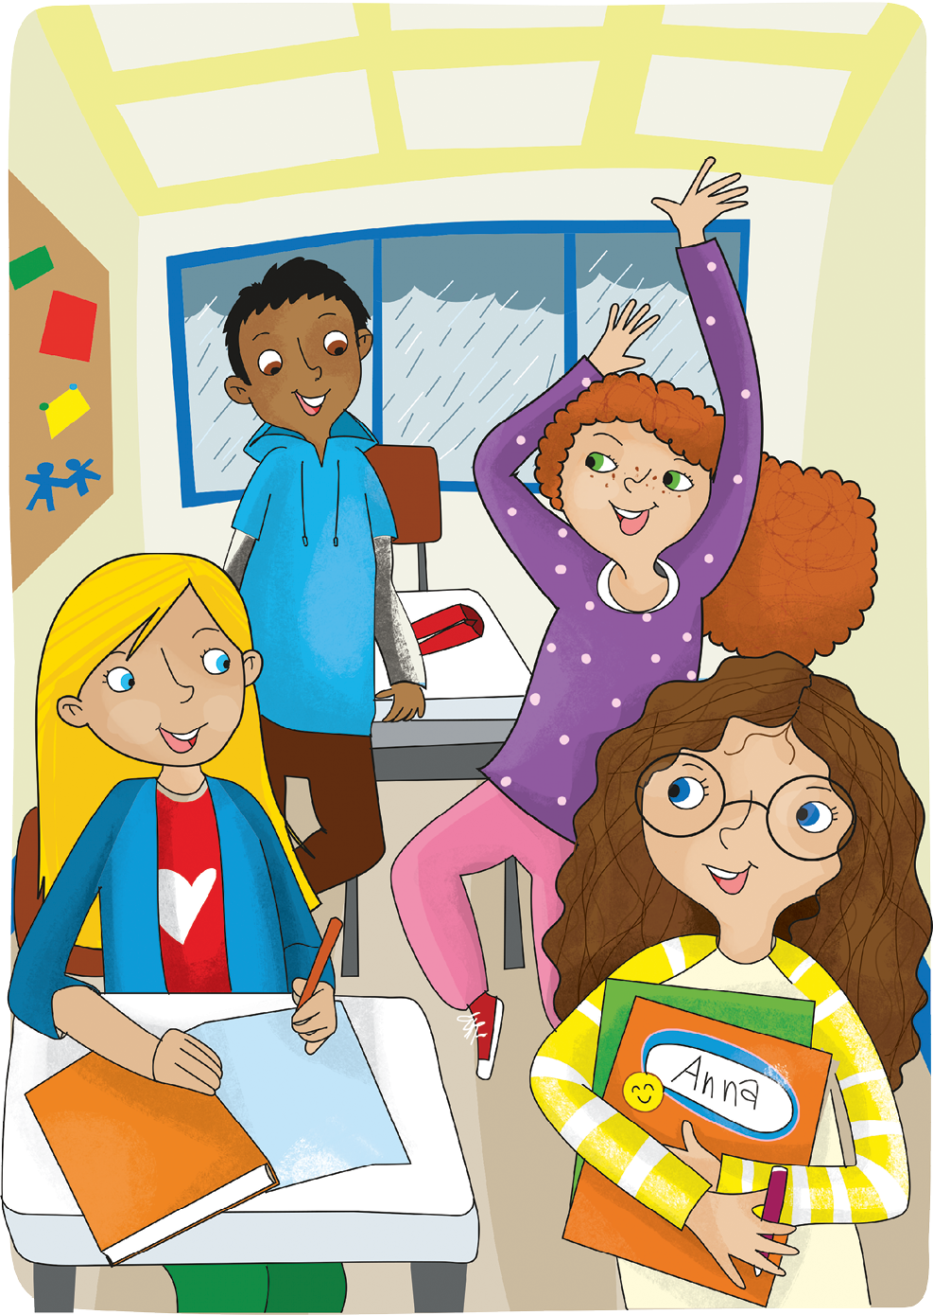

Teacher’s instructions

 Ask questions about the student(s).
- What colour is your hair?
- Is it long or short?
- What colour are your eyes?
- Are they big or small?
- Are you tall or short?

 Familiarise the student(s) with the picture and ask them the following questions:
- Where are the children?
- What’s the weather like?
- Who’s dancing?
- What’s the boy like?
- Who’s Anna?

SPEAKING TASK 2

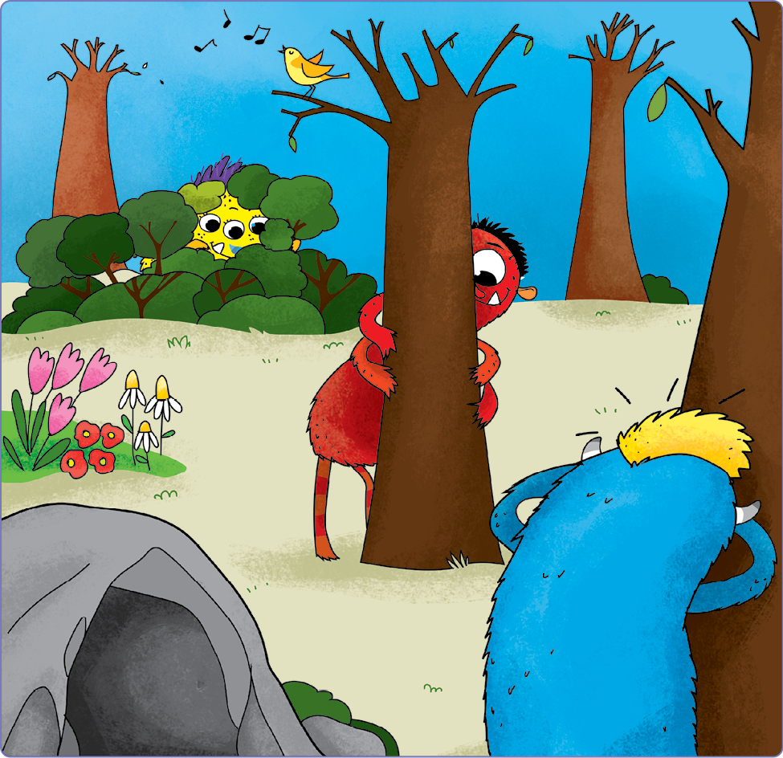

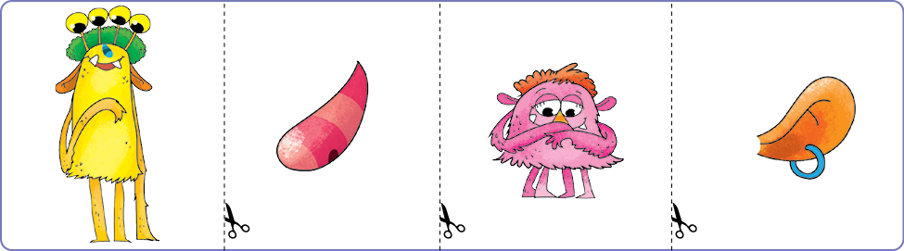

Teacher’s instructions

Familiarise the student(s) with the picture and ask them the following questions:
- How many monsters are there?
- What are they doing?
- Can the blue monster see?
- What colour is the hair of the monster with three eyes?
- What’s the monster hiding behind the tree like?

Ask the student(s) the following questions about the cards and ask them to put
the object cards in various locations on the picture.
- Which one is the nose?
- Put the nose near the flowers.
- Which one is the short monster?
- What’s he like?
- Put the short monster in the cave.
- Which one is the ear?
- Put the ear where you can use it.
- What’s the tall monster like?
- Put the tall monster near the yellow hair monster.

