Listening
 Listen and draw  lines.
Ben | Susan | Anne
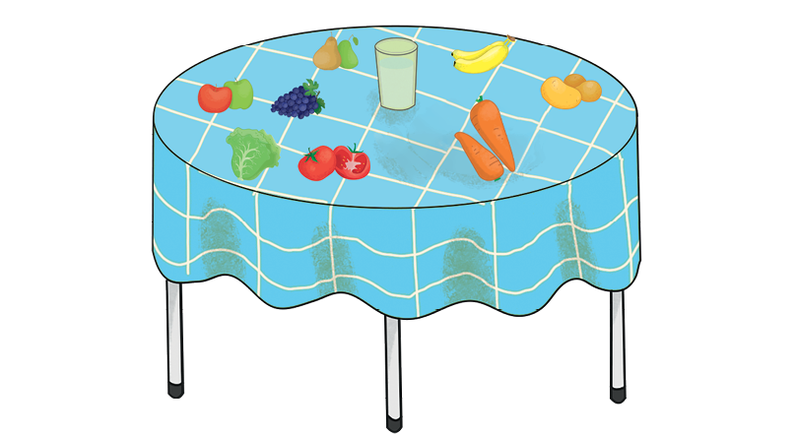
John | Lily | Peter
 Listen and circle .

  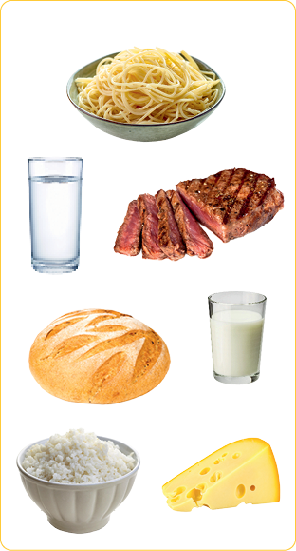 |   Lucas |   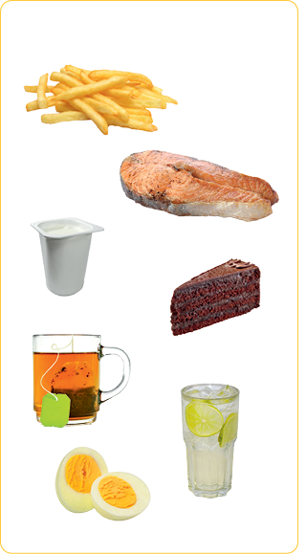

Reading
Look and read . Find  and tick .
bread | meat | water | yoghurt | lettuce | spaghetti | milk | pears
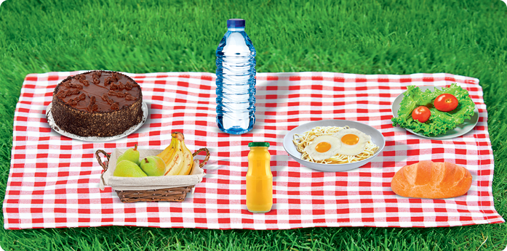
tomatoes | carrots | cake | rice | juice | bananas | apples | eggs

Look and read . Then match .There is an extra word.
• oranges
• potatoes
• peas
• tea
• beans
• meat

a) |  | •
b) |  | •
c) | 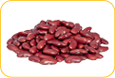 | •
d) | 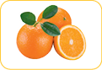 | •
e) | 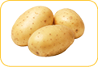 | •

Writing
Read and complete the sentences.
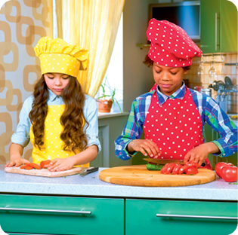
Hello! My name is Karen and this is my brother Ben.
Today is a very special day! It’s our mother’s birthday.
We are cooking her favourite food: rice and meat.
She likes vegetables as well. Carrots and tomatoes are
her favourite. She doesn’t like lettuce. She loves orange
juice and her favourite fruit is banana.
Her birthday cake is ready too! It’s a yoghurt cake, her
favourite!
She will love our surprise!
a) It’s Karen and Ben’s mother’s .
b) Her favourite food is .
c) Her favourite vegetables are .
d) Their mother doesn’t like .
e) Her favourite drink is .
f) Her favourite fruit is .
g) She likes cake.

Write about your favourite food (for breakfast, for lunch and for dinner).
