Listening
 Listen and draw  lines.
Ben | Susan | Anne
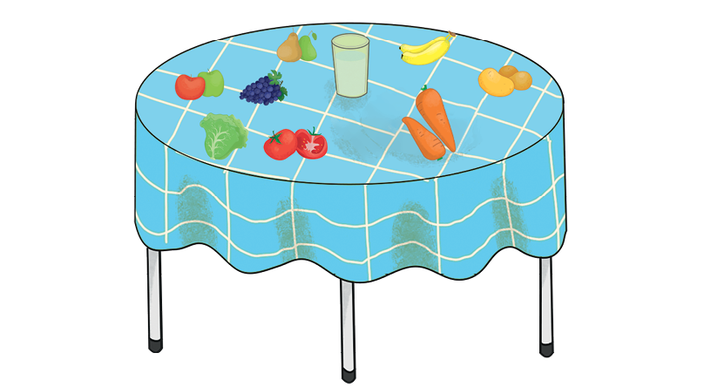
Lily |  | Peter
 Listen and circle .

  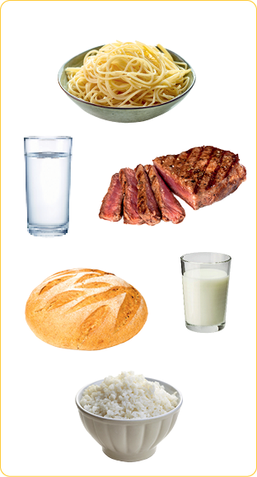 |   Lucas |   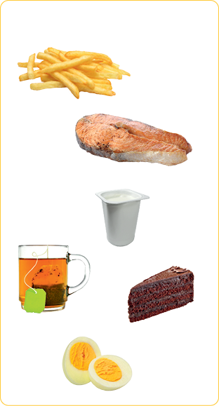

Reading
Look and read . Find  and tick .
bread | meat | water | lettuce | spaghetti | milk | pears
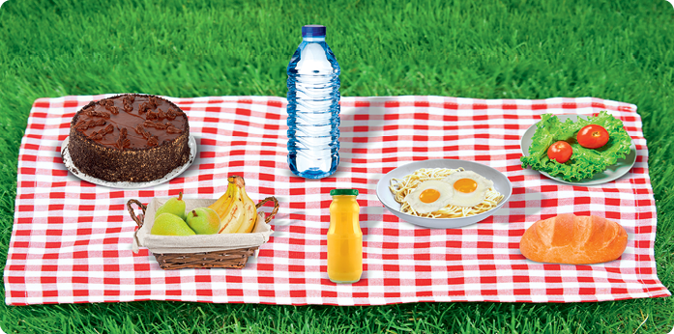
tomatoes | cake | rice | juice | bananas | apples | eggs

Look and read . Then match .
• oranges
• potatoes
• tea
• beans
• meat

a) |  | •
b) |  | •
c) | 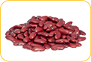 | •
d) |  | •
e) | 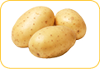 | •

Writing
Read and circle yes or no.
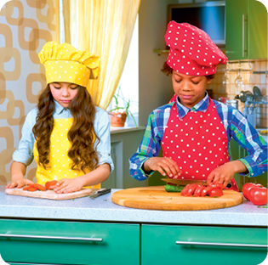
Hello! My name is Karen and this is my brother Ben.
Today is a very special day! It’s our mother’s birthday.
We are cooking her favourite food: rice and meat.
She likes vegetables as well. Carrots and tomatoes are
her favourite. She doesn’t like lettuce. She loves orange
juice and her favourite fruit is banana.
Her birthday cake is ready too! It’s a yoghurt cake, her
favourite!
She will love our surprise!
a) It’s Karen and Ben’s mother’s birthday. yes / no
b) Her favourite food is spaghetti and fish. yes / no
c) Her favourite vegetables are carrots and tomatoes. yes / no
d) Their mother doesn’t like lettuce. yes / no
e) Her favourite drink is apple juice. yes / no
f) Her favourite fruit is pear. yes / no
g) She likes yoghurt cake. yes / no

Write about your favourite food (for breakfast, for lunch and for dinner).
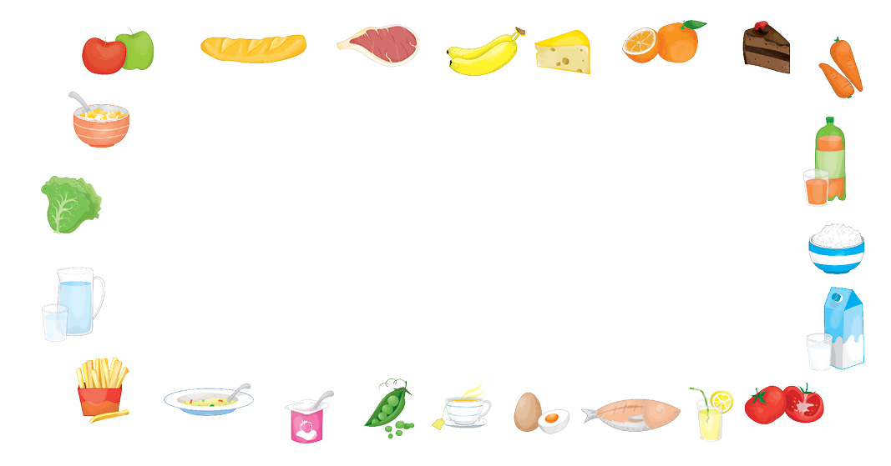
For breakfast I like

For lunch I like

For dinner I like

