SPEAKING TASK 1
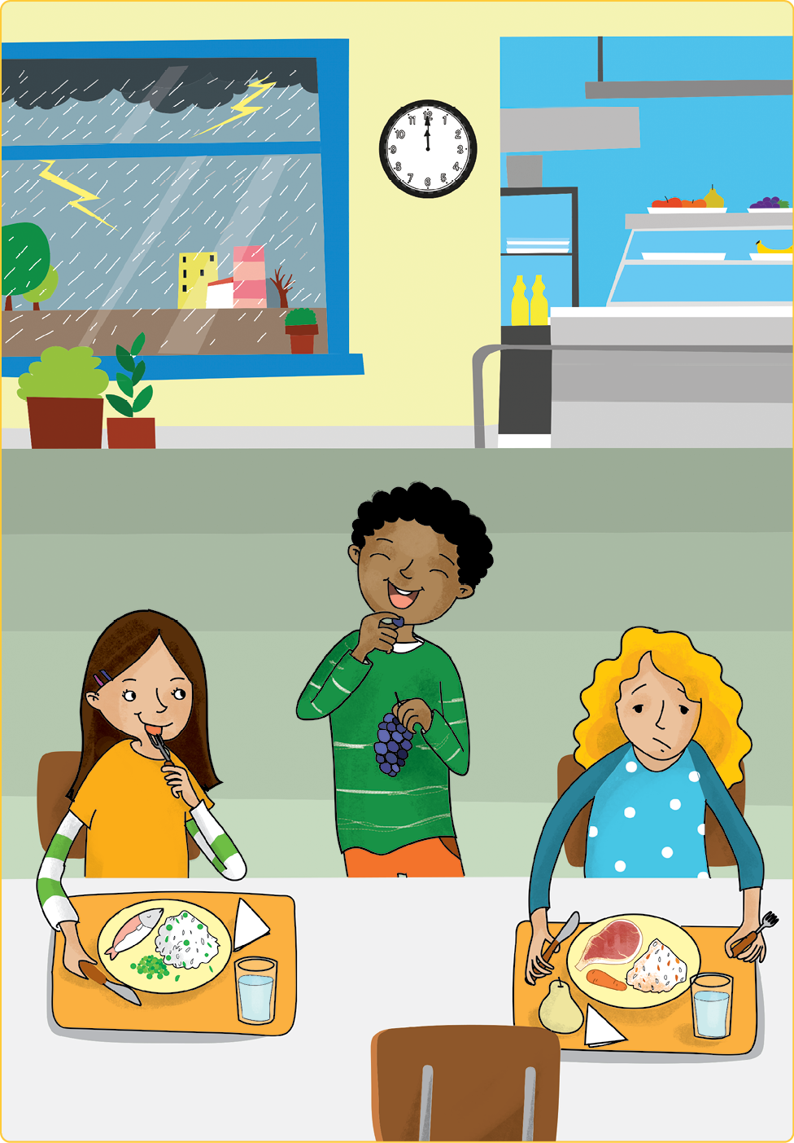

Teacher’s instructions

 Ask questions about the student(s).
- Do you like oranges?
- What’s your favourite food?
- What do you like to eat for breakfast?
- What’s your favourite drink?
- What do you like to eat for dinner?

 Familiarise the student(s) with the picture and ask them the following questions:
- Where are the children?
- What’s the weather like?
- What’s the boy eating?
- Is the blonde girl happy or sad?
- What’s the girl with brown hair eating?

SPEAKING TASK 2

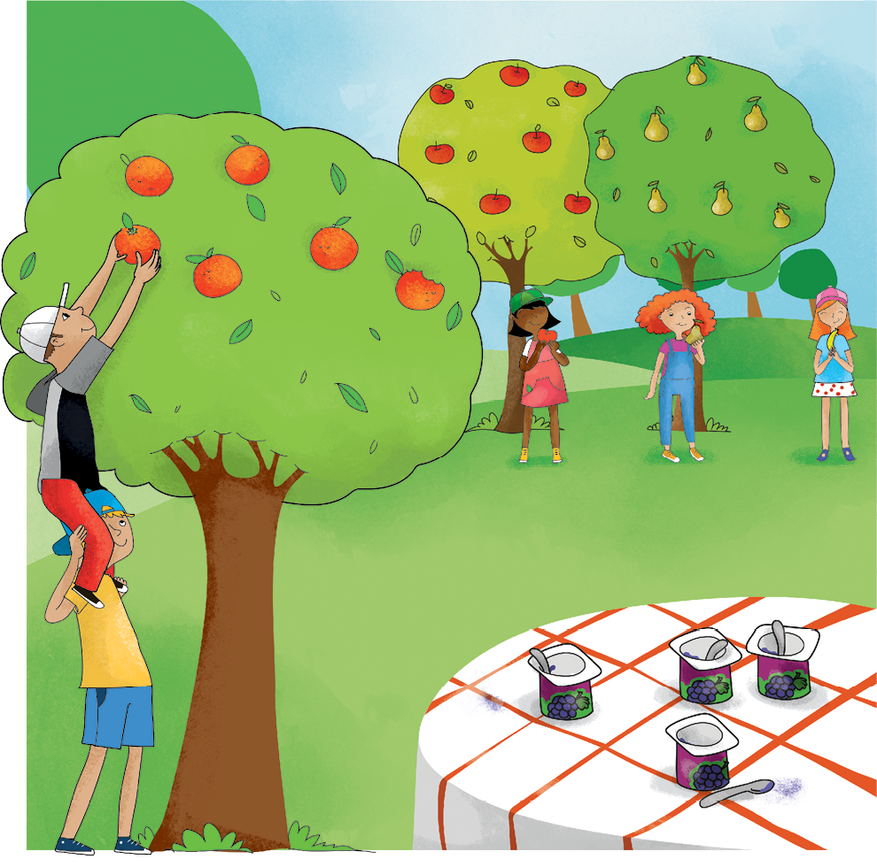

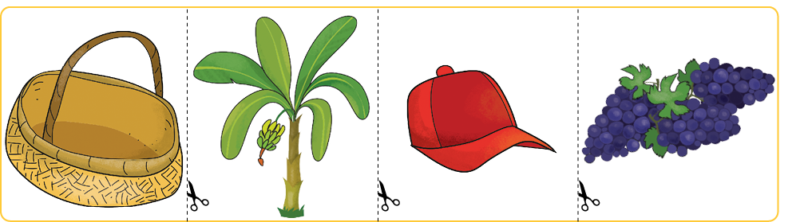

Teacher’s instructions

Familiarise the student(s) with the picture and ask them the following questions:
- How many children are there?
- What are they doing?
- What’s the weather like?
- How many oranges can you see?
- Which fruit is on the yoghurts?

Ask the student(s) the following questions about the cards and ask them to put
the object cards in various locations on the picture.
- Which one is the banana tree?
- Put the banana tree near the correct girl.
- Which one is the basket?
- Put the basket in front of the boys.
- Which ones are the grapes?
- Put the grapes in the basket.
- What colour is the cap?
- Put the cap on the correct girl.

