Listening
 Listen and draw  lines.
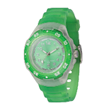 | 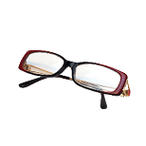 | 
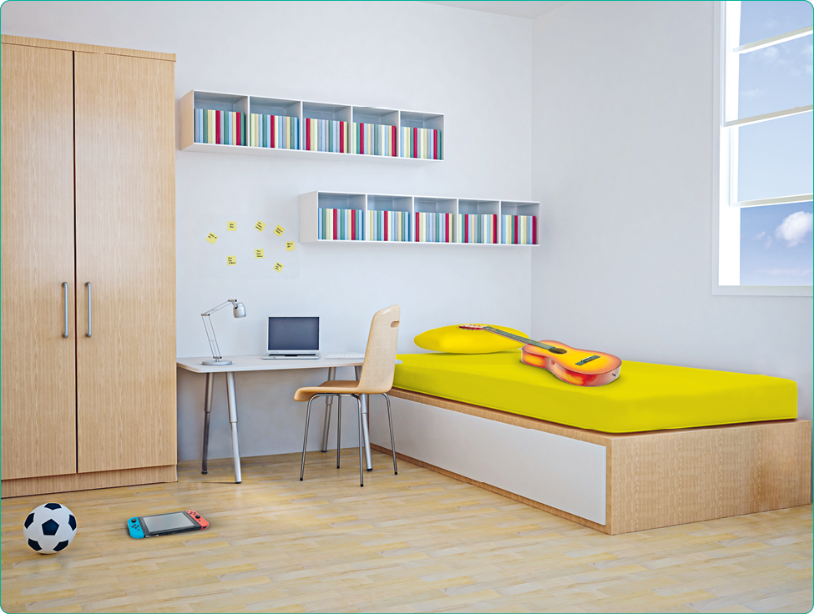
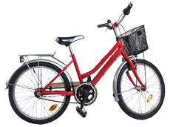 | 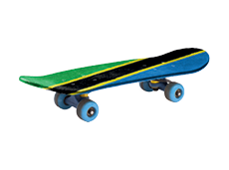 | 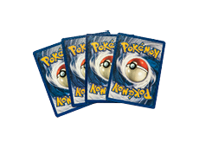

Reading
Look and read . Then tick .
a) |  | hospital
a) |  | shopping centre
b) | 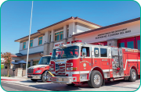 | police station
b) |  | fire station
c) |  | train station
c) |  | town hall
d) | 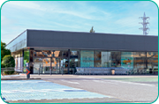 | supermarket
d) |  | church
e) | 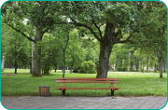 | train station
e) |  | park
f) | 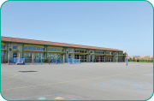 | school
f) |  | shopping centre
g) | 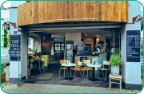 | police station
g) |  | café
h) |  | town hall
h) |  | post office

Writing
Look and read . Then write a part of the house.
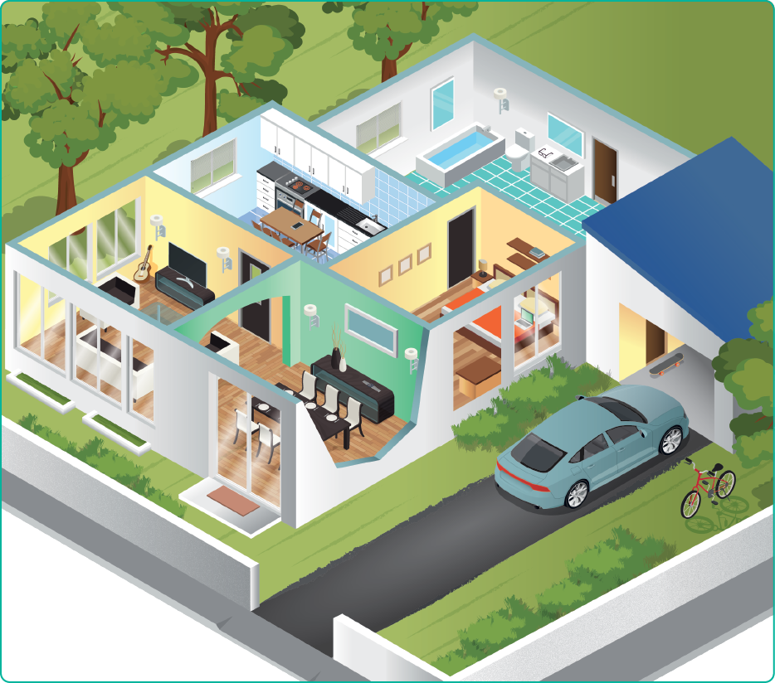

a) In this place there’s a guitar.
b) In this place there are glasses.
c) In this place there’s a skateboard.
d) In this place there’s a laptop.
e) In this place there’s a bike.
f) In this place there’s a watch.
g) In this place there’s a mobile phone.

 Look and read . Then write .
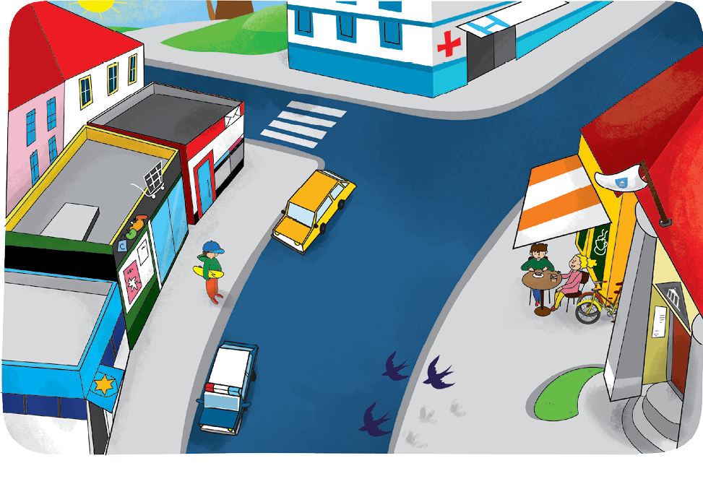

Complete the sentences.
a) There is a yellow car in front of the .
b) There’s a boy with a skateboard in front of the .

Answer the questions.
c) Where’s the supermarket?
.
d) Where’s the town hall?
.

Write two sentences about the picture.
e) .
f) .

