SPEAKING TASK 1
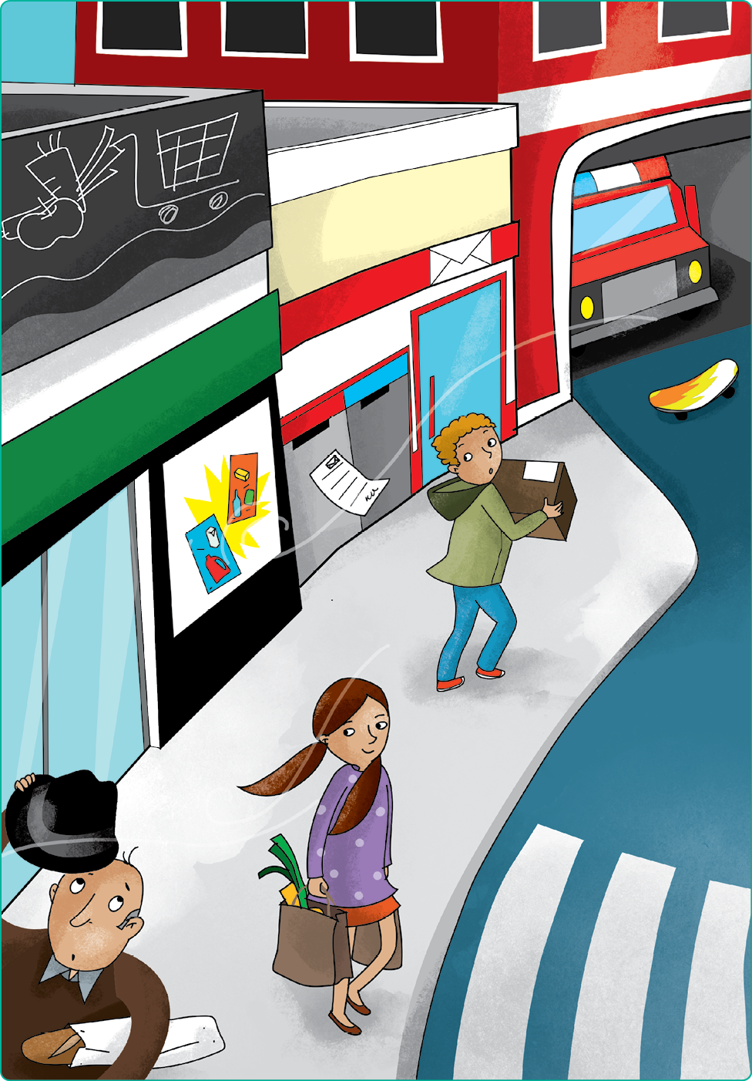

Teacher’s instructions

 Ask questions about the student(s).
- Where do you live?
- What buildings are there in your town?
- What’s your house like?
- How many chairs are there in your kitchen?
- What’s your favourite personal object?

 Familiarise the student(s) with the picture and ask them the following questions:
- How many people do you see?
- What’s the weather like?
- Where’s the post office?
- Where’s the supermarket?
- Where’s the skateboard?

SPEAKING TASK 2

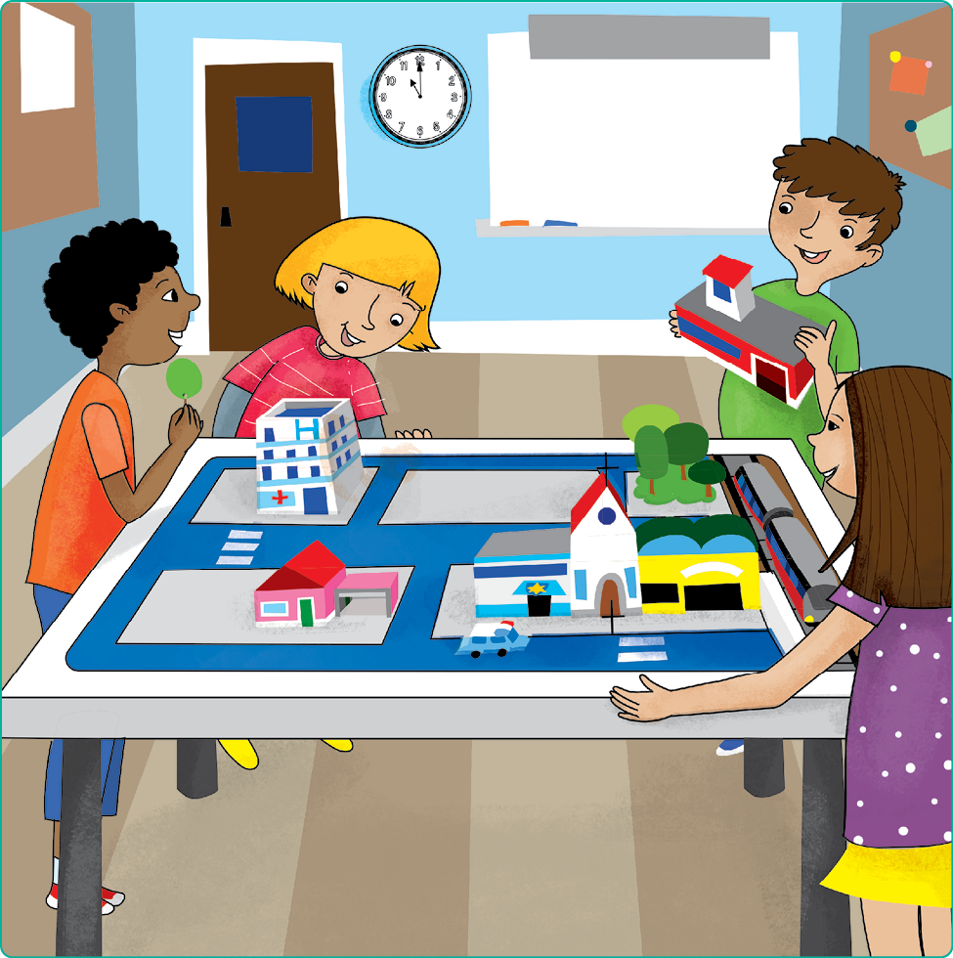

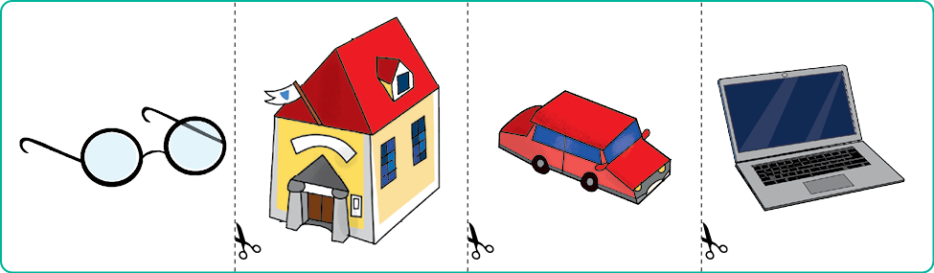

Teacher’s instructions

Familiarise the student(s) with the picture and ask them the following questions:
- How many children are there?
- Where are they?
- What are they doing?
- What time is it?
- What buildings do you see?

Ask the student(s) the following questions about the cards and ask them to put
the object cards in various locations on the picture.
- Which one is the laptop?
- Put the laptop under the desk.
- Which one is the car?
- Put the car in the garage.
- What building is this?
- Put it near the hospital.
- What colour are the glasses?
- Put the glasses on a girl’s face.

