Listening
 Listen and write .
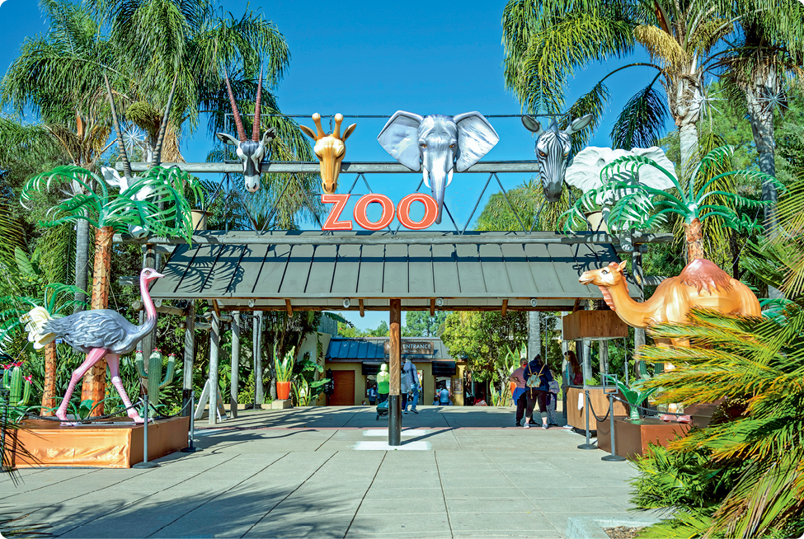
School trip to the Zoo
a) Day of the school trip: on
b) Number of animals:
c) Can feed the…:
d) Visit the…:
e) Special present: a toy

Reading
Look and read . Then tick or cross . There is one example.
 | 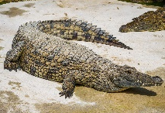 | This is a bear. | X
a) | 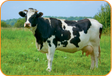 | This is a cow.
b) | 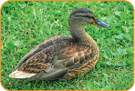 | This is a donkey.
c) | 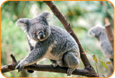 | This is a penguin.
d) | 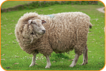 | This is a sheep.
e) | 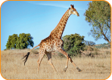 | This is a hippo.

 Look and read . Then circle .
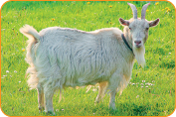 |  | 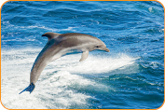 |  | 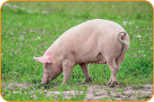 |  | 
 | 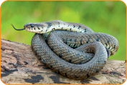 |  | 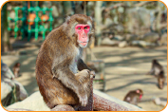 |  | 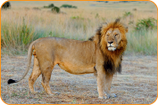
a) It eats fruit. It can climb. monkey / dolphin / lion
b) It can swim. It lives in the sea. pig / snake / dolphin
c) It has got two wings. It can fly. lion / eagle / goat
d) It lives on the farm. It can jump. snake / goat / monkey
e) It eats meat. It can run. It has got eagle / dolphin / lion
four legs.
Writing
Read . Then choose a word and write .
A horse
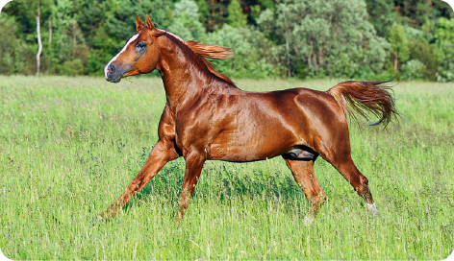
It has got four a) _________________, two ears and a long b) _________________.
It lives on the c) _________________. It likes eating d) _________________ and
apples.
It drinks e) _________________.
It can run and f) _________________.
carrots jump water legs
cake tail farm wings
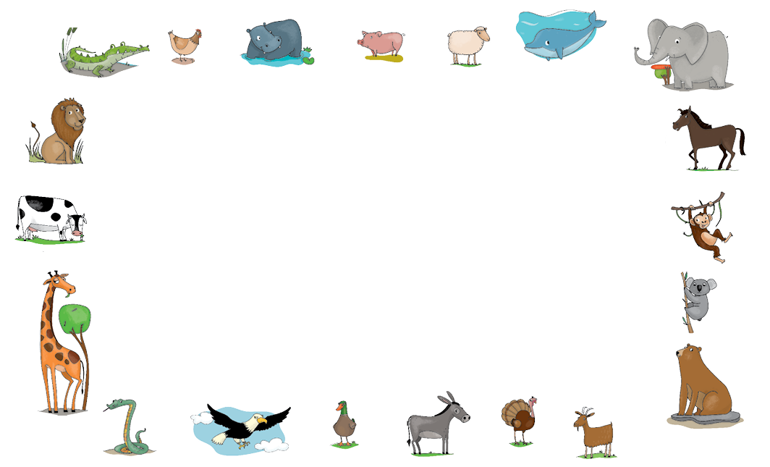
Write about your favourite animal.

