SPEAKING TASK 1
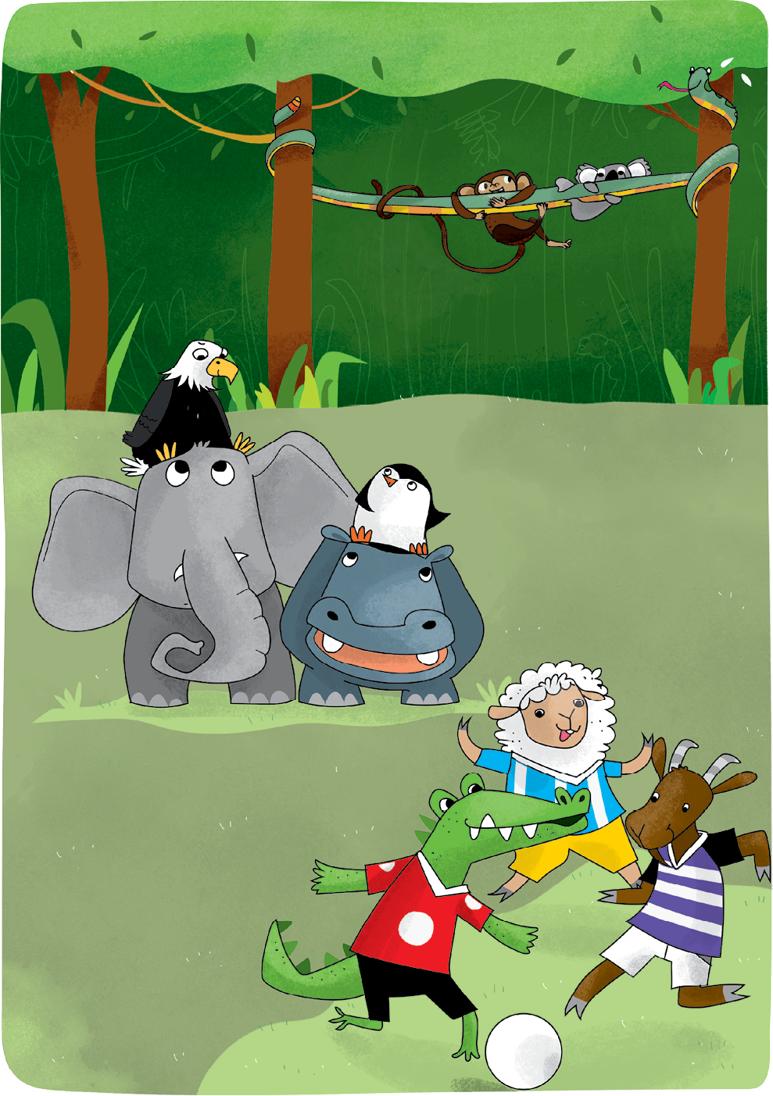

Teacher’s instructions

 Ask questions about the student(s).
- What’s your favourite farm animal?
- Can you swim?
- What’s your favourite wild animal?
- Can you climb?

 Familiarise the student(s) with the picture and ask them the following questions:
- How many animals are there in the picture?
- Who’s playing football?
- Where’s the monkey?
- Where’s the eagle?
- Where’s the hippo?

SPEAKING TASK 2

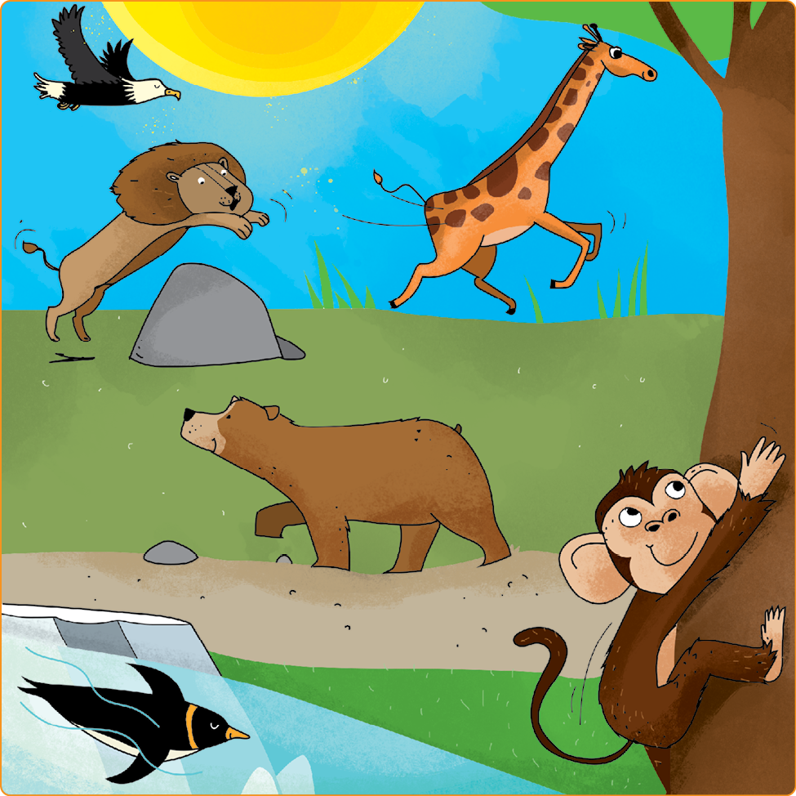

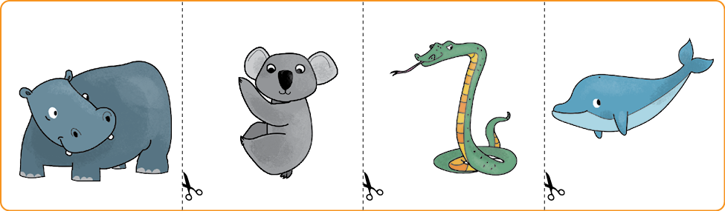

Teacher’s instructions

Familiarise the student(s) with the picture and ask them the following questions:
- How many wild animals are there?
- What’s the weather like?
- What can the lion do?
- Who’s flying?
- What can the penguin do?

Ask the student(s) the following questions about the cards and ask them to put
the object cards in various locations on the picture.
- Which one is the snake?
- Put the snake behind the giraffe.
- Which one is the hippo?
- Put the hippo in front of the bear.
- Which one is the dolphin?
- Put the dolphin near the penguin.
- What colour is the koala?
- Put the koala on the tree.

