Young Learners English Starters
Reading & Writing Paper
Mock Test

There are 25 questions.
You will need a pen or pencil.

My name is: _________________________________________________________

PART 1
- 5 questions -
Look and read. Put a tick () or a cross () in the box. There are two examples.

Examples:
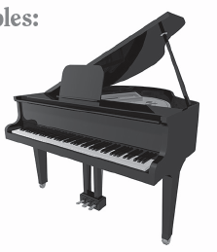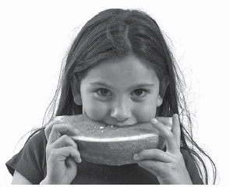
This is a piano. ☑ She’s eating a hamburger. 

Part 1

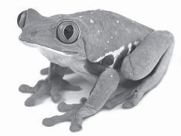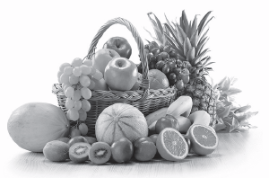
1. This is a lizard. □ 2. These are vegetables. □

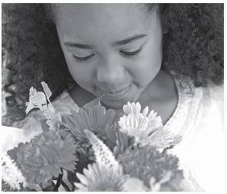
3. She is smelling flowers. □

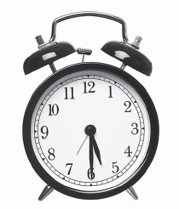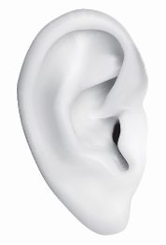
4. This is a clock. □ 5. These are eyes. □

PART 2
- 5 questions -
Look at the picture and read. Write Yes or No. There are two examples.

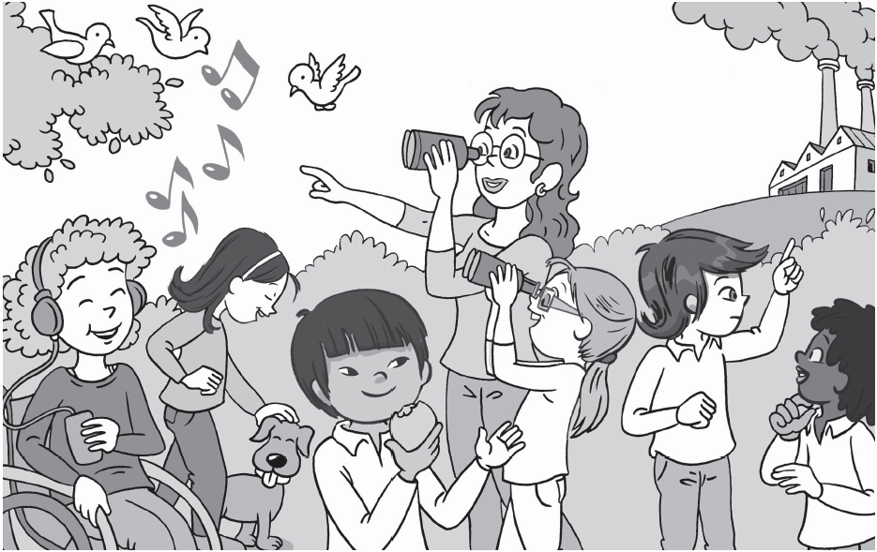

Examples:
The Stars are at school. Yes
Miss Parker is singing. No

Part 2
1. Lee is eating an apple. __________________
2. Chloe and Ana are listening to music. __________________
3. Jessie is touching a dog. __________________
4. Charlie is smelling a flower. __________________
5. Ana and Miss Parker are looking at birds. __________________

PART 3
- 5 questions -
Look at the pictures. Look at the letters. Write the words. There is one example.

Example:

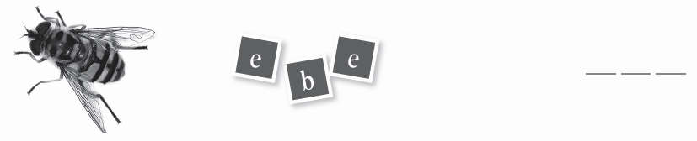
1.


2.

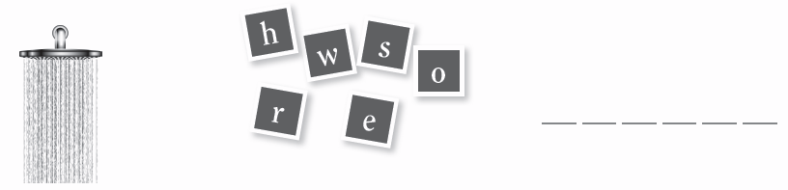
3.

4.


5.
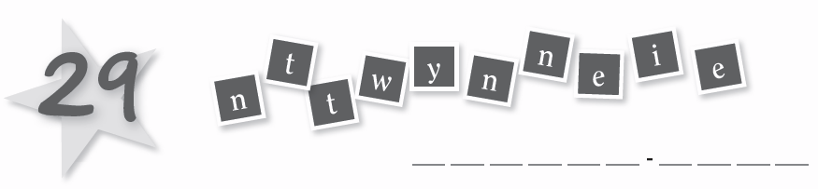

PART 4
- 5 questions -
Look at the picture and choose a word. Write the correct word next to numbers 1–5. There is one example.
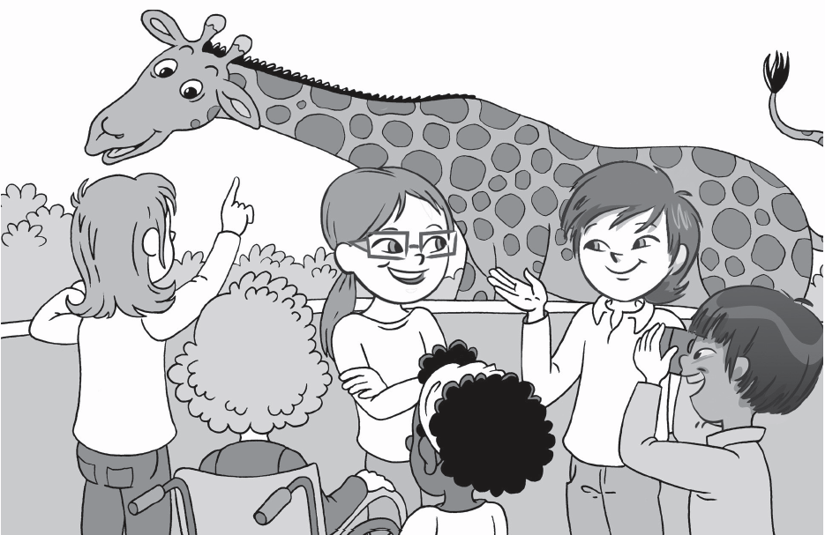

I’ve got four legs , two ears, two eyes and a long 1) _____________ I’m a big animal. I don’t live in a 2) _____________ or a garden. I like eating 3) _____________ and apples. I drink 4) _____________. I am a 5) _____________.

☑ □ □ □ □ □
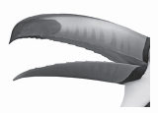
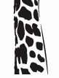
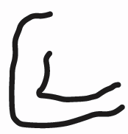
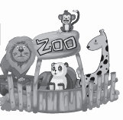



legs arms neck beak house zoo


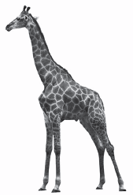

☑ □ □ □ □ □
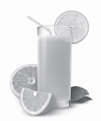
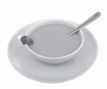
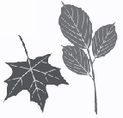

leaves soup orange juice water giraffe elephant

PART 5
- 5 questions -
Look at the picture and read the questions. Write one-word answers. There is one example.

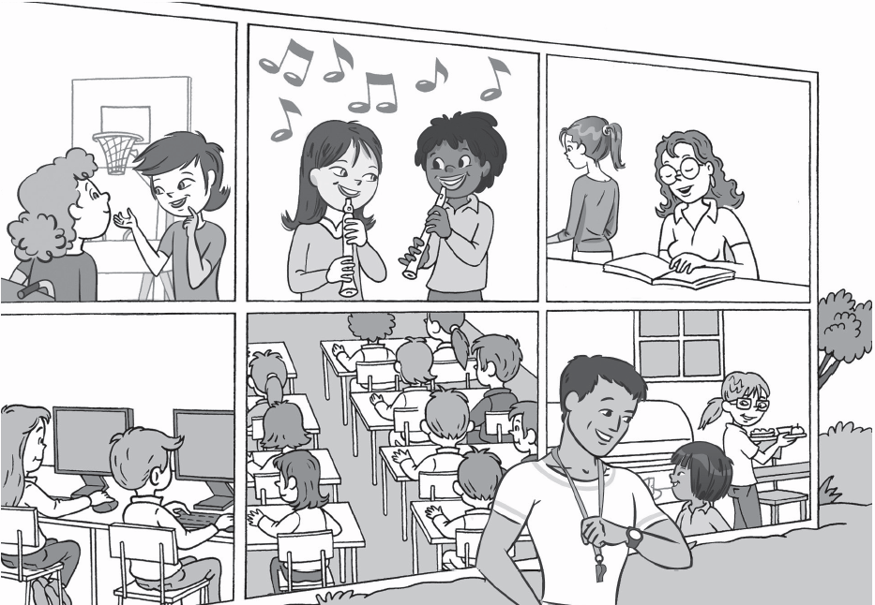

Example:
Where is Miss Parker? She’s in a classroom .

1. How many classrooms do you see? I see ____________________ classrooms.
2. Where is Lee? He is in the ______________________.
3. Who’s in the playground? ____________________________________.
4. Where are Chloe and Charlie? They are in the ______________________.
5. Who’s in the library? _________________________________.

