Unit 1 TEST A
My name is: ___________________________________________________________________________



Listen and tick () the box. There is one example.

Example:
How old is Mike?

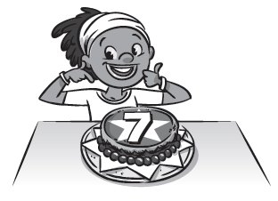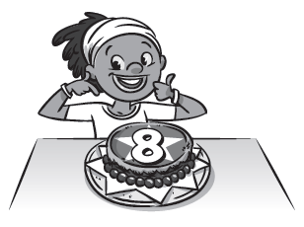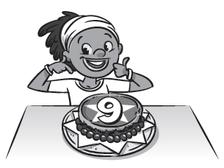
A □ B ☑ C □

1. What is Ana’s favourite subject?

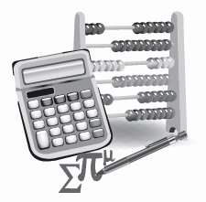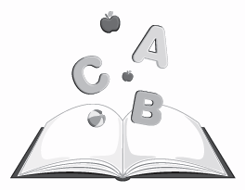
A □ B □ C □

2. Where does Mike get the book?

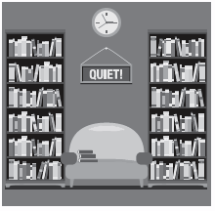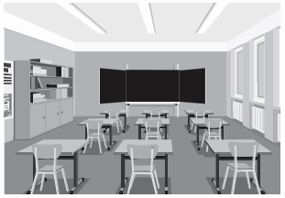
A □ B □ C □

3. How many tablets does the computer room have?

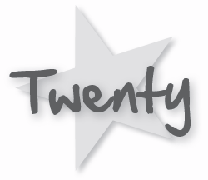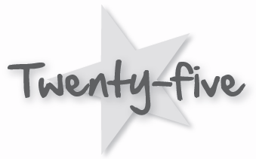
A □ B □ C □

4. What’s Miss Parker teaching today?

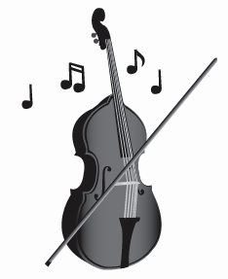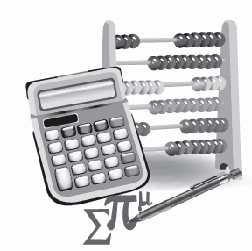
A □ B □ C □

5. What are they doing?

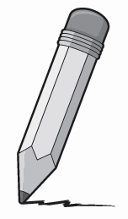
A □ B □ C □

Unit 1 TEST A
My name is: ___________________________________________________________________________



Look and read. Put a tick () or a cross () in the box. There are two examples.

Examples:
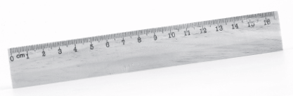
This is a ruler. ☑ This is a birthday cake. 

Part 1
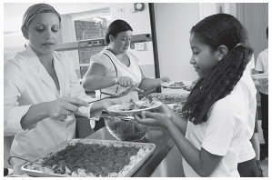
1. This is a library. □ 2. This is a music room. □
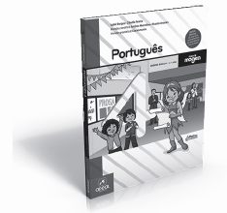 3. This is a Portuguese book. □
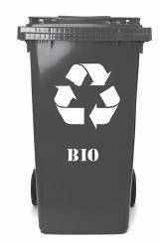
4. This is a playground. □ 5. This is a corridor. □
Look at the pictures. Look at the letters. Write the words. There is one example.

Example:

Part 2

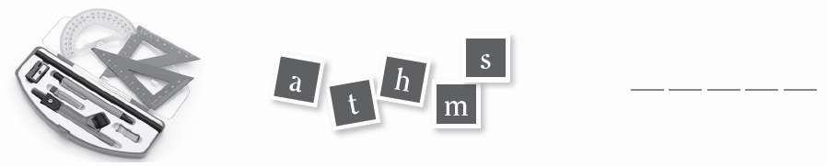
1.

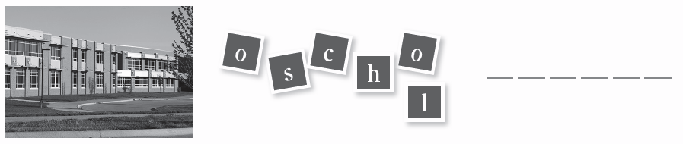
2.

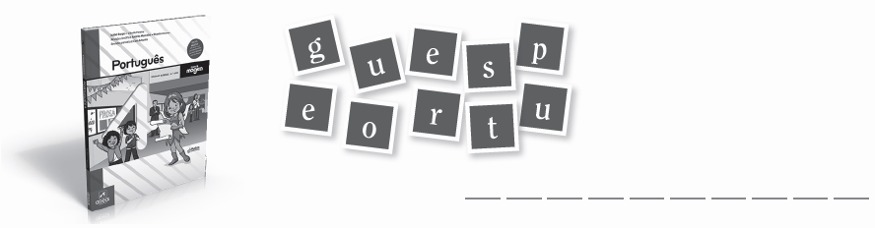
3.

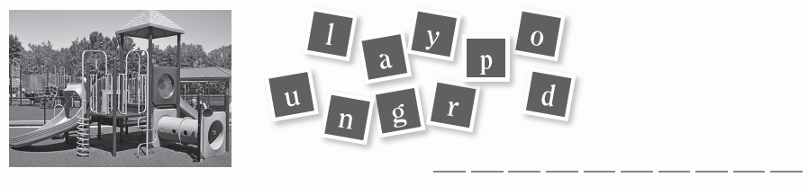
4.



5.

Look at the picture and read the questions. Write one-word answers.
There is one example.

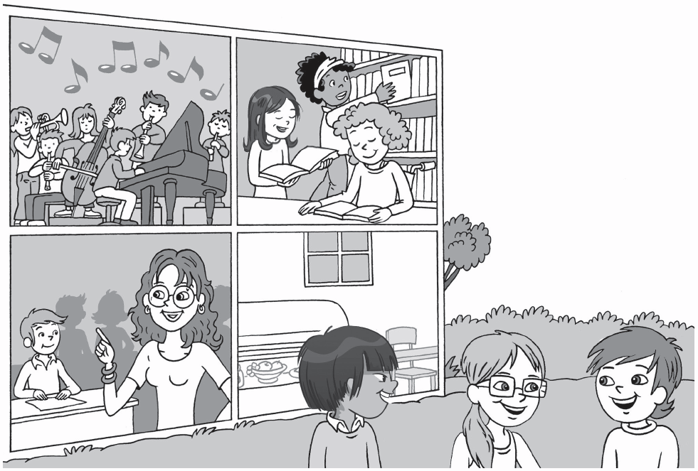

Example:
Where is Miss Parker? She’s in a classroom .

Part 3
1. How many classrooms do you see? I see ______________________ classrooms.
2. Where is Lee? He is in the ______________________.
3. How many students are in the
music room? ______________________ students.
4. Where are Chloe, Jessie and Mike? They are in the ______________________.
5. Where do the Stars eat? In the ______________________.

