Unit 2 TEST A
My name is: ___________________________________________________________________________



Listen and tick () the box. There is one example.

Example:
How old is Mike?

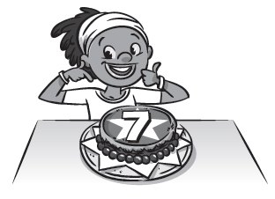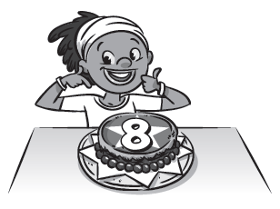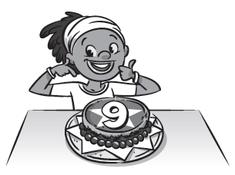
A □ B ☑ C □

1. What is Ana shaking?

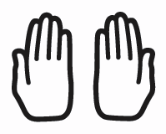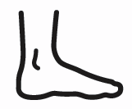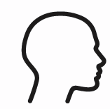
A □ B □ C □

2. Who wins the race?

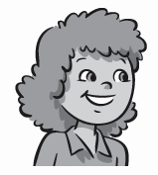
A □ B □ C □

3. What is Jessie doing?

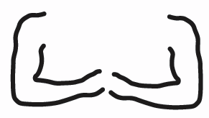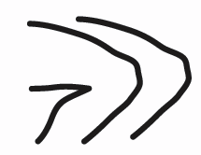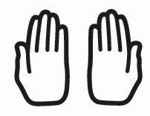
A □ B □ C □

4. What’s Lee playing with?

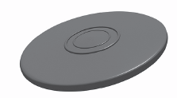
A □ B □ C □

5. What are the children doing?

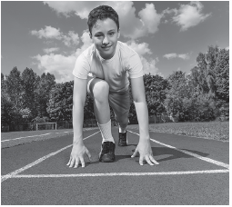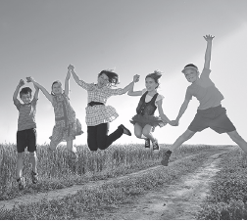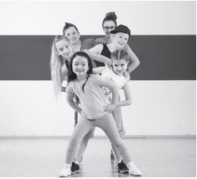
A □ B □ C □

Unit 2 TEST A
My name is: ___________________________________________________________________________



Look and read. Put a tick () or a cross () in the box. There are two examples.

Examples:
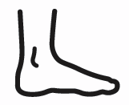
This is a foot. ☑ This is a basketball. 

Part 1

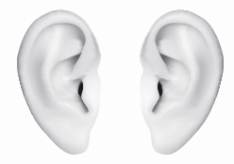
1. This is a football. □ 2. These are ears. □

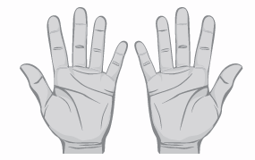
3. These are toes. □

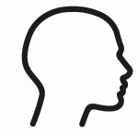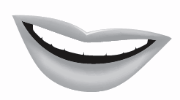
4. This is a head. □ 5. This is a frisbee.□
Look at the pictures. Look at the letters. Write the words. There is one example.

Example:

Part 2

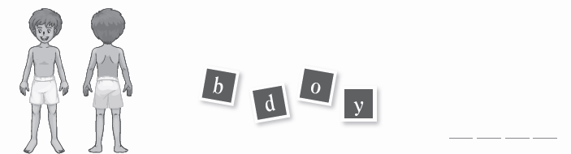
1.


2.

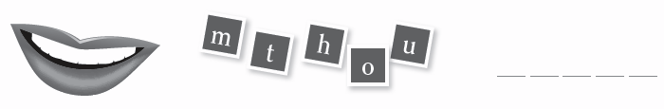
3.



4.



5.
Look at the picture and choose a word. Write the correct word next to numbers 1–5. There is one example.

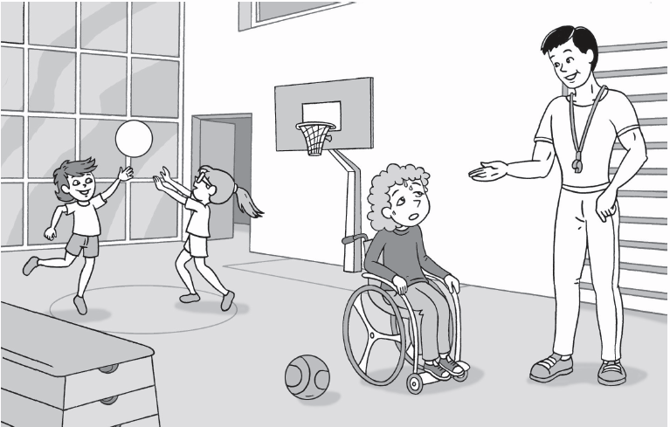

Part 3

I’m Chloe and I’m in the 1) _______________. My PE teacher is 2) _______________. I’ve got two big 3) _______________ and two 4) ________________. I can’t run, but I can race you in my

5) ________________.

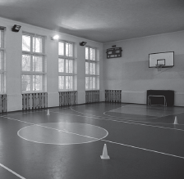
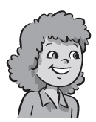
☑ □ □ □ □
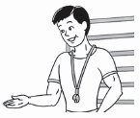

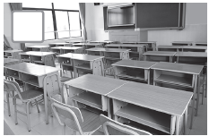

Chloe classroom gym Miss Parker Mr Luke

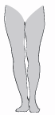
□ □ □ □ □

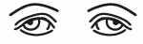
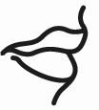


eyes nose legs mouth wheelchair

