Unit 3 TEST A
My name is: ___________________________________________________________________________



Listen and tick () the box. There is one example.

Example:
How old is Mike?

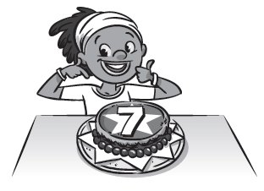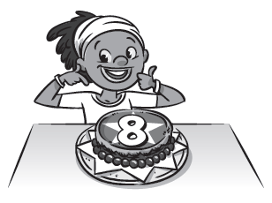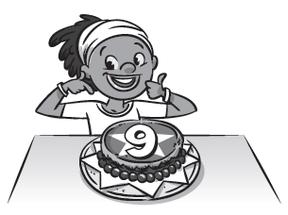
A □ B ☑ C □

1. What is Ana eating?

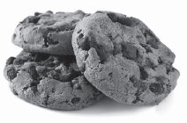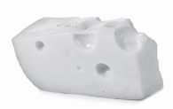
A □ B □ C □

2. Who loves grapes?


A □ B □ C □
3. What’s in Miss Parker’s lunchbox?

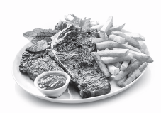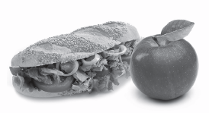
A □ B □ C □

4. What food doesn’t Lee like?

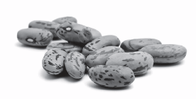
A □ B □ C □

5. Is the popcorn sweet, spicy or salty?

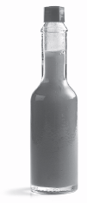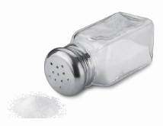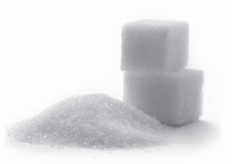
A □ B □ C □

Unit 2 TEST A
My name is: ___________________________________________________________________________



Look and read. Put a tick () or a cross () in the box. There are two examples.

Examples:
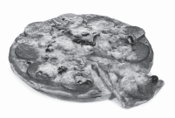
This is pizza. ☑ This is soup. 

Part 1

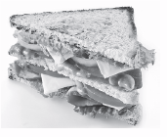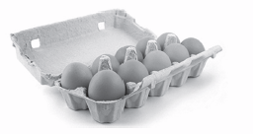
1. This is a steak. □ 2. These are vegetables. □

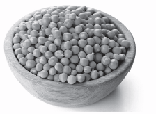
3. These are peas. □

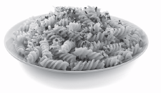
4. These are tomatoes. □ 5. This is pasta.□
Look at the pictures. Look at the letters. Write the words. There is one example.

Example:

Part 2
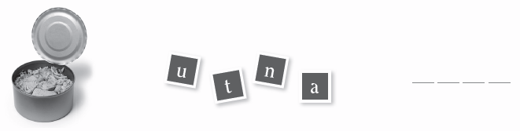
1.


2.

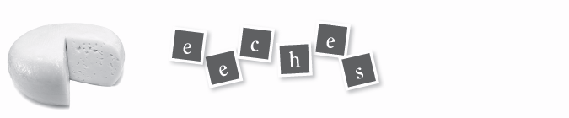
3.

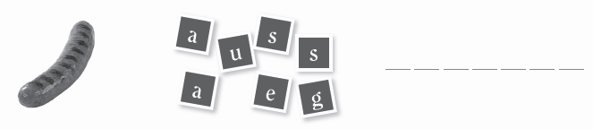

4.

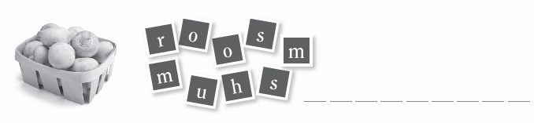

5.
Look at the picture and choose a word. Write the correct word next to numbers 1–5. There is one example.
å
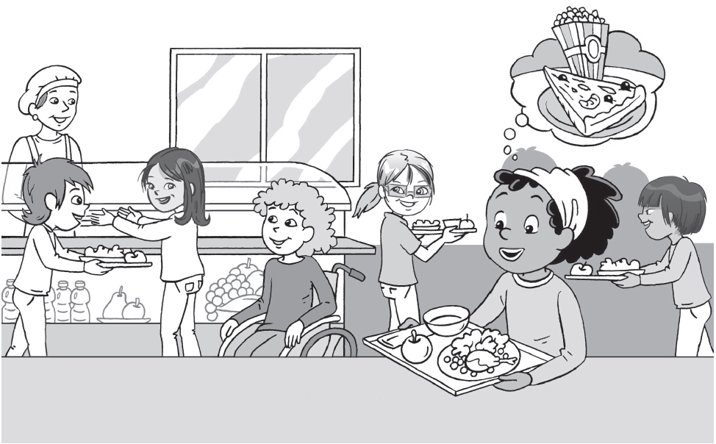

Part 3

I’m Mike and I’m in the 1) ______________. I like the food here. Today I’m eating 2)______________ with vegetables. I’m also eating 3) _______________ and fruit. I love party food like 4) _______________ and 5) _______________, but they’re not good for you.


☑ □ □ □ □
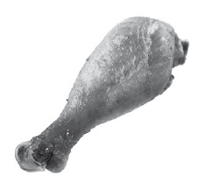

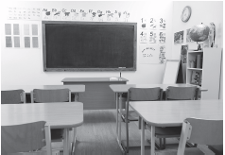
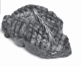

Mike canteen classroom chicken steak


□ □ □ □ □
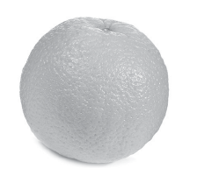
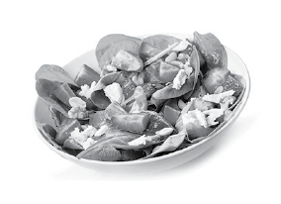
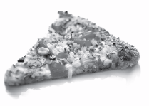


salad soup popcorn pizza orange

